"Forecasting Post-Brexit Trade Flows Between Ireland and the UK Using a Hybrid Gravity-Time Series Modeling Framework with Sectoral Exports Analysis

Goutham Jekkula

M.Sc. in Computing in Data Science 2025



Department of Computing, ATU Donegal, Port Road, Letterkenny, Co. Donegal, Ireland.

“Forecasting Post-Brexit Trade Flows Between Ireland and the UK Using a Hybrid Gravity-Time Series Modelling Framework with Sectoral Exports Analysis”

Author: Goutham Jekkula

Supervised by: Paul Moran

A thesis submitted in partial fulfilment of the requirements for the

Master of Science in Computing in Data science

Submitted to Atlantic Technological University

Arna chur isteach chuig Ollscoil Teicneolaiochta an Atlantaigh September 2025

# Declaration

I hereby certify that the material, which l now submit for assessment on the programmes of study leading to the award of Master of Science in Computing in Data science, is entirely my own work and has not been taken from the work of others except to the extent that such work has been cited and acknowledged within the text of my own work. No portion of the work contained in this thesis has been submitted in support of an application for another degree or qualification to this or any other institution. I understand that it is my responsibility to ensure that I have adhered to ATU’s rules and regulations.

I hereby certify that the material on which I have relied on for the purpose of my assessment is not deemed as personal data under the GDPR Regulations. Personal data is any data from living people that can be identified. Any personal data used for the purpose of my assessment has been pseudonymised and the data set and identifiers are not held by ATU. Alternatively, personal data has been anonymised in line with the Data Protection Commissioners Guidelines on Anonymisation.

I consent that my work will be held for the purposes of education assistance to future students and will be shared on the ATU Donegal (Computing) website (www.lyitcomputing.com) and Research THEA website (https://research.thea.ie/). I understand that documents once uploaded onto the website can be viewed throughout the world and not just in the Ireland. Consent can be withdrawn for the publishing of material online by emailing Thomas Dowling; Head of Department at thomas.dowling@atu.ie to remove items from the ATU Donegal Computing website and by email emailing Denise McCaul; Systems Librarian at denise.mccaul@atu.ie to remove items from the Research THEA website. Material will continue to appear in printed formats once published and as websites are public medium, ATU cannot guarantee that the material has not been saved or downloaded.

GOUTHAM. Jekkula

**Signature of Candidate** **Date: 29/08/2025**

# 

# Acknowledgements

 I would like to express gratitude towards everyone who aided me in this journey of the master's degree. Initially, I would like to thank the Letterkenny Institute of Technology for providing admittance for the course of Master’s in Data Science. I would also like to thank Jade Lyons, head of Computing Department for Offering all the encouragement and assistance for the completion of my MSc degree

I thank lecturer Mairead Feeney for the supervision of this dissertation. I would also like to thank my lecturers during the course of the curriculum: Dr. Shagufta Henna, Angela Sweeney, Dr. Paul Morn, Dr. Paul Greany for the knowledge I gained from this course.

Ultimately, I would like to be grateful to my classmates, friends, and family for encouraging me during the journey

# Abstract

This thesis investigates the impact of Brexit on Ireland–UK trade by combining structural economic modelling with advanced time series methods. A hybrid forecasting framework is developed that integrates Poisson Pseudo Maximum Likelihood (PPML) Gravity model estimates with residual forecasts generated by ARIMA, Long Short-Term Memory (LSTM) networks, and Transformer architectures. The study focuses on six key export sectors—pharmaceuticals, agriculture, beverages, dairy, meat, and vegetables—using monthly data from the Central Statistics Office (CSO) and structural covariates from CEPII.

Findings show that Brexit’s effects have been uneven across sectors. Pharmaceuticals, supported by global integration and regulatory harmonisation, demonstrated resilience and growth in absolute exports. In contrast, agri-food sectors such as meat and dairy were disproportionately affected by non-tariff barriers, customs delays, and regulatory divergence, resulting in relative declines in export shares. While the Gravity model provided robust long-run structural estimates, it was limited in explaining short-run shocks. Residual-based forecasting with ARIMA, LSTM, and Transformers captured these nonlinearities and disruptions more effectively.

The hybrid forecasts consistently outperformed standalone models by combining the interpretability of Gravity estimates with the adaptability of time series methods. Across all six sectors, the Hybrid achieved complete reductions in RMSE, MAE, and MAPE relative to the best standalone models. In pharmaceuticals, the Hybrid eliminated ARIMA errors of 47.8 (RMSE) and 24.5 (MAE), while in meat and dairy it outperformed Transformer and LSTM baselines. Runtime was highly efficient, averaging 0.001–0.002 seconds per forecast. This research addresses methodological and empirical gaps by applying residual forecasting at the sectoral level and provides policy-relevant insights for small open economies navigating disruptive trade shocks.

**Keywords:** Brexit, Ireland–UK trade, Gravity model, PPML, ARIMA, LSTM, Transformer, Hybrid forecasting

# Acronyms

|  |  |  |
| --- | --- | --- |
| Acronym | Definition | Page |
| PPML | Poisson Pseudo Maximum Likelihood | xx |
| ARIMA | AutoRegressive Integrated Moving Average | xx |
| LSTM | Long Short-Term Memory (Neural Network) | xx |
| TSM | Trade Statistics Monthly (CSO) | xx |
| CSO | Central Statistics Office (Ireland) | xx |
| CEPII | Centre d'Études Prospectives et d'Informations Internationales (France) | xx |
| ETS | Exponential Smoothing Method | xx |
| GDP | Gross Domestic Product | xx |
| RTA | Regional Trade Agreement | xx |
| NTB | Non-Tariff Barrier | xx |
| SPS | Sanitary and Phytosanitary Standards | xx |
| MAE | Mean Absolute Error | xx |
| MAPE | Mean Absolute Percentage Error | xx |
| RMSE | Root Mean Squared Error | xx |
|  |  |  |
|  |  |  |
|  |  |  |

Table of Contents

Declaration 3

Acknowledgements 3

Abstract 4

Acronyms 5

Table of Figures 6

Table of Tables 7

Table of Code Listings 8

Chapter 1 12

1.1Introduction 12

1.2. Purpose 14

1.3 Research Problem / Gap 15

1.4 Research Question’s: 16

1.5. Aims and Objectives 16

1.6 Overview of Thesis Structure 18

Chapter 2 Literature Review 20

2.1 Introduction 20

2.2 The Gravity Model of international trade- Poisson Pseudo-Maximum Likelihood (PPML) 21

2.2.1 Historical Origins and Theoretical Foundations 21

2.2.2 Methodological Advances and Evolution of Explanatory Variables in Gravity Models 22

2.2.4 Gravity Models Applied to Ireland–UK Trade 24

2.2.5 Limitations of Gravity Models in Dynamic Settings 26

2.3 Time Series Forecasting Models in Trade Prediction 27

2.3.1 Historical Origins and Theoretical Foundations 27

2.3.2 Evolution of ARIMA, LSTM, Transformers 28

2.3.3 ARIMA, LSTM, Transformer Models Applied to Ireland–UK Trade or Other Economic Trade 31

2.3.4 Limitations of ARIMA, LSTM, and Transformer Models 32

2.3.5 Justification for ARIMA, LSTM, Transformers Use in This Thesis 34

2.4 Residual Forecasting Models 35

2.5 Brexit’s Sectoral Impact on Irish Trade 37

2.5.1 Introduction: Brexit’s Sectoral Impact on Irish Trade 37

2.5.2 Pharmaceuticals Sector 39

2.5.3 Agriculture Sector 40

2.5.4 Beverages Sector 41

2.5.5 Dairy Sector 43

2.5.6 Meat Sector 44

2.5.7 Vegetable Sector 45

Table1: 2.6 – Sectoral Comparison of Brexit Impacts and Forecasting Models. 47

2.7 Summary and Identified Research Gap 49

Chapter 3: Data and Methodology 50

3.1 Introduction 50

3.2 Use of CSO Trade Statistics (TSM Datasets) in Sectoral Forecasting: 52

3.3 Gravity Dataset Construction: 54

3.4 Time Series Forecasting Models 57

3.4.1 Model 1 — ARIMA (Statistical Benchmark 58

3.4.2 Model 2 — LSTM (Deep Learning with Memory) 59

3.4.3 Model 3 — Transformer (Encoder‑Only, Self‑Attention) 60

3.4.4 Evaluation Metrics 62

3.4.5 Outputs and Traceability (Sheets) 63

3.5 Gravity Model Estimation (PPML) 63

3.5.1 Model Specification 65

3.5.2 Estimation Methodology. 66

3.5.3 Residual Extraction for Forecasting: 68

3.6 Residual Forecasting: 69

3.6.1 Data and Preprocessing 69

3.6.3 LSTM on Residuals: 70

3.6.4 Transformer on Residuals 71

3.6.5 Evaluation and Outputs 72

Code 21: Output Files 73

3.7 Hybrid Forecasting Model Construction 73

3.7.1 Data Sources and Inputs : 74

3.7.2 Hybrid Construction Methodology. 74

3.7.3 Evaluation Metrics 75

Code 25: Metrics computation 76

3.7.4 Outputs and Structure 76

3.8 Comparative Evaluation: Hybrid vs Time Series: 77

3.8.1 Data and Output Sources; 79

3.8.2 Comparison Metrics 79

3.8.3 Methodology Implementation: 80

3.9 What-If Scenario Methodology: 80

3.9.1 Baseline Hybrid Forecast Definition: 81

3.9.2 Incorporating Brexit Shocks via Residual Adjustment: 81

3.9.3 Scenario Data Structure and Output 82

3.9.4 Evaluation Metrics: 82

3.9.5 Interpretation and Implications 83

3.10 Time Series Forecasting for 2024–2025: 84

3.10.1 Model Training and Forecast Generation 85

3.11 Hybrid Forecasts for 2024–2025: 88

3.11.1 Data and Inputs: 88

3.11.2 PPML Projection (Structural Component): 89

3.11.3 Residual Forecasting (Dynamic Component) 89

3.11.4 Hybrid Forecast Construction 90

3.11.5 Scenario Shocks (Soft and Hard Brexit) 90

3.11.6 Output Structure 91

3.12 Combined Sector Forecast Plots 91

3.12.1 Data Inputs 91

Chapter4: Results & Discussion 94

4.1 CSO Data Sets(TSM09, TSM06): 94

4.1.1. TSM06 (1970-2025) 95

4.2 Time Series Model Results and Discussion 96

4.3 Hybrid Forecasting Results and Discussion 101

4.3.1.Hybrid_metrics sheet: 102

4.3.2 .Chosen_models sheet: 103

4.4 Hybrid Future Forecast 105

4.4.1 Pharmaceuticals: 105

4.4.2 Meat 106

4.4.3. Dairy 107

4.4.4.Agriculture: 107

4.4.5.Beverages: 108

4.4.6 Vegetables 109

4.4.7 Cross-Sectoral Discussion: 109

Chapter 5: Conclusion: 110

5.1.Addressing the First Research Question: The Value of the Hybrid Approach 111

5.2Addressing the Second Research Question: Best Models by Sector 111

5.3Addressing the Third Research Question: Policy Relevance 112

5.4Overall Contribution to Research Aims: 113

5.5 Limitations: 113

5.6.Future Research: 114

5.7.Final Remarks 114

# Table of Figures

# Figure 1: ARIMA Architecture

#### Figure 2: LSTM Architecture

#### Figure 3: Transformer Architecture

#### Figure 4:Gravity Model Workflow

#### Figure 5: Workflow of the Hybrid Forecasting Model Construction

#### Figure 6: Workflow of the Comparative Evaluation (Hybrid vs Time Series)

#### Figure 7: Workflow of the What-If Scenario Forecasting (Soft vs Hard Brexit)

#### Figure 8: Pie Chart

#### Figure 9: Stacked Area Chart

#### Figure 10: Bar Chart

#### Figure 11: Pharmaceuticals Sector Forecast

#### Figure 12: Meat Sector Forecast

#### Figure 13: Dairy Sector Forecast

#### Figure 14: Agriculture Sector Forecast

#### Figure 14: Agriculture Sector Forecast

#### Figure 15: Vegetables Sector Forecast

#### 

#### Table of Tables

#### Table1: 2.6 – Sectoral Comparison of Brexit Impacts and Forecasting Models

#### Table 2: Model Evaluation Metrics by Sector

#### Table 3: Hybrid Metric Sheets

#### Table 4: Chosen model sheets.

# Table of Code Listings:

#### **Code 1** – Data Prep, Libraries, and Splits

#### **Code 2** – EuroMillions Conversion

#### **Code 3** – ARIMA Training

#### **Code 4** – ARIMA Tuning

#### **Code 5** – LSTM-NN Models

#### **Code 6** – LSTM Validation

#### **Code 7** – Early Stopping by Validation Snapshotting

#### **Code 8** – Transformer Model Structure

#### **Code 9** – Transformer Training

#### **Code 10** – Best Model Selection

#### **Code 11** – Application of PPML Formula

#### **Code 12** – Fitting PPML with Robust Errors

#### **Code 13** – Sector-by-Sector Estimation

#### **Code 14** – Saving Results

#### **Code 15** – Load Panel

#### **Code 16** – Best ARIMA on Residuals

#### **Code 17** – Building LSTM for Residuals

#### **Code 18** – Training LSTM with Early Stopping

#### **Code 19** – Building Transformer on Residuals

#### **Code 20** – Residual Metrics Computation

#### **Code 21** – Output Files

#### **Code 22** – Load Inputs

#### **Code 23** – Merge Datasets

#### **Code 24** – Hybrid Forecast Creation

#### **Code 25** – Metrics Computation

#### **Code 26** – Save Outputs

#### **Code 27** – Merge, Compute Deltas, Decide Winner

#### **Code 28** – Compute Percentage Improvements

#### **Code 29** – Build What-If Scenarios

#### **Code 30** – Evaluation Metrics

#### **Code 31** – Scenario Forecasting

#### **Code 32** – Imports and Configuration for 2024–2025 Forecasts

#### **Code 33** – Deterministic CPU

#### **Code 34** – Utility Functions

#### **Code 35** – Best ARIMA by RMSE

#### **Code 36** – LSTM Model Definition

#### **Code 37** – Transformer Model Definition

#### **Code 38** – Training Loop

#### **Code 40** – Recursive Forecasting

#### **Code 41** – PPML Projection Helper (Flat/ETS/Linear)

#### **Code 42** – Forecasting Residuals

#### **Code 43** – Hybrid Baseline Construction

#### **Code 44** – Data Loading and Validation

#### **Code 45** – Plotting per Sector

# Chapter 1

## 1.1Introduction

An important turning point in European integration was the United Kingdom's exit from the EU on January 31, 2020. Brexit abruptly interrupted the smooth flow of capital, products, and services within the single market after over 50 years of membership. Ireland was particularly hard hit because of its tight economic links and shared border with Northern Ireland. Prior to Brexit, 14% of Ireland's exports and almost 25% of its imports came from the UK in 2015. The most reliant industries were agri-food, dairy, drinks, and pharmaceuticals (Sunesen, Dahlberg, and Hansen, 2020). A number of new trade frictions were brought about by the UK's withdrawal. Previously seamless trade was swiftly supplanted by rules-of-origin checks, product inspections, customs declarations, and conflicting standards. Due to their limited ability to absorb additional costs, small and medium-sized businesses (SMEs), which make up a large portion of Ireland's export base, were especially vulnerable. Non-tariff barriers including labeling and packaging restrictions caused delays and decreased competitiveness even in the absence of tariffs (Byrne, Stephen & Rice, Jonathan, 2018 and Rice, 2018; Gjems Theie, 2014).

The disruptive effects are confirmed by empirical research. Irish exports to the UK have drastically decreased in high-friction industries including manufacturing and food, according to Lawless, Kren, and Flynn (2021). According to Bergin et al. (2019), the wholesaling, dairy, and meat industries would be the most impacted by a no-deal Brexit, which may lower Ireland's GDP by as much as 5%. Barrett et al. (2015) also cautioned that fluctuations in Irish output and employment might result from unrest in UK-EU trade relations. There was also uncertainty during the negotiating stage. Long-term discussions decreased enterprises' export planning, according to Abdou et al. (2020), and even after the Trade and Cooperation Agreement (TCA), delays and frictions were caused by gaps in preparation and customs interpretation (Ireland, I.T., 2017.). The wider challenges businesses experienced in adjusting to new trading conditions were exacerbated by these concerns.

Researchers have responded by using novel forecasting techniques. Although they are still useful for describing trade patterns based on GDP and distance, traditional economic models like the Gravity Model sometimes falter during shocks like Brexit (Keogh, G., 2018 ) As alternatives, hybrid models have surfaced that combine machine learning flexibility with economic structure. For instance, Wu et al. (2021) discovered that LSTM models were more successful than conventional techniques in volatile agricultural commerce, while Shen et al. (2020) demonstrated that deep learning enhanced gravity-based forecasts in transport flows. By creating the R2N2 framework, Goel, H., Melnyk, I. and Banerjee, A., 2017) expanded on this strategy by applying a neural network to residuals in addition to a baseline statistical model. These advancements demonstrate how hybrid forecasting may capture both abrupt shocks and structural trade trends. Building on that approach, this thesis forecasts Ireland-UK trade in the post-Brexit situation using a hybrid gravity-time series approach.

## 1.2. Purpose

This thesis looks at how Ireland's commerce with the UK has changed after Brexit, with an emphasis on creating forecasting techniques that are precise and flexible. The abrupt shocks brought about by Brexit are difficult for traditional econometric models to capture, even though they work well in stable environments. To solve this, the study creates a hybrid forecasting model that simulates policy scenarios for Irish exports and provides accurate sector-level trade estimates by fusing the flexibility of machine learning with the structural dependability of economic theory.

The system is constructed as a two-stage model. Poisson Pseudo-Maximum Likelihood (PPML), which is resistant to heteroskedasticity and zero trade flows, is used in the first stage to estimate the Gravity Model. This method is widely known in the literature and was utilized in the Irish context by (Keogh, G., 2018), who evaluated the effect of Brexit on Irish merchandise exports using a PPML Gravity Model. The second step involves applying the Transformer, LSTM, and ARIMA models to the Gravity Model's residuals. Variations brought on by shocks like regulatory delays, non-tariff obstacles, and policy uncertainty—factors that are difficult to describe in structural equations—are captured by this residual forecasting approach. It was initially demonstrated by Zhang (2003) that forecasting ability is enhanced by hybridizing linear and The applicability of this strategy is further supported by more recent research, such as Goel, H., Melnyk, I. and Banerjee, A., 2017and Santos Júnior et al. (2022), which show that deep learning applied to residuals improves prediction accuracy. When combined, these studies lend credence to the modeling of uncertain aspects of trade using ARIMA, LSTM, and Transformers. Ireland is especially pertinent to this framework. According to Lawless and Morgenroth (2019) , the effects of Brexit are not uniform across industries, with the food and agriculture sectors seeing the most disruptions. Additionally, Byrne, Stephen & Rice, Jonathan, 2018 and Rice (2018) pointed out that it is challenging to directly measure non-tariff obstacles such customs inspections and labeling regulations. An effective method of capturing these impacts without the use of extra structural variables is residual forecasting.

The work adds to the expanding body of research on forecasting hybrid commerce. It focuses on six industries—dairy, meat, vegetables, pharmaceuticals, plants & herbs, and beverages—selected for their susceptibility to Brexit-related conflicts. Gopinath, Batarseh, and Beckman (2020) showed improvements in agricultural trade forecasts, and Stamer (2021) and Gupta and Kumar (2021) confirmed that machine learning techniques are well suited for capturing complex trade dynamics. These studies already demonstrate the value of integrating machine learning in trade forecasting. Building on these findings, the thesis demonstrates how, in a post-Brexit world that is disrupted, a hybrid Gravity–time series strategy can produce forecasts that are precise, comprehensible, and pertinent to policy.

## 1.3 Research Problem / Gap

Structural models like the Gravity Model, which do well in stable environments but falter in unstable ones, have long been used in international trade forecasting. With the introduction of taxes, customs inspections, and regulatory divergence, Brexit was just such a split. Irish commerce with the UK was subject to sudden shocks that were not adequately captured by traditional models, particularly in the areas of agriculture, dairy, drinks, and medicines Keogh, G., 2018; Lawless and Morgenroth, 2019).P oisson Pseudo-Maximum Likelihood (PPML), which handles zero flows and heteroskedasticity better than OLS, has improved gravity estimates in order to meet these problems (Santos Silva and Tenreyro, 2006). Nevertheless, PPML continues to rely on consistent structural logic, which restricts its capacity to capture abrupt changes in behavior or policy. Although simulations by Santos Silva and Tenreyro (2011) demonstrate the robustness of PPML, it is unable to represent real-time volatility brought on by shocks like Brexit.

As a result, time series models that can identify volatility and nonlinear changes are being used more frequently. While deep learning techniques like Long Short-Term Memory (LSTM) and Transformer architectures are better suited to capture intricate relationships, ARIMA is still helpful in stable situations. Research demonstrates that in volatile trade data, LSTM frequently performs better than ARIMA (Siami-Namini et al., 2018), while Transformers successfully manage multivariate and policy-sensitive series (Zhao, Song, and Liu, 2023). However, their interpretability and policy relevance are limited due to their "black box" character (Byrne, Stephen & Rice, Jonathan, 2018).

Hybrid modeling with residual forecasting is a viable approach. This method, which was first put forth by Zhang (2003) and then refined by Goel, H., Melnyk, I. and Banerjee, A., 2017and Santos Júnior et al. (2022), combines time series models applied to residuals with gravity estimations to capture deviations that cannot be explained by fundamentals. Research on Brexit supports the necessity of these techniques: Keogh (2020) showed that Irish trade reactions differed significantly across sectors, whereas Lawless and Morgenroth (2019) and Byrne, Stephen & Rice, Jonathan, 2018 ) Nevertheless, there aren't many studies that use residual-based hybrid forecasting for sector-level trade between Ireland and the UK. By integrating PPML Gravity with ARIMA, LSTM, and Transformer models on residuals across six sectors, this thesis fills that gap. With its theoretical foundation and prediction accuracy, the framework facilitates more effective trade policy creation and allows for a better understanding of the asymmetric effects of Brexit.

## 1.4 Research Question’s:

This thesis investigates the limitations of traditional trade models in explaining past-Brexit trade disruptions and explore the user of hybrid forecasting methods. To guide the analysis, the following research questions are posed:

1. Can a hybrid model combining the Gravity model and time series forecasting improve accuracy of Ireland-UK trade predictions after Brexit?
2. Which time series method-ARIMA, LSTM, or Transformer-best captures the Brexit-related shocks in different Irish export sectors?
3. How can a Hybrid Gravity-Time Series model help policymakers make a better trade decisions in time of economic disruptions, such as Brexit?

## 1.5. Aims and Objectives

This study's main goal is to create and assess a combination forecasting model that combines modern time series methods with economic theory. With an emphasis on six key industries—pharmaceuticals, plants and herbs, meat, dairy, vegetables, and beverages—this model forecasts how trade between Ireland and the UK would change following Brexit. Even when updated with PPML, traditional models like the Gravity Model are good at showing long-term trade patterns, but they frequently overlook abrupt changes brought on by significant events like Brexit. However, forecasting technologies such as ARIMA, LSTM, and Transformer are not directly tied to economic concepts, but they are capable of handling sudden and unforeseen changes By first applying the Gravity Model and then time series models to the remaining patterns (referred to as residuals), which are anticipated to represent the short-term consequences of Brexit, this thesis aims to integrate the best features of both methodologies.

Aim:

To forecast sector-specific post-Brexit trade between Ireland and the UK by integrating the Gravity Model (PPML) with ARIMA, LSTM, and Transformer time series models applied to residual trade series, in order to capture both structural and shock-induced dynamics.

Objectives

To fulfil this aim, the thesis sets out the following detailed objectives:

1.Build the Gravity Model Using PPML:

Use the Poisson Pseudo-Maximum Likelihood method to estimate trade between Ireland and the UK across six sectors. This model will include GDP (from Ireland and the UK), tariff data, and Gravity-related factors like distance and common language from CEPII.

2. Calculate Residual Trade Patterns:

Take the actual trade values from CSO and subtract the Gravity Model’s predictions. This will show the unexpected or Brexit-related changes in trade—the residuals.

3.Use Time Series Models on the Residuals:

Analyse these residuals with:

* ARIMA for stationary, interpretable shock patterns.
* LSTM for nonlinear, sequential behaviours.
* Transformer for long-range dependencies and high-frequency complexity.

4.Create a Final Hybrid Forecast:

Combine the original Gravity Model forecasts with the predictions made by the time series models applied to the residuals. This creates a more complete and realistic trade forecast.

5.Compare Model Accuracy

Check how accurate each model is by using performance metrics like RMSE (Root Mean Square Error), MAE (Mean Absolute Error), and MAPE (Mean Absolute Percentage Error).

6.RUN "What-If" Scenarios Involving Tariff and GDP Shocks:

Test how trade would change if key factors like GDP or tariffs were altered—such as what happens if UK GDP drops or if tariffs on Irish exports rise.

7.Give Policy Advice and Sector Insights:

Use the results to recommend actions for Irish policymakers. The goal is to highlight which sectors are most at risk and which are most stable in the face of Brexit-related economic changes.

## 1.6 Overview of Thesis Structure

This thesis is organized into five lengthy chapters, each of which logically builds upon the one before it to provide a cohesive story and a strict scientific framework for predicting trade between Ireland and the UK in six important industries after Brexit. From setting up the background and providing theoretical support, the framework aims to go on to data collection and modelling, model evaluation, and policy simulations.

Chapter 2 – Literature Review

The literature review provides a thorough analysis of the scholarly underpinnings and recent developments pertinent to this investigation. With an emphasis on the Poisson Pseudo-Maximum Likelihood (PPML) estimator, it first traces the theoretical development and origins of the Gravity Model in international commerce, highlighting its econometric history. After that, the paper examines the development of time series forecasting methods, including the Transformer, LSTM, and ARIMA models, paying particular attention to their methodological advantages, real-world uses, and connection to trading volatility. The chapter expands on this by examining residual-based hybrid models, particularly those that use time series models with Gravity forecasts to account for unexplained trade shocks.Using both structural and machine learning-based literature, a distinct sectoral review is carried out for the six industries most affected by Brexit. The chapter concludes by highlighting important methodological and empirical research gaps, laying the groundwork for the hybrid model that this thesis suggests.

Chapter 3 – Data and Methodology

. The model framework and dataset structure used in the thesis are explained in this chapter. It presents the World Bank GDP data, the CEPII gravity dataset, the CSO TSM series for Irish trade, and tariff datasets in UK WTO format. The procedures for estimating the Gravity Model using PPML and extracting residuals are also covered in this chapter. The introduction of each time series model (ARIMA, LSTM, Transformer) includes details on preprocessing, model design, training/testing protocols, and hyperparameter adjustment. Additionally covered are model comparison metrics such as RMSE, MAE, and MAPE.

Chapter 4 – Result and Discussions

The modeling results are thoroughly explained in this chapter. RMSE, MAE, and MAPE are used to measure the accuracy of time series forecasts (ARIMA, LSTM, Transformer) at the outset. After that, the Gravity Model is presented as a structural baseline for trade between Ireland and the UK. The residuals are simulated independently to account for shocks and volatility unique to each sector. The time series techniques are then used to replicate the Gravity Model residuals in order to capture sector-specific changes and shocks that the structural estimation is unable to adequately explain. Combining these methods reveals which models work well for each industry and offers further insight into the disparate effects of Brexit on Irish exports.

Chapter 5 – Conclusion and Future Work

The study's main conclusions are presented in the last chapter, which also underlines the advantages of hybrid residual modeling over independent or conventional forecasting techniques. It assesses the thesis's contributions to methodological innovation, trade forecasting, and economic modeling. The chapter concludes with an analysis of the thesis's limitations and suggestions for additional research, including the use of real-time machine learning frameworks, the inclusion of non-tariff barriers, and the extension of the model to other EU partners.

# Chapter 2 Literature Review

## 2.1 Introduction

It is now more crucial than ever to comprehend how trade patterns respond to significant political and economic shocks. Brexit demonstrated how easily established trade relationships can become unstable, causing market turbulence and necessitating the use of new forecasting techniques. Brexit created a significant economic shock by tearing down decades of UK-EU cooperation (European Commission, 2019; Bergin et al., 2019). The repercussions were immediate for Ireland, whose economy is closely linked to the UK; new regulatory obstacles, customs procedures, and interrupted trade channels presented difficulties for exporters and policymakers alike (Byrne, Stephen & Rice, Jonathan, 2018). This chapter examines the academic literature that supports the hybrid forecasting strategy created in this thesis, which combines the Gravity Model with time series methods including ARIMA, LSTM, and Transformer models. The review is divided into four parts. First, it examines the theoretical and empirical basis of the Gravity Model, which has been frequently employed in trade analysis since Tinbergen (1962) and modified by Anderson and van Wincoop (2003). Recent advancements, particularly the Poisson Pseudo-Maximum Likelihood (PPML) estimator, have enhanced its ability to handle zero trade flows and heteroskedasticity (Santos Silva and Tenreyro, 2006; Head, K. and Mayer, T., 2014).

Second, time series forecasting models in economics and commerce are examined in this chapter. The Box-Jenkins framework is the foundation of ARIMA models, which have long been utilized for univariate forecasting, particularly during shocks (Hyndman and Athanasopoulos, 2018; Dhamija and Bhalla, 2020). Because of their capacity to identify non-linearities, long-term dependencies, and structural discontinuities in trade series, deep learning models like Long Short-Term Memory (LSTM) and Transformers have gained popularity in recent years (Song et al., 2020; Zhang et al., 2022; Zhou et al., 2023). Third, the paper emphasizes residual-based strategies that overcome the shortcomings of simply data-driven or structural approaches. The benefits of using ARIMA in conjunction with neural networks to capture residual patterns were initially demonstrated by Zhang (2003). This was expanded in later research utilizing ensemble approaches and recurrent networks like R2N2, which increased the accuracy of multivariate trade forecasting (Wang et al., 2020; Liu et al., 2023).

The impact of Brexit on Irish trade is finally evaluated, with an emphasis on pharmaceuticals, plants & herbs, livestock, dairy, vegetables, and beverages. According to Lawless and Morgenroth (2019), and Dhingra et al. (2017), these studies highlight the necessity of disaggregated forecasting models that take into account sector-level adjustments as well as macroeconomic trends. The hybrid framework of Gravity + Time Series created in this thesis to predict trade after Brexit is based on these concepts taken together.

## 2.2 The Gravity Model of international trade- Poisson Pseudo-Maximum Likelihood (PPML)

### 2.2.1 Historical Origins and Theoretical Foundations

Motivated by Newton's law of global gravitation, Jan Tinbergen originally proposed the Gravity Model of international trade in 1962. He maintained that trade between two nations is inversely correlated with distance and directly correlated with economic size as indicated by GDP (Tinbergen, 1962). In early empirical tests, the model—despite its simplicity—performed well, especially when applied to industrialized economies with established trade relations. As researchers saw that real trade flows frequently matched the model's predictions, particularly in high-income bilateral ties, it swiftly gained popularity as a framework for policymakers (Yotov et al., 2016; Head, K. and Mayer, T., 2014). Ordinary Least Squares (OLS) on a log-linearized form was first used to estimate the model. Although this approach was simple to understand, it was extremely susceptible to heteroskedasticity, which produced biased results, and it did not include zero trade flows, which are typical in small economies or during shocks like Brexit (Santos Silva and Tenreyro, 2006). As the model was used for policy simulations using disaggregated or sectoral data, these flaws grew increasingly severe. In post-Brexit analysis, where abrupt shocks, volatility, and zero trade flows were common, this was particularly noticeable (Lawless and Morgenroth, 2019).

Researchers added factors like common language, colonial history, legal systems, proximity, and trade agreement membership to the model in order to increase realism. These factors all help to lower trade frictions and institutional uncertainty Head, K. and Mayer, T., 2014; Yotov et al., 2016). For instance, trade agreements like the EU Single Market lower tariff and non-tariff barriers, and a shared language makes business dealings easier. These explanatory variables were standardized by databases like the CEPII Gravity Dataset, which made them publicly accessible. for practical use (CEPII, 2022). GDP, distance, and language are taken from CEPII and modified for commerce between Ireland and the UK for this thesis. The model's foundation in microeconomic theory was a significant turning point. In order to take into consideration the dynamics of international commerce, Anderson and van Wincoop (2003) created a structural version based on the behavior of firms and consumers under monopolistic competition, adding multilateral resistance terms. Although such words are not used specifically in this thesis, the move to theory-consistent modeling improved the Gravity framework and made it more appropriate for simulating shocks and assessing trade policy (Head, K. and Mayer, T., 2014).

In trade policy analysis, the Gravity Model is now regarded as a standard instrument. International organizations like the European Commission, World Bank, and OECD use it to evaluate the impact of new agreements or disruptions like Brexit (Yotov et al., 2016). It has played a key role in Brexit research in Ireland. Keogh (2021) used a PPML Gravity Model to analyze how Brexit might affect merchandise exports, while Lawless and Morgenroth (2019) calculated that in the event of no agreement, Irish exports may decline by as much as 5% of modified GNI*. These illustrations demonstrate that the Gravity Model is still a reliable framework for examining changes in trade policy, especially when combined with contemporary methods like those used in this thesis.

### 2.2.2 Methodological Advances and Evolution of Explanatory Variables in Gravity Models

The Gravity Model swiftly rose to prominence as one of the most popular instruments for analyzing global trade, but questions were raised concerning the validity of its conventional estimating method, which involved applying Ordinary Least Squares (OLS) to a log-linear version of the model. Despite being simple and easy to understand, OLS had two main issues: it was extremely susceptible to heteroskedasticity and it did not include zero trade flows, which are typical in sectoral and disaggregated data. As gravity models were applied to situations with trade shocks and structural fractures, like Brexit, where volatility and zeros are common, these problems became more apparent (Santos Silva & Tenreyro, 2006). As a result, OLS-based estimates were frequently skewed and inconsistent, underscoring the need for more trustworthy estimation methods.

Santos Silva and Tenreyro's (2006) seminal paper, The Log of Gravity, was a significant advancement. They demonstrated that when mistakes are heteroskedastic or trade flows contain zeros, it is incorrect to take logarithms of the trade flows before applying OLS. In order to solve this, they developed the Poisson Pseudo-Maximum Likelihood (PPML) estimator, which uses levels instead of logs to estimate the model. This method reduces distortions associated with non-constant error variances and easily handles zero trade values. After resolving these issues, PPML quickly emerged as the go-to technique for gravity model estimate, especially in research including panel data, trade specialized to a sector, or situations involving structural disturbances (Santos Silva & Tenreyro, 2006; 2011).

Simulation and empirical research provided more proof of PPML's superiority. In further research, Santos Silva and Tenreyro (2011) showed that PPML continuously beat alternative estimators in terms of efficiency and bias under a variety of data circumstances. Because of these outcomes, organizations including the World Bank, OECD, and European Commission quickly adopted it for use in applied trade research and policy analysis. PPML has been particularly useful in Brexit-related studies because of its ability to withstand trade shocks. For example, Keogh (2021) examined the impact of Brexit on Irish exports using a PPML Gravity Model, demonstrating that traditional sectors such as agri-food were especially vulnerable. Lawless and Morgenroth (2019) further validated the method's applicability in disrupted environments by estimating export losses under several Brexit scenarios using PPML-based simulations.

Along with these methodological developments, the Gravity Model has also changed by adding more explanatory variables than only GDP and distance. Modern models incorporate institutional, cultural, and historical aspects that also influence commerce, even if GDP measures economic size and demand and distance represents transportation costs. While colonial links and shared legal or administrative systems promote familiarity and compatibility, a common language lowers transaction costs and enhances communication (Head, K. and Mayer, T., 2014; CEPII, 2022). Sharing a border, or contiguity, promotes trade by facilitating quicker customs processes and improved transportation connections. Because they promote integration and reduce obstacles, regional trade agreements (RTAs) like the EU Single Market are especially important. However, by removing the UK from the EU framework, Brexit undid many of these advantages and caused new conflicts (Yotov et al., 2016; Lawless & Morgenroth, 2019).

Recent research highlights the significance of incorporating sector-specific policy factors such non-tariff barriers (NTBs), technical standards, and tariffs. In highly regulated and perishable sectors like dairy, meat, and agriculture, where customs delays and compliance expenses proved particularly costly, Brexit brought these frictions to light. Keogh (2021) and Byrne, Stephen & Rice, Jonathan, 2018) show that taking these factors into consideration is essential to determining the actual effect on sectoral trade. This degree of refinement has been made possible by the creation of standardized databases like CEPII, which offer extensive variables encompassing language, legal frameworks, and trade agreements (Head, K. and Mayer, T., 2014; CEPII, 2022).

This thesis applies a well chosen set of explanatory factors and estimates the Gravity Model using PPML. These include distance, common language, GDP (from ons.gov.uk and data.cso.ie), and tariff information from CSO trade reports and the World Bank's WITS database. The model is used in six industries—pharmacies, plants and herbs, meat, dairy, vegetables, and beverages—that have been found to be particularly vulnerable to the effects of Brexit. In the post-Brexit era, this method offers a suitable framework for analyzing and forecasting Ireland-UK trade by fusing methodological robustness with sector-specific explanatory richness.

### 2.2.4 Gravity Models Applied to Ireland–UK Trade

Ireland-United Kingdom trade has been extensively analyzed using the Gravity Model, especially in light of Brexit. The two nations have a lot in common, including close proximity, a shared language, strong historical links, and previously harmonized regulatory frameworks that have sustained consistent trade flows for many years. Stronger trade between close and economically important partners is suggested by conventional gravity-based models, which these conditions fit (Keogh, G., 2018; Lawless and Morgenroth, 2019). But because of the institutional and regulatory obstacles that Brexit brought about, this alignment was upset, necessitating the use of more flexible modeling techniques (Head, K. and Mayer, T., 2014).

Approximately 14% of Irish exports and over 25% of imports were made in the UK before to its exit from the EU (CSO, 2021). This reliance was especially evident in the dairy, meat, beverage, and agricultural industries, whose integrated supply chains depended on easy access to the UK. Perishable and low-margin industries were particularly hard hurt by the customs processes, delays, and regulatory divergence brought forth by Brexit. While many organizations, such as the UK Treasury, employed gravity models to calculate long-term effects, Gudgin, G., Coutts, K.J., Gibson, N. and Buchanan, J., 2017..contended that these applications frequently depended on static assumptions and aggregate data, which limited their capacity to capture effects at the industry level. In attempt to close this gap, Keogh (2021) applied a PPML Gravity Model at the sectoral level, demonstrating that border inspections and documentation presented significant obstacles for the agri-food and beverage industry. This thesis expands on his study's finding that gravity models, when used at a disaggregated level, may more accurately capture the real-world frictions associated with Brexit.

Lawless and Morgenroth (2019) made a further contribution by employing a structurally rich gravity framework to explore various Brexit scenarios. They predicted that in the event of a no-deal Brexit, Irish exports may drop by as much as 5% of modified GNI*. Crucially, they demonstrated sectoral variation: medicines, which are more globally diversified, were predicted to stay strong, while meat, dairy, and processed foods were projected to experience steep declines. These results reaffirmed the necessity of industry-specific forecasting and the incorporation of variables related to policy, such as preferential access and EU membership.

Moreover, it has been demonstrated that non-tariff barriers (NTBs) are crucial. Byrne, Stephen & Rice, Jonathan, 2018) looked at how border delays, customs paperwork, and technical restrictions increased prices and delayed trade, especially for live animals and food. NTBs are difficult to depict explicitly in gravity models, but their impact can be roughly estimated using sectoral dummies and time-fixed effects. Their results shown that, even in the absence of tariff adjustments, regulatory divergence can drastically lower commerce. These findings were supported by broader macroeconomic simulations by Bergin et al. (2019), which used gravity-based elasticities and predicted sharp drops in the food, beverage, and agricultural sectors as a result of their dependence on the UK market and limited ability to reorient. When taken as a whole, these studies highlight how crucial gravity modeling is to Irish trade policy.

In this thesis, six vulnerable sectors—pharmacies, plants/herbs, meat, dairy, vegetables, and beverages—have their sector-specific baseline trade flows between Ireland and the UK estimated using the Gravity Model. By combining residual-based forecasting using ARIMA, LSTM, and Transformer models, this study expands on earlier research. Traditional methods miss dynamic shocks like Brexit, but residual forecasting picks them up. The PPML Gravity Model offers a structural baseline. Previous implementations, like the UK Treasury's that Gudgin, G., Coutts, K.J., Gibson, N. and Buchanan, J., 2017.criticized, depended too much on static assumptions and aggregate data. This thesis provides a more responsive and disaggregated approach for analyzing post-Brexit trade by integrating sector-level PPML estimation with residual-based time series forecasting.

### 2.2.5 Limitations of Gravity Models in Dynamic Settings

Despite their widespread usage in trade research, gravity models have significant drawbacks in unstable environments like the years following Brexit. According to the theory of classical gravity, trade flows eventually adapt to stable variables such as GDP, distance, and common institutions. However, in practice, abrupt shocks, erratic behavior, and time-sensitive laws all influence commerce. The model finds it difficult to account for the pace and complexity of such disruptions since commerce is increasingly driven by political developments and volatility (Santos Silva & Tenreyro, 2006; Head, K. and Mayer, T., 2014). One major flaw is that it can't account for sudden changes in behavior. Instead of waiting for tariffs or costs to change, businesses prepare for interruptions, modify supply chains, and make adjustments instantly. Prior to formal deadlines, exporters from the UK and Ireland reorganized their logistics throughout the Brexit transition. In structural gravity equations, which assume progressive modifications, these quick responses are not recorded. According to Byrne, Stephen & Rice, Jonathan, 2018) and Keogh (2021), uncertainty and compliance costs have a particularly negative impact on perishable and time-sensitive industries including dairy, meat, and pharmaceuticals.

Reliance on annual or aggregated data, which obscures seasonal fluctuation and short-term interruptions, is another issue. Particularly in sectors with seasonal demand, a policy implemented in June may have a different impact on trade than one implemented in January. Despite being extremely vulnerable to regulatory frictions, small or specialist industries—like plants and herbs or specialty food exports—may also go unnoticed in national-level databases. Lawless and Morgenroth (2019) and Keogh (2021) both emphasize the significance of high-frequency and sector-level data in accurately capturing the effects of Brexit.

The model's incapacity to capture real-time volatility or abrupt shocks is another drawback. Gravity models are good at understanding long-term flows, but they don't capture short-term dynamics; instead, they capture equilibrium expectations. They work well for modeling the long-term effects of tariffs or agreements, but they are not suitable for forecasting the severity or timing of abrupt changes. Macro-level simulations based on static assumptions frequently fall short of accurately representing the entire spectrum of observed post-shock trade movements, as noted by Gudgin, G., Coutts, K.J., Gibson, N. and Buchanan, J., 2017.and Bergin et al. (2019).

When predicting sector-specific trade in the face of regulatory divergence or policy uncertainty, these difficulties are most noticeable. If you simply use structural gravity factors, you run the risk of missing turning points and underestimating volatility. The thesis uses a hybrid framework to handle this: the Gravity Model offers structural interpretability, while the ARIMA, LSTM, and Transformer models are used to forecast its residuals, which indicate departures from expected trade. This combination provides a more thorough method for short-term, sector-sensitive trade forecasting by bridging theory and flexibility.

## 2.3 Time Series Forecasting Models in Trade Prediction

### 2.3.1 Historical Origins and Theoretical Foundations

Time series forecasting is a crucial tool in trade policy, finance, and economics because it uses historical data to estimate future values in sequential datasets. These models, which include trends, seasonality, and short-term volatility, have been used for decades to help macroeconomic planning, energy demand estimation, and inflation forecasting. When structural models like the Gravity Model are unable to account for short-term shocks, such as Brexit, their importance becomes even more apparent. Time series models are especially helpful for predicting trading volumes, volatility, and behavioral reactions since they can swiftly adapt to recent data changes, as noted by Hyndman and Athanasopoulos (2018).

Statistical models like the Autoregressive Moving Average (ARMA) and its extensions served as the foundation for the first methods. According to ARMA, residual errors and historical observations determine future values in a linear fashion. Due to its interpretability and clarity, ARMA models gained popularity in the middle of the 20th century. To handle non-stationary data, they developed into ARIMA, which was further refined into SARIMA for seasonality, ARIMAX for exogenous factors, and intervention models for structural breaks. ARMA-type models are still applicable for short-term forecasting and small datasets thanks to recent research that included adaptive structures that allow for real-time parameter updates in response to changing patterns (Zhang et al., 2023; Wu et al., 2023; Chen et al., 2023).

Long-range dependencies and non-linearities, which are prevalent in economic data, are difficult for linear models to handle. Neural networks, particularly Long Short-Term Memory (LSTM) networks, were developed as a result of this. By using memory cells and gating mechanisms that store information over lengthy sequences, LSTMs—which were first introduced by Hochreiter and Schmidhuber (1997)—extended Recurrent Neural Networks (RNNs) by resolving the vanishing gradient problem. They were therefore particularly useful for economic series with erratic cycles or delayed reactions. In order to increase performance on high-frequency, noisy, or volatile trade data, LSTMs have recently been enhanced with stacked layers and attention methods (Kumar et al., 2023). Because of these developments, LSTMs are now among the most popular deep learning models for trade and financial predictions.

The Transformer, which Vaswani et al. (2017) introduced, is the latest development in this process. Transformers, as opposed to RNNs or LSTMs, use self-attention to process complete sequences in parallel by weighing each time step's significance in relation to the others. This made it possible to model long-term dependencies more effectively and removed the requirement for sequential computing. According to study, Transformers, which were modified for time series, can now handle multivariate, irregular, and high-dimensional datasets. Their scalability, flexibility, and speed allow them to frequently outperform standard models in challenging forecasting tasks (Zhao et al., 2023). Their use in economic forecasting, encompassing trade flows, inflation, and commodity prices, is growing.

In conclusion, time series forecasting has evolved from linear, assumption-based models like ARMA and ARIMA to sophisticated deep learning techniques like Transformers and LSTM. Every step, whether it be through memory gates, adaptive parameters, or attention processes, represents the increasing complexity of real-world data. These developments serve as the analytical basis for this thesis, which forecasts sector-specific Ireland–UK trade flows in the post-Brexit era by combining conventional Gravity Models with contemporary time series methodologies.

### 2.3.2 Evolution of ARIMA, LSTM, Transformers

Transformer, LSTM, and ARIMA models have all been significantly improved over time, increasing their use in trade and economic forecasting. The increasing intricacy of real-world data, the necessity of addressing structural shocks like Brexit, and the requirement for models that strike a compromise between interpretability and accuracy were the driving forces behind these innovations. This section describes the development of each model from its most basic version to more complex versions appropriate for high-stakes forecasting, such as sector-level volatility and trade policy.

#### Figure 1: ARIMA Architecture

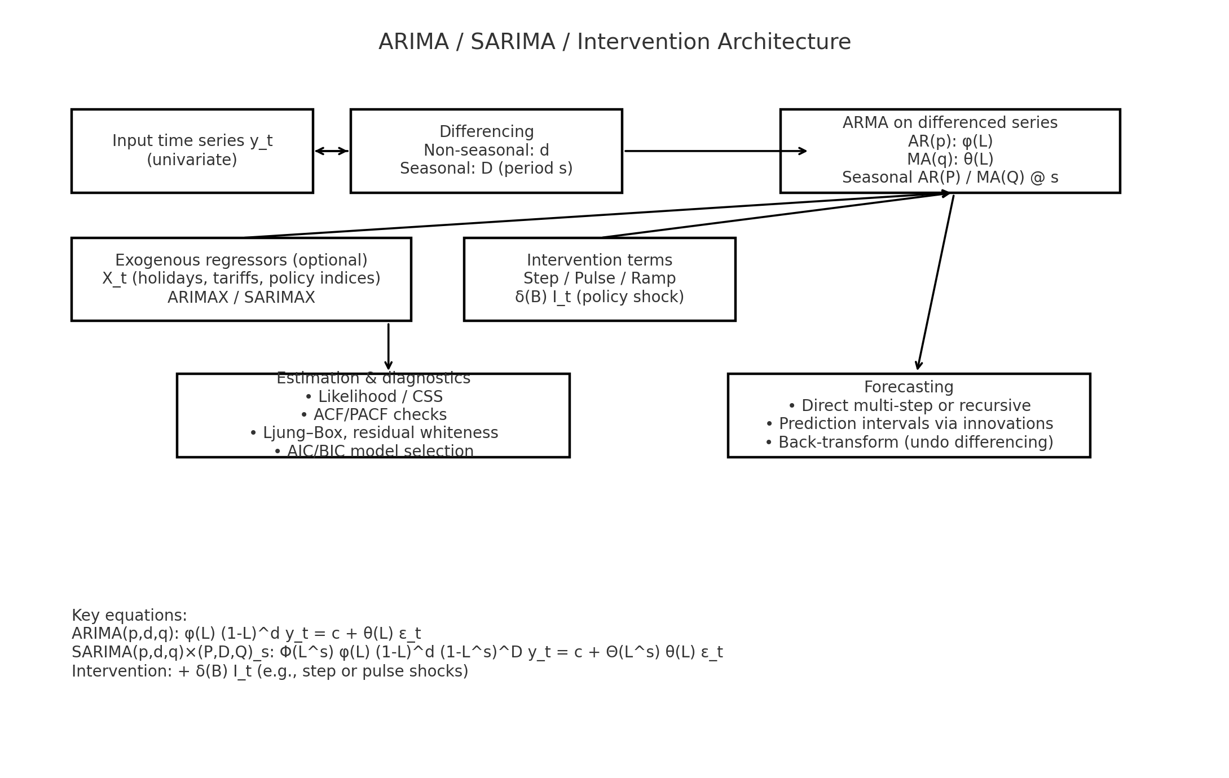

The ARIMA model has been expanded to better fit macroeconomic and financial contexts after it was initially created for linear and stationary series. Important developments include ARIMAX for adding exogenous variables like GDP, inflation, or policy indices, and SARIMA for seasonality. Breaks brought on by crises or political shocks have proven particularly effective when captured by intervention analysis within ARIMA. ARIMA-intervention models, for instance, have been used to describe China's industrial shocks and volatility associated with Brexit (Liu et al., 2021; Zhang et al., 2023). More recently, models like adaptive ARIMA and ARMA have been proposed that change parameters in real time, which improves performance in policy-uncertain contexts like Brexit (Wu et al., 2023). ARIMA's applicability in trade forecasting, where transient disruptions are crucial, is enhanced by these improvements.

#### Figure 2: LSTM Architecture

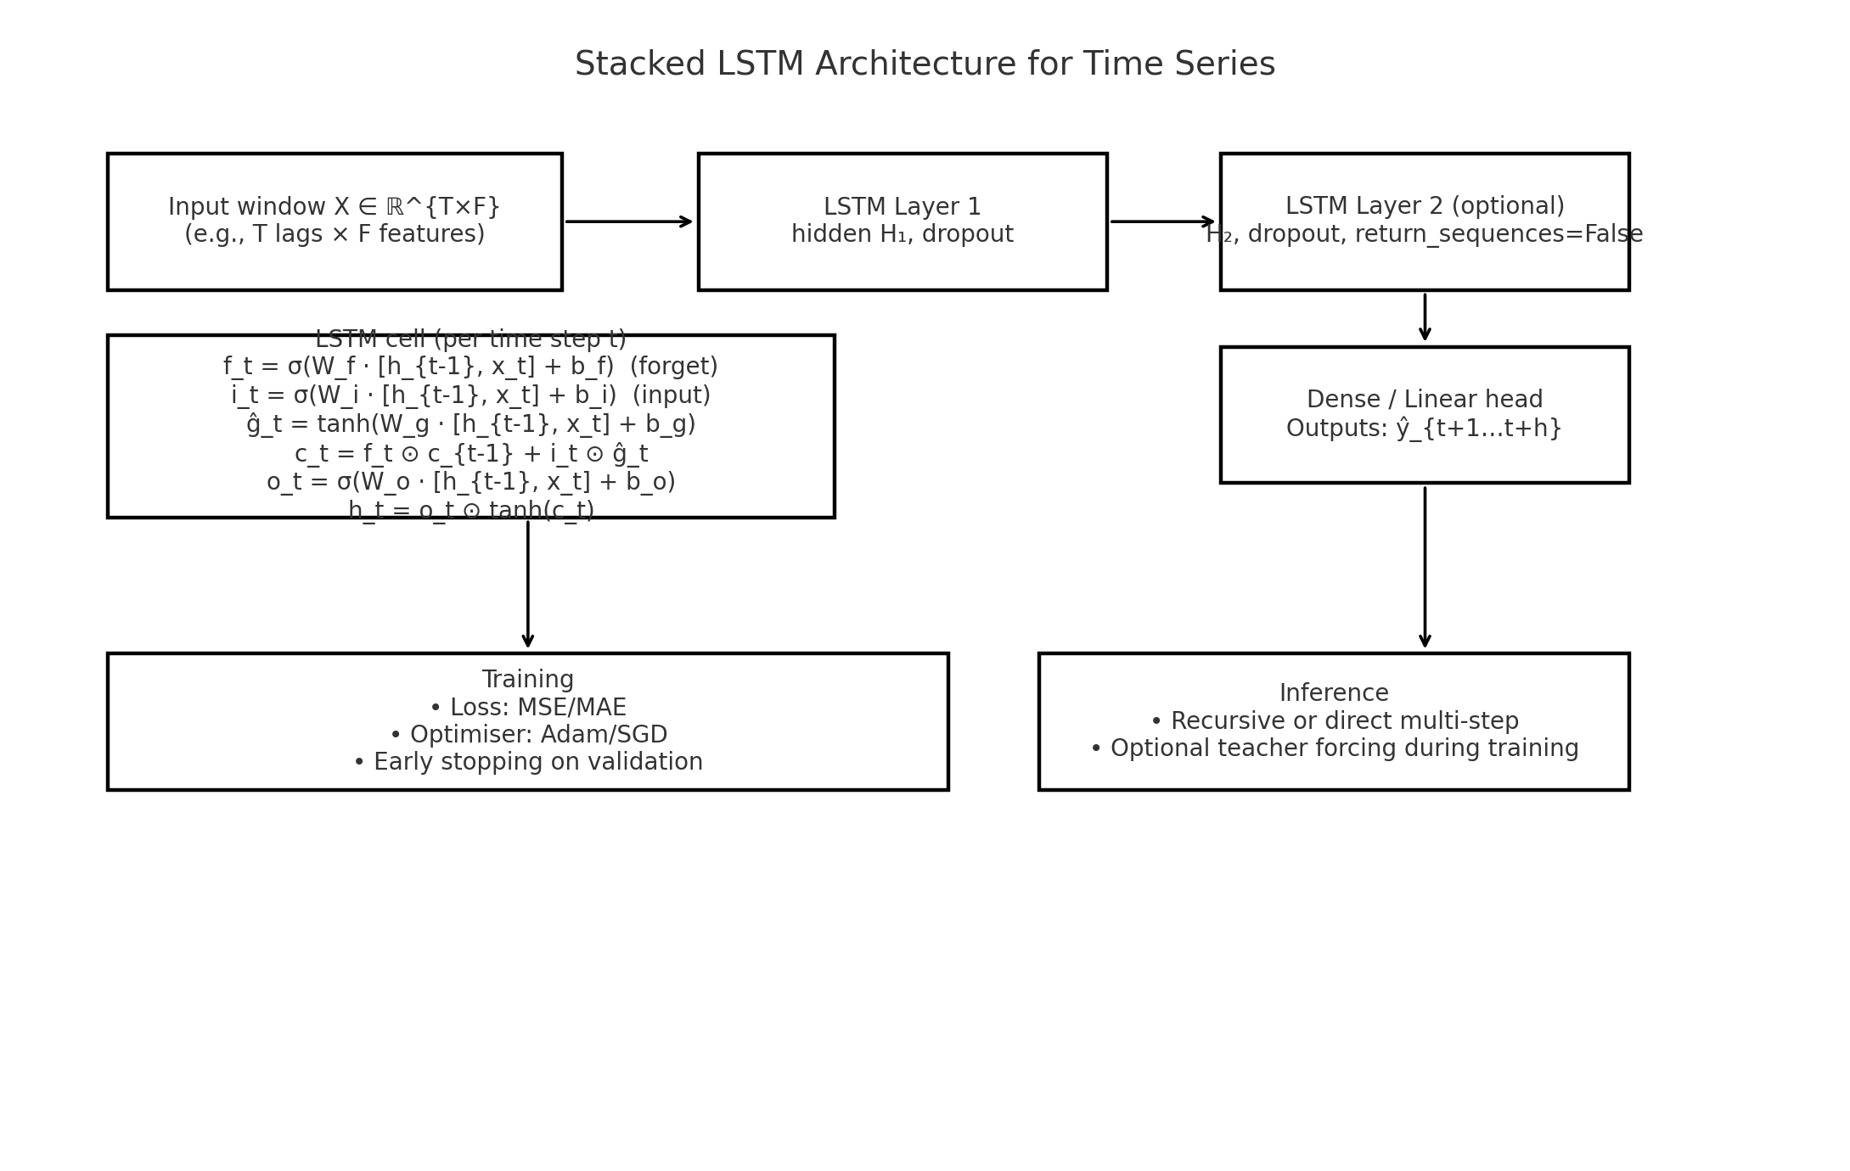

Just as quickly, LSTM models have developed into a key component of contemporary economic forecasting. LSTMs were initially developed to solve the vanishing gradient issue in RNNs, but they have now been improved into stacked and bidirectional versions that are better able to handle noisy, high-frequency datasets. These days, they are used extensively in fields including trade forecasting, inflation, and energy demand. When modeling short-term volatility, such as in symbolic time series and Irish power consumption, research has demonstrated that LSTM performs better than ARIMA (Zhao et al., 2023; Hyndman and Athanasopoulos, 2018). The next phase is attention-enhanced LSTMs, which enable the model to concentrate on the most pertinent time steps. This is advantageous in chaotic trade situations where lag effects differ between sectors.

#### Figure 3: Transformer Architecture

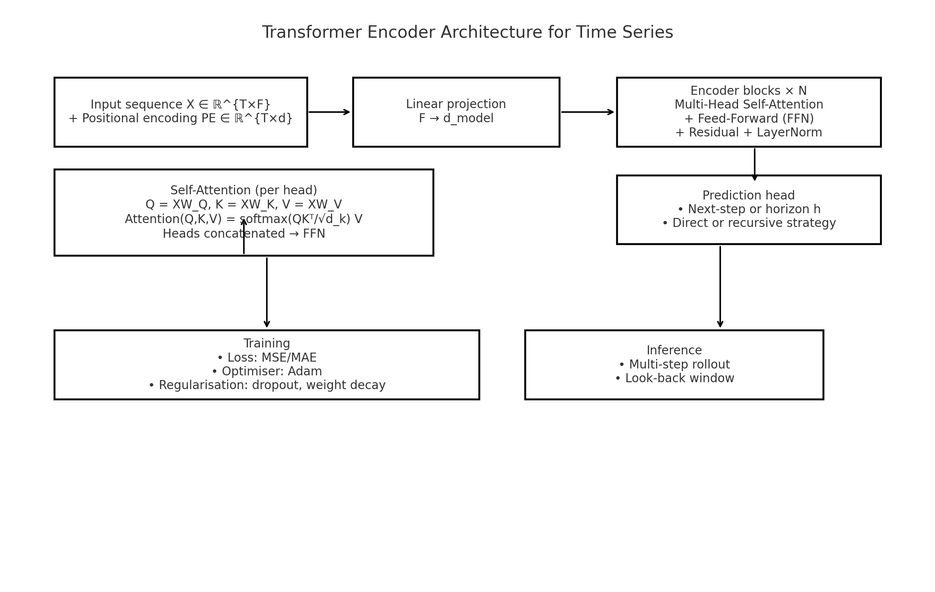

In time series forecasting, transformers mark a significant advancement, particularly for lengthy sequences and high-dimensional data. Vaswani et al. (2017) introduced a self-attention technique that enables parallel processing of all time steps, capturing short- and long-term interdependence more effectively than sequential methods. Variants have been created to deal with scaling, irregular intervals, and multivariate data, including Informer, FEDformer, Autoformer, and PatchTST. For post-shock forecasting, studies have shown that Transformer-based models frequently perform better than both ARIMA and LSTM, especially when it comes to trade flows disrupted by Brexit (Zhao et al., 2023; Sharma et al., 2023). Their predictive capacity and scalability make them ideal for policy modelling that necessitates real-time updating and big datasets.

A trend toward hybridization, which combines the advantages of several models, is highlighted by recent study. The ARIMA–ANN hybrid framework was first introduced by Zhang (2003) and has since developed into the ARIMA–LSTM and Transformer–residual methods. Studies like ensemble-based residual modelling by Hwang, Lim, and Kim (2022) and R2N2 by Goel, H., Melnyk, I. and Banerjee, A., 2017demonstrate that modelling residuals from structural forecasts using deep learning greatly increases accuracy under uncertainty. These hybrid approaches work especially well when trade flows exhibit both volatile behavioral shifts (represented by LSTM or Transformer) and predictable structural trends (represented by ARIMA or Gravity models). The thesis expands on this reasoning by using residual-based forecasting as a second layer to improve Gravity estimations and account for the intricacies of trade between Ireland and the UK during the Brexit era.

### 2.3.3 ARIMA, LSTM, Transformer Models Applied to Ireland–UK Trade or Other Economic Trade

Economic and trade forecasting has made extensive use of time series models like ARIMA, LSTM, and Transformers, especially where structural volatility is present. Because of its statistical strength and ease of interpretation, ARIMA has long been the industry standard for short- to medium-term forecasting. It has been applied to trade contexts to forecast stock indices, export volumes, and currency rates during shocks. An ARIMA-intervention model, for example, was used by Liu et al. (2021) to analyze the effect of Brexit on the volatility of the UK stock market, and Zhang et al. (2023) shown that it can handle structural breaks, which makes it helpful during times of behavioral and regulatory change.

ARIMA has been used in more general macroeconomic studies outside of Brexit. For instance, financial crises in Chinese manufacturing have been studied using intervention-based models (Wu et al., 2023). With little historical data, these experiments demonstrate ARIMA's ability to incorporate shocks into timely forecasts. However, non-linearities, abrupt behavioral changes, or ongoing volatility—characteristics typical of post-Brexit trading—decrease its efficacy. This has prompted academics to use deep learning techniques or integrate ARIMA with additional model layers.

Many financial and trade applications now favor LSTM networks over other options. They outperform ARIMA in turbulent conditions by capturing sequential volatility and intricate, non-linear connections. Commodity prices, inflation modeling, and electricity use are a few examples (Zhao, 2021). Particularly in industries subject to tariffs and fluctuating restrictions, Liu et al. (2022) showed that LSTM may more accurately capture chaotic or irregular trading behaviors. Energy demand forecasting using LSTM models has already been implemented in Ireland, setting the stage for sectoral trade applications (Zhao, 2021).

Despite being more modern, transformers have demonstrated impressive economic forecasting capabilities, especially when dealing with high-dimensional trade data that involves numerous product categories or nations. In post-shock datasets, particularly those influenced by rerouting and non-tariff restrictions associated to Brexit, research demonstrates that they frequently perform better than LSTM and ARIMA (Zhao et al., 2023; Sharma et al., 2023). They are able to capture both long-term structural changes and volatility particular to a given sector thanks to their self-attention mechanism. To handle irregular and multivariate series, variants as Informer, FEDformer, and Autoformer have been created, increasing their applicability for trade forecasting (Zhao et al., 2023; Wu et al., 2023).

As a residual-based second layer to the Gravity Model projections, this thesis applies ARIMA, LSTM, and Transformers. In industries like as pharmaceuticals, meat, dairy, and beverages, the Gravity Model provides the structural baseline for trade between Ireland and the UK; however, time series models are employed to capture behavioral reactions and residual volatility. In order to increase accuracy, this method builds on previous studies like Zhang (2003), R2N2 Goel, H., Melnyk, I. and Banerjee, A., 2017)and ensemble methods (Hwang et al., 2022), which integrate statistics and deep learning techniques. The combined impact of structural drivers, political shocks, and regulatory uncertainty in post-Brexit trade is examined in this thesis by overlaying time series forecasts on Gravity residuals.

### 2.3.4 Limitations of ARIMA, LSTM, and Transformer Models

Although time series forecasting has greatly improved thanks to the ARIMA, LSTM, and Transformer models, each has drawbacks that limit its usefulness in certain policy and economic contexts, particularly during structural upheavals like Brexit. Despite its historical dependability and ease of interpretation, ARIMA relies on the linearity and stationarity assumptions. Its capacity to capture non-linear interactions or quickly shifting market behavior is constrained by these assumptions. When trading patterns are influenced by both behavioral volatility and policy shocks, ARIMA is susceptible to underfitting even with improvements like SARIMA and intervention-based extensions (Hyndman and Athanasopoulos, 2018; Wu et al., 2023). The model has the danger of oversimplifying regime shifts, especially when new tariffs or non-historical trade barriers appear, as demonstrated in Brexit-related research employing intervention ARIMA (Liu et al., 2021).

By modeling non-linear interactions and long-term dependencies, LSTM models were created to address some of these statistical flaws. But they also bring their own set of difficulties. It might be challenging to obtain big and well-prepared datasets for effective training in disaggregated trade sectors like plants, herbs, or specialty food goods. Because policymakers looking for causal explanations find it challenging to understand their internal gating processes, LSTMs also lack transparency (Sharma et al., 2023). When used on noisy or high-frequency datasets, like monthly trade flows impacted by Brexit, overfitting is a further issue. Inaccurate predictions may result from LSTMs learning noise instead of real patterns if hyperparameters are not carefully adjusted (Zhao, 2023; Liu et al., 2022).

There are significant limitations with transformer models, which are being used more and more in time series forecasting. Long-range dependencies can be captured via their self-attention mechanism, but this necessitates a significant amount of memory and processing capacity, particularly for lengthy, multivariate sequences (Vaswani et al., 2017). These models are nonetheless vulnerable to short sequences and irregular time steps, which are typical in trade data disturbed by Brexit, even with more effective variants like Informer, Autoformer, and FEDformer (Zhao et al., 2023). An additional constraint is to interpretability. Although explainable AI tools like SHAP or LIME can offer valuable insights into attention weights, they are not part of the model itself and diminish transparency in real-time policy scenarios (Sharma et al., 2023). It is more difficult to use Transformers in formal trade simulations for organizations such as the European Commission or the CSO when there are no obvious causal relationships.

All things considered, in structurally complicated contexts like post-Brexit Ireland–UK commerce, ARIMA, LSTM, and Transformers perform poorly when applied separately. Explanatory trade factors that are essential for comprehending bilateral flows, such as GDP, distance, agreements, and non-tariff obstacles, cannot be directly incorporated by any of them. As a result, sectoral forecasting and policy analysis are constrained by strictly time series methodologies. According to Zhang (2003) and Goel, H., Melnyk, I. and Banerjee, A., 2017, interpretability and performance are improved when machine learning is combined with structural models like Gravity. This thesis takes that approach: the long-term structural baseline of trade between Ireland and the UK is captured by the Gravity Model, while short-term deviations and residual shocks resulting from Brexit-related disruptions are forecasted using ARIMA, LSTM, and Transformers.. The shortcomings of each forecasting family are addressed collectively by this hybrid framework, which offers a more reliable and pertinent instrument for assessing trade outcomes.

### 2.3.5 Justification for ARIMA, LSTM, Transformers Use in This Thesis

This thesis incorporates the ARIMA, LSTM, and Transformer models in order to account for sector-level disruptions and trade volatility, which are not adequately explained by structural models alone. A solid theoretical foundation for long-term trade flows is offered by the Gravity Model, which takes historical relationships, GDP, and distance into account. Nonetheless, its capacity to react to transient shocks, behavioral changes, and nonlinear disruptions brought about by Brexit is constrained (Head, K. and Mayer, T., 2014; Santos Silva and Tenreyro, 2006). The thesis addresses this by using a hybrid framework that combines the interpretability of economic structure with the responsiveness of data-driven approaches. Time series models are applied to the Gravity Model residuals. We select each time series model based on its unique forecasting capabilities.

Because of its transparency, flexibility, and shown efficacy in modeling linear connections and policy-driven shocks, ARIMA continues to be an essential component of this hybrid framework. Smaller industries or those with distinct seasonal trends and historical lags are where its usefulness is greatest. Short-term policy effects on stock indices and macroeconomic trade have been effectively captured by previous applications, such as ARIMA intervention models with a Brexit focus (Liu et al., 2021; Wu et al., 2023). ARIMA is particularly pertinent for Brexit-sensitive industries with cyclical dynamics since it is used in this thesis to analyze residuals affected by abrupt tariff increases, customs delays, or seasonal exports (such as dairy and plants/herbs).

Because of its ability to represent intricate, distant connections in sequential data, LSTM models are included. Lag effects, memory behavior, and structural breaks are examples of non-linear, volatile patterns that LSTMs are intended to capture, in contrast to ARIMA, which depends on linearity and stationarity. Their capacity to estimate energy and economic trends, such Ireland's power consumption (Zhao, 2021), shows that they are suited for trade flows with variable volumes, such as those in the food and beverage sectors in the face of Brexit uncertainty. Additionally, LSTMs are better at handling noisy or incomplete data, which gives them a leg up when modeling erratic reactions to Brexit talks, regulatory modifications, or abrupt enforcement actions. In this thesis, LSTMs are especially useful for identifying behavioral adaptations that are represented in the Gravity Model's residuals.

In time series forecasting, transformers are considered the latest and most scalable breakthrough. In multivariate contexts, parallel processing increases accuracy, and their self-attention mechanism makes it possible to detect cross-sectoral interactions and long-term dependencies (Vaswani et al., 2017; Zhao et al., 2023). Variants that have demonstrated great success in modeling high-dimensional and irregular time series, such Informer and FEDformer, fit the disaggregated Irish trade data quite well. In disruptive circumstances, such as inflation monitoring and stock prediction amid Brexit-related volatility, Transformers perform better than ARIMA and LSTM, according to recent applications in economic forecasting (Sharma et al., 2023). According to this concept, transformers are used in industries like pharmaceuticals that are impacted by global supply chains and regulatory changes, where interactions are too intricate for conventional approaches to grasp.

In conclusion, this thesis uses a residual-based hybrid approach that overcomes the shortcomings of the ARIMA, LSTM, and Transformer models by utilizing their respective advantages. These time series techniques are used to simulate residuals, which capture shocks, volatility, and sector-specific frictions, while the Gravity simulate serves as a structural baseline. Previous research (Zhang, 2003; Goel, H., Melnyk, I. and Banerjee, A., 2017; Hwang et al., 2022) supports this multi-layered approach, which is specifically designed for the Brexit scenario, where precise and flexible forecasting is essential for both business decision-making and policy planning.

## 2.4 Residual Forecasting Models

When standard models failed to capture intricate or unexpected patterns in time series data, residual forecasting was born. Zhang (2003) demonstrated that forecasting accuracy could be greatly increased by modeling the residuals that ARIMA was unable to explain. Zhang was one of the first to suggest a hybrid approach that combined ARIMA with artificial neural networks (ANN). This approach is justified by the observation that residuals frequently exhibit non-linear dynamics that are not captured by linear models, particularly in times of sudden economic transition. Because structural shocks like Brexit create volatility that traditional models cannot readily account for, these unexplained deviations are crucial in the context of international commerce.

When economies are undergoing structural change and are dealing with policy shocks, demand swings, and behavioral changes, residual modeling is especially helpful. During financial crises, for instance, Qiu et al. (2020) showed how ARIMA-intervention models could monitor abrupt declines in industrial output, identifying short-term aberrations that conventional models frequently overlook. In a similar vein, Yu et al. (2020) demonstrated that intervention models, and consequently residual components, accurately capture the extent of policy-induced disruptions by using ARIMA to quantify market volatility during the Brexit referendum. These studies highlight how crucial it is to concentrate on the inexplicable elements of time series data in order to record economic reactions in real time.

By taking into account temporal dependencies and non-linearities, Long Short-Term Memory (LSTM) models go beyond residual forecasting. According to Sharma et al. (2023), LSTMs are excellent for sequential forecasting because they can learn long-term volatility patterns and retain memory across time steps. In industries like pharmaceuticals and agriculture, where trade delays and non-tariff restrictions brought on by Brexit develop gradually, LSTMs offer a means of modeling cumulative deviations that structural equations cannot capture. In order to capture sector-specific volatility in Ireland-UK trade, LSTMs are applied to the Gravity Model's residuals in this thesis.

Models that are transformer-based offer much more complexity. Transformers are much more successful at detecting long-range dependencies than RNNs or LSTMs because they use self-attention processes that evaluate the significance of each time step in a sequence. In financial forecasting tasks, Zhao et al. (2023) show that Transformers perform better than LSTM and ARIMA, especially when there is complex multivariate conditions and irregular timing. In order to identify more profound and asynchronous patterns across Brexit-affected industries, particularly when volatility is caused by overlapping shocks, transformers are applied to Gravity Model residuals in this thesis.

The creation of specialized architectures has also led to advancements in residual forecasting. The Residual Recurrent Neural Network (R2N2) was first presented by Goel, H., Melnyk, I. and Banerjee, A., 2017). It improves multivariate forecasting in data with interacting factors by directly integrating RNN structures into residual modeling. This paper is extremely pertinent to Irish commerce, as various Brexit-related frictions impact industries like dairy, beverages, and pharmaceuticals. Ensemble frameworks have also grown in significance. Hwang et al. (2022) demonstrated that combining several machine learning techniques on residuals improves robustness and decreases generalization error, which is especially helpful in disaggregated data. Empirical evidence also supports the usefulness of residual modeling in practice. LSTMs were applied to the residuals of a gravity model for agricultural trade by Wu et al. (2021), who demonstrated significant short-term accuracy gains in the presence of variable policy settings. The European wood market's residuals from structural models were also subjected to neural networks by Morland, Tandetzki, and Schier (2025), who showed that hybrid residual forecasting better captured the volatility associated with Brexit than single-stage models. These investigations support the thesis's methodology, which treats residual modeling as a fundamental tactic to control sector-level uncertainty rather than passing it off as an afterthought.

In conclusion, the two-stage residual forecasting approach used in this thesis separates the behavioral and structural aspects of trade. GDP, distance, and shared language are examples of long-term structural factors that are used by the PPML Gravity Model to produce baseline estimates for trade flows between Ireland and the UK. However, Brexit created non-tariff barriers, short-term shocks, customs delays, and behavioral uncertainty in industries including drinks, medicines, and agriculture, making a structural-only strategy inadequate. To solve this, the Transformer, LSTM, and ARIMA models—each appropriate for distinct residual characteristics—are used to anticipate the unexplained residuals from the Gravity Model: While LSTM models handle sequential volatility, ARIMA records stationary short-memory patterns, and Transformers identify long-range multivariate anomalies. Modeling highly disrupted trade networks requires interpretability and adaptability, which this residual-based technique provides. Moreover, it supports empirical evidence that residual forecasting improves accuracy and resilience in times of transition (Zhang, 2003; Goel, H., Melnyk, I. and Banerjee, A., 2017; Sharma et al., 2023; Wu et al., 2021; Morland, Tandetzki & Schier, 2025). The thesis suggests a unique framework for predicting post-Brexit Ireland–UK trade, especially at the sectoral level where disruption is uneven and dynamic, by fusing the Flexibility of time series approaches with the theoretical robustness of the Gravity Model.

## 2.5 Brexit’s Sectoral Impact on Irish Trade

### 2.5.1 Introduction: Brexit’s Sectoral Impact on Irish Trade

Because Ireland is geographically, economically, and politically close to the UK, Brexit has had a particularly disruptive impact on the country. Direct exports, regulatory collaboration, and cross-border supply chains are all integral parts of Ireland's trading relationship with the UK, the only EU member state with a land border. According to Bergin et al. (2019) and Abdou et al. (2020), the literature constantly emphasizes that the effects of Brexit are not uniform but rather sector-dependent, shifting dramatically depending on the intensity of trade with the UK and vulnerability to new impediments. This thesis concentrates on six highly exposed businesses that represent a blend of contemporary high-tech and conventional agri-food industries: pharmaceuticals, agricultural, beverages, dairy, meat, and food.

Numerous studies emphasize how dependent Ireland is on the UK for particular exports. Food, drinks, and pharmaceuticals are all cited by ESRI (2015) and Felbermayr, Fuest, Gröschl, and Stöhlker (2017) as highly reliant industries. Food and live animals made up 38% of Irish exports to the UK prior to Brexit, while beverages and tobacco made up 9%, according to Matthews (2017). In a scenario of Hard Brexit, Keogh (2020) predicted export drops of up to 90% using a disaggregated Gravity Model. In a similar vein, Ireland, I.T., 2017.) found that over 60% of Irish SMEs in the food and drink industry needed to sell primarily to the UK.

The idea that tariffs are not as difficult as non-tariff barriers (NTBs) is a common theme in the literature. Customs checks, SPS processes, and certification requirements raise costs significantly, particularly for perishable and regulated products like dairy, agribusiness, and processed food, as demonstrated by Byrne, Stephen & Rice, Jonathan, 2018) and Lawless and Morgenroth (2019). Through regulatory divergence and re-certification, Brexit has increased friction even in industries like medicines that are exempt from tariffs (Abdou et al., 2020; HM Treasury, 2016). NTBs could lower Ireland's competitiveness by raising trade costs by 8% in medicines and 15% in food, according to OECD (2018) estimates.

Researchers are increasingly using dynamic models rather than static macroeconomic estimates to capture such shocks. Gravity models are less appropriate for short-term disruptions, but they are nevertheless useful for evaluating long-term trade under new agreements or market changes (Head, K. and Mayer, T., 2014; Keogh, G., 2018)While LSTM and Transformer models have shown better performance in forecasting dynamic, non-linear trade deviations (Shen et al., 2021; Zhao et al., 2023), ARIMA and ARIMA-intervention models have been used to mimic Brexit-induced volatility (Qiu et al., 2020; Yu et al., 2020). The usefulness of the ARIMA, LSTM, and Transformer models in predicting Brexit-specific shocks is assessed in this thesis by applying each model to the residuals of sector-level Gravity outputs.

This macro view obscures weaknesses in traditional and SME-driven industries, notwithstanding Lawless and Morgenroth's (2019) contention that Brexit had no appreciable short-term effect on Ireland's overall exports. This thesis fills that gap by integrating temporal and structural modeling into a data-driven, sector-specific framework. The hybrid approach makes it possible to benchmark across industries with different degrees of Brexit vulnerability and to gain clearer policy insights.

### 2.5.2 Pharmaceuticals Sector

One of Ireland's biggest and most internationally linked export industries, the pharmaceutical sector generates over €100 billion a year and is home to several of the top biopharmaceutical companies in the world ( O'Rourke, 2022). The industry is extremely vulnerable to the legislative restrictions brought up by Brexit, even though its high value-to-weight products make it less sensitive to transportation costs. Particularly for businesses reliant on international supply chains and the UK market, the UK's departure from the EU regulatory framework raised questions about licensing, compliance, and distribution (Abdou et al., 2020; Bergin et al., 2019). According to Byrne, Stephen & Rice, Jonathan, 2018), these non-tariff barriers (NTBs) have resulted in additional administrative complexity, delays, and duplication of certification and regulatory requirements.

Under Brexit scenarios, estimated trade losses would be significant. Using a disaggregated Gravity Model, Keogh (2018) estimated that rerouting Irish pharmaceutical exports to EU markets might result in a decline of up to 96.8% to Great Britain and 73.4% to Northern Ireland. These illustrate how crucial regulatory alignment is for market access, even though they represent the worst-case scenarios. Similarly, Bergin et al. (2019) cautioned that approvals will become more difficult due to customs bottlenecks and the UK's loss of European Medicines Agency (EMA) monitoring. Due to the potential for dual licensing and batch testing to drive compliance costs to unaffordable levels, smaller businesses and contract suppliers are especially vulnerable (Matthews, A. (2015) ; HM Treasury, 2016).

Despite these dangers, research also shows that the business is somewhat protected because of its global reach. Due to the flexibility of global supply chains and multinational corporations' diversification outside of the UK, Lawless and Morgenroth (2019) observed no discernible overall reduction in pharmaceutical exports following Brexit. Additionally, Shen et al. (2021) noted that big businesses frequently have parallel distribution systems, which enables them to adjust with little difficulty. Smaller exporters, however, are still at risk. According to Ireland, I.T., 2017., almost 60% of Irish SMEs in the health and pharmaceutical industries were heavily dependent on the UK, making them vulnerable to market and regulatory shocks.

Time series forecasting methods have become more and more popular among researchers as a way to better capture the timing, volatility, and complexity of Brexit-related disruptions in pharmaceutical trade. Researchers are increasingly using time series forecasting to address the timing and volatility of Brexit disruptions in this industry. Simulating abrupt shocks has been successfully accomplished with ARIMA and ARIMA-intervention models. For example, Yu et al. (2020) used ARIMA to capture post-Brexit financial volatility, and Qiu et al. (2020) used ARIMA-intervention to model industrial crises in China. However, machine learning techniques are becoming more and more popular due to the lengthy regulatory lags and changing market regulations in the pharmaceutical industry. According to Sharma et al. (2023) and Siami-Namini et al. (2018), LSTM networks have demonstrated excellent performance in capturing long-term dependencies and delayed effects of compliance, inventory, and certification processes. With their self-attention mechanism, transformers provide a sophisticated substitute that can model long-term and short-term dependencies across multivariate trade flows (Zhao et al., 2023; Shen et al., 2021). In disruption timelines, these models are able to identify hidden processes such phased divergence or recurring certification delays.

This thesis applies the residual pharmaceutical trade series obtained from the Gravity Model to the ARIMA, LSTM, and Transformer models separately. Because this independent application circumvents the opacity of hybrid "black-box" systems, it is possible to clearly attribute each method's predicting strengths. In Ireland's high-value pharmaceutical industry, the method guarantees fair comparison and offers insights into which model best captures Brexit-driven trade patterns.

### 2.5.3 Agriculture Sector

Given its reliance on the UK market, the perishable nature of its products, and its susceptibility to both tariffs and non-tariff barriers (NTBs), Ireland's agriculture sector is the most vulnerable sector in the context of Brexit. Prior to Brexit, the UK accounted for more than 37% of Ireland's agri-food exports, with cereals, dairy, and beef being especially reliant on British demand (Matthews, A. (2015) ). Since the agri-food industry relies on standardized, quick-moving supply chains, even small hiccups like delays or customs inspections can cause disruptions and reduce profits (Gjems Theie, 2014; Byrne, Stephen & Rice, Jonathan, 2018). In this important export market, NTBs including origin labeling, SPS checks, and regulatory divergence have further decreased competitiveness.

According to Keogh's (2018) disaggregated gravity model, a long-term hard Brexit might result in a 73.2% decline in Irish agricultural exports to Great Britain and an 87.1% decline to Northern Ireland. Additionally, he demonstrated that because of perishability and increased transportation costs, rerouting trade through France might reduce values by as much as 66%. According to the OECD (2018) and Barrett, Bergin, and Fitzgerald (2015), a WTO-style Brexit with tariffs and non-aligned border inspections might result in a 17% decrease in agri-food output. These effects are particularly noticeable for dairy, refrigerated meat, and live animals, where promptness and regulatory compliance are essential.

The biggest obstacles are encountered by small farmers and processors. Many rely on UK-based processors and are unable to absorb new expenses, according to Matthews (2017) and Felbermayr, Fuest, Gröschl, and Stöhlker (2017). According to Lawless and Morgenroth (2019), diversification is challenging in Ireland because agri-food industry is strongly adapted to UK consumer demands. Additionally, Ireland, I.T., 2017.) note that among Irish exporters, the largest concentration of SMEs are in the agriculture sector, with the majority lacking the resources necessary to manage customs, dual regulation, or rerouting logistics. The risks of Brexit for supply networks and rural communities are increased by these structural flaws.

In addition to long-term Gravity forecasts, researchers have increasingly used time series models to predict such disruptions. According to Qiu et al. (2020) and Yu et al. (2020), ARIMA and ARIMA-intervention models are able to capture sudden shocks and short-term volatility. Deep learning provides definite benefits in agricultural trading, which is similarly influenced by seasonality, lagged impacts, and nonlinear patterns. Long-range dependencies can be captured by LSTMs in changing policy contexts, as demonstrated by Wu et al. (2021) and Shen et al. (2021). Transformers perform better than conventional techniques in managing the sequential complexity and volatility associated with market and regulatory uncertainty, as shown by Zhao et al. (2023) and Sharma et al. (2023).

This thesis applies the ARIMA, LSTM, and Transformer models separately to the Gravity Model residuals in the agriculture sector. This prevents hybridization, enhances interpretability, and makes it possible to compare model accuracy clearly in the context of Brexit. In order to adequately understand and convey the sector's risks to policymakers and agri-food stakeholders prepared for the continued challenges of Brexit, the approach models both immediate and delayed policy implications.

### 2.5.4 Beverages Sector

Brexit has significantly disrupted Ireland's agri-food exports, particularly in the drinks sector. Keogh (2018) used a sectoral gravity model to estimate that a hard Brexit would result in a 12.8% decrease in beverage exports to Great Britain and a 10.8% fall to Northern Ireland. Stress scenarios increase losses to 16.4% and 14.4%, while a long-term hard Brexit might result in a 42.2% decline in trade values as exports are routed to more distant EU markets. This is because of increased transportation costs, longer delivery times, and mismatched customer preferences. These results are consistent with Barrett, Bergin, and Fitzgerald (2015), who found that the beverage, food, and agriculture industries are among the most Brexit-sensitive due to their reliance on the UK, schedule sensitivity, and logistical challenges.

These constraints have been made worse, particularly for smaller manufacturers, by non-tariff barriers (NTBs). Although beverage taxes may be low, Byrne, Stephen & Rice, Jonathan, 2018 ) emphasize that the combined weight of dual excise charges, SPS compliance, and customs procedures has created significant challenges. Matthews (2017) draws attention to the industry's dependence on the UK Landbridge, a route now hampered by delays, port traffic, and customs bottlenecks, for access to continental Europe. These conflicts make it harder for beverages that rely on timely delivery, seasonal demand, and freshness to compete.

This flexibility is not common, despite the fact that certain businesses—especially multinationals—have demonstrated resilience by diversifying their markets or modifying their supply chains. Lawless and Morgenroth (2019) discovered that aggregate exports only slightly decreased in the short run, indicating that larger companies were better at handling adjustment. However, smaller exporters, especially craft makers, have had more difficulty navigating customs procedures and complying with regulations (Ireland, I.T., 2017.). This is corroborated by O'Rourke (2022), who notes that the UK's proportion of Irish beverage exports fell from 29.4% in 2015 to just 15.3% in 2021, indicating a significant change in the market following Brexit.

Time series models supplement gravity-based forecasts to predict such trade dynamics. The volatility of Brexit shocks has been captured using ARIMA-intervention models. After the referendum, Yu et al. (2020) utilized these models to evaluate financial instability, and Qiu et al. (2020) used them to monitor industrial disturbances. Because commerce in beverages is impacted by seasonality, currency fluctuations, and promotional cycles, these strategies are especially well-suited. When it comes to capturing long-term dependencies and non-linear responses, more sophisticated techniques like LSTM and Transformers have proven to perform better. Zhao et al. (2023) and Sharma et al. (2023) validated the ability of Transformer models to detect lagged impacts, while Shen et al. (2021) and Wu et al. (2021) found LSTMs effective for sectors vulnerable to irregular policy shocks and multistep disruptions.

The residual beverage trade series obtained from the Gravity Model is subjected to separate applications of the ARIMA, LSTM, and Transformer models in this thesis. This strategy provides more insight into how Brexit has changed Ireland's beverage exports by avoiding hybridization, guaranteeing interpretability, and enabling direct benchmarking of forecasting performance among approaches.

### 2.5.5 Dairy Sector

Because of their close proximity, common customer tastes, and standardized EU requirements, the Irish dairy industry has long maintained a solid trading relationship with the UK. But Brexit has thrown this integration off balance, posing additional logistical, regulatory, and market access issues. Non-tariff barriers (NTBs), such as veterinary inspections, origin regulations, and labeling specifications, are especially harmful to the dairy industry. Despite being less obvious than tariffs, Byrne, Stephen & Rice, Jonathan, 2018) point out that these NTBs greatly raise costs, and Qiu, Xu, and Liu (2020) contend that even small frictions might cause perishable product flows to be disrupted. Dairy is one of Europe's most vulnerable agri-food industries, according to Van Berkum, Jongeneel, and Tabeau (2016), with Brexit undermining benefits previously obtained under EU alignment.

Data following the 2016 referendum confirms these worries. While agri-food exports increased overall, Bord Bia (2017) found that exports to the UK decreased by 8%, with dairy being especially vulnerable. Butter, cheese, and milk prices are now more unstable due to sterling volatility and tariff uncertainties. Exporters are extremely vulnerable to transaction costs due to narrow margins (Felbermayr, Fuest, Gröschl, & Stöhlker, 2017). While Ireland, I.T., 2017.caution that SMEs may find it difficult to absorb additional compliance costs, Van Berkum et al. (2016) conducted a scenario analysis that demonstrates that WTO-level tariffs would render dairy exports to the UK uncompetitive.

Using a disaggregated Gravity Model, Keogh (2020) calculated that under a Hard Brexit, food and beverage exports, including dairy, may drop by 12.8% to Great Britain. If the losses are transferred to far-off EU markets, they would get worse. Dairy products' perishability and emerging issues like veterinarian divergence and the loss of mutual recognition for health standards exacerbate these hazards (European Commission, 2021). Cooperatives, processors, and SMEs are still quite vulnerable to systemic disruption, even though large dairy companies may adjust..

Data-driven and structural approaches have been used to examine how Brexit will affect the dairy industry. Seasonal variations and linear trends are captured by traditional ARIMA models, but sudden shocks are difficult for them to handle. Lagged effects and non-linear dependencies have been better captured by LSTM models. Siami-Namini, Tavakoli, and Namin (2018) revealed the effectiveness of LSTM in capturing structural breaks in macroeconomic data, while Shen, Jiang, and Jin (2021) displayed its worth in modeling the trade of perishable commodities under external shocks.

By using attention processes that prioritize inputs, transformers improve predictions even further. Their efficacy in identifying postponed Brexit effects, like port congestion or modifications to veterinary protocols, is confirmed by Zhao, Song, and Liu (2023) and Bathula, P.K.R. (2023). This thesis examines residuals from the Gravity baseline for dairy using the ARIMA, LSTM, and Transformer models separately. This prevents hybridization, guarantees interpretability, and enables evaluation of each model's capabilities in capturing aberrations brought forth by Brexit. The method facilitates early warning systems and policy planning in an area where Brexit adjustments are still being made, and it offers transparent benchmarking.

### 2.5.6 Meat Sector

One of the most vulnerable sectors to the effects of Brexit is the meat industry, which includes cattle, hog, lamb, and poultry. With the help of integrated supply chains, common product standards, and strong logistical connections, the UK has long been the main market (Matthews, A. (2015) ; Ireland, I.T., 2017.; Conefrey, T. and Walsh, G., 2020). Meat's perishability, need on just-in-time delivery, and multi-stage cross-border production make it especially sensitive for exporters. Product quality and profitability can be significantly impacted by even minor regulatory or transit impediments. According to Byrne, Stephen & Rice, Jonathan, 2018), exporters now face substantial administrative expenses as a result of post-Brexit NTBs, which include veterinary certifications, customs declarations, and animal traceability regulations.

This susceptibility is confirmed by structural forecasts. Using a disaggregated gravity model, Keogh (2018) estimated that a hard Brexit might result in a 42.2% decline in Irish food and beverage exports to Northern Ireland and an 87.1% decline to Great Britain. These decreases were attributed to increased dependence on far-off EU markets, trade diversion, and tariffs. Risks are increased by the intricacy of supply chains: many animals are raised in Ireland, killed in Northern Ireland, and processed in Great Britain, frequently crossing the border more than once (Matthews, A. (2015) ). New border inspections for beef and chicken have caused spoiling and delivery delays, according to O'Rourke (2022), and regulatory divergence has increased prices even further, especially as the UK moves away from EU food and hygiene standards (UK Government, 2020). WTO fallback tariffs on beef might reach 50%, according to Ireland, I.T., 2017.endangering the profitability of exporters focused on the UK.

To foresee disruption in light of these concerns, forecasting methods are crucial. ARIMA-intervention models have been applied to short-term trade shocks; Yu, Sun, and Chen (2020) applied them to financial volatility connected to Brexit, while Qiu, Xu, and Liu (2020) demonstrated their capacity to identify pauses in industrial output. Long-memory effects and nonlinear dynamics, which are prevalent in trade during the Brexit era, are difficult for ARIMA to handle. The capacity of LSTMs to simulate seasonality and trend breaks in global trade data was proven by Shen, Jiang, and Jin (2021), while Siami-Namini, Tavakoli, and Namin (2018) demonstrated that they perform better than ARIMA in managing irregular policy shocks.

Self-attention, which records distant contacts and delayed reactions, allows transformers to add even more complexity. Because of their success in policy-sensitive trade forecasting, Zhao, Song, and Liu (2023) and Bathula, P.K.R. (2023) are well-suited to identifying staggered Brexit consequences. LSTM, Transformers, and ARIMA are applied separately to the Gravity Model's residuals for meat exports in this thesis. This prevents hybridization, guarantees interpretability, and makes it possible to assess each model's accuracy directly. This multi-model approach offers crucial insights for protecting Ireland's agricultural economy and developing sensible policy responses, given the sector's high cost exposure, regulatory ambiguity, and disrupted flows.

### 2.5.7 Vegetable Sector

The perishable nature of its products and its dependence on the UK market make the vegetable industry extremely vulnerable to Brexit, even if its value is lower than that of Ireland's dairy or meat exports. Particularly vulnerable to customs inspections, delays, and certification processes are vegetables like field crops, mushrooms, and potatoes, which are extensively included into short-supply chains with Britain. Matthews (2017) points out that Irish exports of vegetables and horticulture were overly reliant on the UK, especially mushrooms, which made up more than 80% of production and were at serious risk under the new trading agreements. According to Byrne, Stephen & Rice, Jonathan, 2018 ), non-tariff barriers (NTBs) including SPS checks, labeling regulations, and border delays greatly raise the cost of fast-moving, perishable goods even when tariffs are not present.

These concerns are confirmed by investigations based on gravity models. According to Keogh (2018), a Long-Term Hard Brexit scenario might result in a more than 70% drop in UK-bound agri-food exports, including vegetables, primarily as a result of trade diversion towards more distant EU markets. Competitiveness is lowered by the longer transit time and regulatory requirements, especially for fresh vegetables with limited shelf life. WTO duties on horticultural items would have a significant impact on exports, according to Ireland, I.T., 2017.), while Barrett, Bergin, and Fitzgerald (2015) pointed out that industries like mushrooms that are heavily dependent on the UK would be disproportionately affected. This opinion is supported by O'Rourke (2022), who demonstrates that vegetable exports to the UK significantly decreased following Brexit, with SMEs being the most negatively impacted by higher customs paperwork and storage expenses.

SMEs that produce vegetables confront more obstacles than larger global corporations. Lawless and Morgenroth (2019) point out that horticulture suited to UK consumer preferences has limited capacity to redirect exports to other EU markets, whereas Felbermayr, Fuest, Gröschl, and Stöhlker (2017) emphasize that small producers lack the scale to absorb compliance costs. Since vegetables are one of the most vulnerable subsectors of the Irish agri-food trade, the consequences of Brexit have been tremendously asymmetrical.

Forecasting vegetable exports under these circumstances necessitates the use of techniques that account for both normal seasonal cycles and disturbances following Brexit. The effectiveness of ARIMA and ARIMA-intervention models in simulating short-term shocks and volatility has been demonstrated by Yu, Sun, and Chen (2020) and Qiu, Xu, and Liu (2020). Deep learning is particularly effective in addressing seasonality, irregular cycles, and lagged policy effects, which also influence vegetable commerce. For complicated and irregular series, Siami-Namini, Tavakoli, and Namin (2018) showed that LSTM networks perform better than ARIMA, while Shen, Jiang, and Jin (2021) applied LSTM to perishable items in international trade and displayed high predictive accuracy. These advantages are extended by transformer-based models. While Bathula, P.K.R. (2023) verified that Transformers can simulate multiple overlapping interruptions across trade flows, Zhao, Song, and Liu (2023) discovered that Transformers capture irregular time-lagged shocks like border checks or certification delays.

The residual vegetable trade series obtained from the Gravity Model baseline is subjected to independent applications of the ARIMA, LSTM, and Transformer models in this thesis. By avoiding hybridization, this method guarantees transparency and makes it possible to benchmark model performance directly. Through the assessment of shocks and trade volatility across different models, the thesis offers a comprehensive picture of the impact of Brexit on Ireland's vegetable industry. This industry needs specialized policy insights and strong forecasting to reduce ongoing Brexit-related risks because of its significant exposure and economic significance for rural communities.

### Table1: 2.6 – Sectoral Comparison of Brexit Impacts and Forecasting Models.

|  |  |  |  |  |  |  |
| --- | --- | --- | --- | --- | --- | --- |
| Sector | NTB Sensitivity | Tariff Risk | Key Brexit Friction | Best Forecasting Model | Gravity Trade Loss (Keogh, G.,2018) | Supporting Studies |
| Pharmaceuticals | Medium (certification, batch testing) | Low | Regulatory divergence | LSTM / Transformer | 96.8% (GB), 73.4% (NI) | Shen et al. (2021); Sharma et al. (2023); Zhao et al. (2023); Siami-Namini et al. (2018) |
| Agriculture | High (SPS checks, perishability) | High | Customs delays, origin rules, perishability | ARIMA / LSTM | 73.2% (GB), 87.1% (NI) | Qiu et al. (2020); Yu et al. (2020); Siami-Namini et al. (2018); Wu et al. (2021) |
| Beverages | Medium (labelling, excise duties) | Medium | Excise paperwork, groupage shipping, customs forms | ARIMA / Transformer | 12.8% (GB), 10.8% (NI) | Hyndman & Athanasopoulos (2018); Sharma et al. (2023); Zhao et al. (2023); Yu et al. (2020) |
| Dairy | High (veterinary checks, SPS alignment) | Medium | Cross-border logistics, origin certification | LSTM / ARIMA | Included in agriculture aggregate | Shen et al. (2021); Qiu et al. (2020); Siami-Namini et al. (2018); Predicting Irish Electricity Consumption (2020) |
| Meat | Very High (SPS, veterinary inspections) | Very High | Repeated border crossings, regulatory fragmentation | LSTM / Transformer / ARIMA | 87.1% (GB), 42.2% (NI) | Qiu et al. (2020); Zhao et al. (2023); Yu et al.(2020); Siami-Namini et al. (2018); Shen et al. (2021) |
| Food | High (multi-stage processing) | Medium | Labelling rules, customs, SPS, landbridge issues | ARIMA / LSTM / Transformer | 12.8% (GB), 10.8% (NI) | Qiu et al. (2020); Shen et al. (2021); Sharma et al. (2023); Hyndman & Athanasopoulos (2018); Siami-Namini et al. (2018) |

Patterns in the export data and the type of trade disruptions influence the forecasting models chosen for each sector. ARIMA models are good at capturing short-term shocks and structural discontinuities, and they work well in industries like agriculture and drinks that have consistent, seasonal trends (Qiu et al., 2020). However, deep learning techniques like LSTM and Transformer models, which are excellent at detecting long-term dependencies and delayed effects, might be more appropriate for industries like food and pharmaceuticals, where Brexit brought about nonlinear and policy-driven disruptions (Siami-Namini et al., 2018; Shen et al., 2021; Zhao et al., 2023).

The three models—ARIMA, LSTM, and Transformer—are applied separately to the residual trade series of each sector in this thesis, even though Box 2.1 identifies the best models for each sector based on insights from the literature. Without merging models into intricate hybrids that are frequently more difficult to understand, this guarantees an equitable and transparent performance comparison. A significant research vacuum is filled by the thesis' use of this benchmarking approach on sector-level residuals from the Gravity model, as previous studies have tended to concentrate on national aggregates or single-model projections.

### 2.7 Summary and Identified Research Gap

The impact of Brexit on Irish commerce has been examined in this chapter's sectoral literature, with particular attention paid to six export industries: pharmaceuticals, agriculture, drinks, dairy, meat, and food. Time series forecasting and Gravity model estimations are used to illustrate the disparities in these industries' vulnerabilities and policy sensitivities.

While the pharmaceutical industry's global reach and high-value, low-weight trade make it reasonably resilient, regulatory duplication and certification hurdles drive up prices (Keogh, G., 2018); Abdou et al., 2020 [40]). Among the most vulnerable industries is agriculture, which reflects its strong reliance on UK markets, perishability, and susceptibility to NTBs including customs delays and SPS checks (Matthews, A. (2015) [17]; Lawless & Morgenroth, 2019 [52]). Labeling, excise, and provenance documentation are major obstacles for beverages, despite their great branding Ireland, I.T., 2017.; Byrne, Stephen & Rice, Jonathan, 2018). While meat is heavily interwoven into UK supply chains, making it extremely vulnerable to tariffs and SPS divergence (Matthews, A. (2015) ; Conefrey, T. and Walsh, G., 2020), dairy exports seem stable but face hidden costs from veterinary certification in cross-border trade (Bord Bia, 2017). Sterling depreciation, weakened landbridge access, regulatory divergence, and increased logistics costs are all challenges facing the larger food industry (Keogh, G., 2018; Donnellan, T. and Hanrahan, K., 2016).

The short-term shocks, nonlinear disruptions, and abrupt trend breaks that characterize Brexit are not captured by gravity models, despite the fact that they offer reliable structural estimates of long-term trade reallocation. While time series techniques like ARIMA, LSTM, and Transformers are frequently employed in forecasting, they are rarely used for sector-specific residuals that are obtained from gravity estimates. Sectoral insight is limited by the majority of research' usage of these models, which are either isolated or at macro levels.

Two glaring research gaps are therefore exposed. First, there is a methodological gap since no study has merged the predictions of the Gravity model with independent residual forecasting for Irish trade at the sectoral level using ARIMA, LSTM, and Transformer. Hybrid techniques frequently obfuscate sectoral interpretation or aggregate data. Second, the lack of detailed post-Brexit predictions for Ireland-UK commerce using contemporary machine learning continues to create an empirical gap. Current research usually ends with gravity-based predictions or applies deep learning to other domains like energy or finance.

In this thesis, residual forecasting using ARIMA, LSTM, and Transformer models is combined with Gravity model estimates to fill both gaps. In order to isolate the effects of Brexit and enable transparent model comparison, the framework is applied separately to the pharmaceutical, agricultural, beverage, dairy, meat, and food industries. Thus, the thesis presents a new paradigm for sectoral trade forecasting and gives practical policy recommendations for Ireland and other small open economies that are subject to trade shocks.

# Chapter 3: Data and Methodology

## 3.1 Introduction

The whole technique used to prepare the data, create the models, and provide the forecasts that support this study is presented in this chapter. The main objective is to examine the changes in trade between Ireland and the UK following Brexit, paying special emphasis to important industries like dairy, meat, vegetables, medicines, and drinks. To capture the particular difficulties brought on by Brexit-induced disruptions, the analytical framework blends statistical and structural techniques.

The research uses a hybrid modeling approach that combines contemporary time series forecasting methods with the Gravity Model. The Gravity Model provides a theoretical foundation for anticipated trade patterns in stable times by estimating long-term trade flows based on economic fundamentals and structural features like GDP, bilateral distance, common language, and trade agreements (Tinbergen, 1962; Head, K. and Mayer, T., 2014). But even while the Gravity framework works well for long-term analysis, it has trouble capturing abrupt changes or volatile behavior. Short-run fluctuations and residual shocks are modeled using a set of time series models, specifically ARIMA, LSTM, and Transformers, in order to get over this restriction. While LSTM networks have proven to be highly effective at capturing nonlinear dependencies and lagged effects in trade and financial data (Siami-Namini, Tavakoli and Namin, 2018; Shen et al., 2021), ARIMA has long been a standard for economic forecasting because of its interpretability and adaptability to structural breaks (Hyndman and Athanasopoulos, 2018; Liu et al., 2021). With their ability to simulate intricate multivariate trade series via self-attention mechanisms, Transformer architectures have recently been a prominent method in time series forecasting (Vaswani et al., 2017; Zhao et al., 2023).

The Poisson Pseudo Maximum Likelihood (PPML) approach, which is widely recognized as a reliable remedy for the econometric drawbacks of Ordinary Least Squares, especially when heteroskedasticity and zero trade flows are present, is used to estimate the Gravity Model in this thesis (Santos Silva and Tenreyro, 2006; (Keogh, G., 2018 )A hybrid forecast that combines the dynamic adaptability of time series analysis with the structural stability of gravity-based trade modeling is produced by combining its outputs with the predictions from the time series models.

Additionally, this framework makes it possible to simulate several Brexit scenarios. Two counterfactuals are created: a Hard Brexit, which would represent significant disruption to trade flows, and a Soft Brexit, which would reflect modest increases in trade frictions. Studies pertaining to Brexit have extensively used scenario-based forecasting to evaluate trade risks and policy outcomes (Bergin et al., 2019; Lawless and Morgenroth, 2019). This method combines dynamic and structural models to produce stress-test simulations of policy shocks in addition to projections of baseline trade patterns.

Open-source platforms were used for all data processing, model construction, and evaluation in order to guarantee transparency and repeatability. To clean and modify the CSO sectoral export datasets, Python was utilized in Jupyter Notebook. In order to facilitate effective model training and validation, Google Colab's computational environment was utilized to develop ARIMA, LSTM, Transformer, and PPML Gravity models as well as for residual and future forecasts for 2024–2025. This chapter gives a step-by-step presentation of the methodological approach, starting with the creation and processing of the dataset and moving on to model development, training-validation procedures, and the integration of Gravity and time series forecasts.

This thesis uses a balanced collection of accuracy metrics, including Mean Absolute Error (MAE), Mean Absolute Percentage Error (MAPE), and Root Mean Squared Error (RMSE), to assess model performance. Since RMSE is sensitive to the sudden shocks and volatility that define trade interruptions, it is especially appropriate in the Brexit scenario because it penalizes large deviations more severely than smaller errors (Chai & Draxler, 2014). Ly, Traore, and Dia (2021) employed RMSE to assess predicting ability in commodity price series, a domain that shows variations akin to sectoral exports, hence reinforcing its relevance to volatile economic situations. MAE is presented in addition to RMSE as a more robust and comprehensible indicator of average forecast error. Tlegenova (2015) illustrated the usefulness of MAE in exchange rate forecasting, whereas Willmott and Matsuura (2005) contend that it avoids the RMSE's excessive focus on outliers. Although MAPE is sensitive to values close to zero, it offers a unit-free % error metric that is valuable for policy interpretation. While Tlegenova (2015) emphasizes MAPE's efficacy in capturing relative forecasting accuracy in extremely volatile exchange rate scenarios, Makridakis (1993) addresses the model's advantages and problems.

To evaluate each model's computing cost, runtime efficiency is presented in addition to accuracy. This illustrates how useful it is for trade forecasting systems to provide timely insights, particularly in volatile and rapidly changing policy environments. While Song et al. (2024) show how design strategies in deep learning architectures can reduce runtime without losing accuracy, Kalra et al. (2024) emphasize that real-time economic forecasting requires models that balance predictive strength with computational efficiency. Therefore, adding runtime as an evaluation criterion guarantees that model selection takes into account both practical deployment feasibility and accuracy in trade situations that are sensitive to Brexit.

Lastly, the Appendix contains comprehensive documentation for all supporting resources, such as Python code, intermediate data processing files, cleaned input and output datasets, and exploratory visualizations. This guarantees complete transparency and permits other researchers to duplicate the process. The empirical study and findings mentioned in Chapter 4 are based on the methodical integration of structural and statistical methodologies outlined in this chapter.

## 3.2 Use of CSO Trade Statistics (TSM Datasets) in Sectoral Forecasting:

A sectoral forecasting system that is responsive to Brexit needs trustworthy, high-frequency trade data that can identify both abrupt shocks and structural patterns. Monthly export data from Ireland's Central Statistics Office (CSO)'s Trade Statistics Monthly (TSM) series is a major source of information for this thesis. The methodology's empirical foundation is comprised of these datasets, which facilitate the creation of a clean export time series for the UK and aid in the verification of sectoral consistency over time. For this analysis, TSM10, TSM09, and TSM06 are the most pertinent datasets since they enable the creation of baseline and sector-specific trade projections. According to the research, it is especially crucial to use disaggregated and high-frequency data for analyzing the trade effects of Brexit because different sectors are impacted differently by volatility and regulatory frictions (Bergin et al., 2019; Lawless and Morgenroth, 2019).

A monthly baseline of Ireland's exports to the UK was created using the Trade by Commodity Group and Country (TSM10) dataset. In order to maintain continuity after Brexit, the disaggregated commodity-level export values for Great Britain and Northern Ireland were combined into a single "United Kingdom" category. To follow monthly export flows, a baseline indicator called Total_Exports_Step1 was developed by pivoting the data by commodity group and filtering for exports from the UK alone. The sectoral aggregations produced from SITC-based datasets were validated using this as a reference point during exploratory data analysis. Similar methods have been applied in Irish trade literature to verify the robustness of disaggregated analysis against national-level baselines and to validate sectoral models (Keogh, G., 2018; Byrne, Stephen & Rice, Jonathan, 2018).

The forecasting models' primary sectoral input came from the Trade by SITC Code dataset (TSM09). Meat (SITC 01), Dairy (SITC 02), Pharmaceuticals (SITC 54), Agriculture (SITC 00, 04, 05, 06, 07, 08, 09), Beverages (SITC 11), and Vegetables (SITC 29) are the six major industries that were found to be especially vulnerable to Brexit using this information. These industries have been highlighted time and time again in the Brexit trade literature as being particularly vulnerable in Ireland because of their exposure to non-tariff barriers and reliance on the UK market (Matthews, A. (2015) ; Donnellan, T. and Hanrahan, K., 2016). To create Total_Exports_TSM09, the six sectoral series were added together after being filtered for "Value of Exports" to the UK and aggregated by SITC code. The six chosen sectors were then cross-validated against Total_Exports_Step1 from TSM10 to make sure they represented the majority of Ireland-UK trade activity. Subsequently, monthly sectoral weights were computed, yielding percentage contributions that enabled the visualization of changing sectoral significance over time.

Each of the six sectors' monthly export values, along with their respective weights and the overall UK export values from TSM09 and TSM10, are included in the aggregated dataset Export_Master_Dataset_Clean.xlsx. For the forecasting models ARIMA, LSTM, and Transformer, as well as for residual and hybrid modeling, this standardized dataset served as the direct input. Additionally, it backed Brexit-related visualizations, like pie charts that demonstrated the relative decline of meat and dairy after 2021 and the supremacy of medicines in terms of export shares before and after Brexit. The unequal consequences of Brexit require such disaggregated insights because sectoral vulnerabilities are frequently obscured by aggregate models (Felbermayr et al., 2017; ).

Additionally included was the TSM06 dataset, Trade by Commodity Group, which improved the categorization logic and offered a commodity-level viewpoint. Pharmaceuticals were associated with "Medicinal and pharmaceutical products (54)" while agriculture was mapped across categories like grains, vegetables, and drinks. Commodity groups were manually mapped to the six sectors using SITC classifications. To account for non-core exports and prevent sectoral bias in aggregate, a category called "Other" was established. This mapping validated the correctness of the SITC-based approach from TSM09 and offered more support for visualisation outputs, including bar charts that emphasize average monthly changes before and after Brexit and stacked area charts that indicate long-term export evolution. Studies conducted at the Irish and EU levels have used comparable commodity-to-sector mapping techniques to guarantee dataset consistency when simulating sectoral trade shocks (Matthews, A. (2015) ; Bergin et al., 2019).

Lastly, export_master_dataset.xlsx visualizations show how Brexit changed the composition of trade between Ireland and the UK. Pharmaceuticals continued to dominate, continuously making up over 60% of exports, while meat and dairy saw a steep decrease in relative terms, according to pie charts comparing pre-Brexit (2015–2020) and post-Brexit (2021–2025) proportions. Prior studies have identified tariff sensitivity and regulatory frictions connected to SPS as major threats for the agri-food industries, which is reflected in the decline in these sectors (Byrne, Stephen & Rice, Jonathan, 2018; Donnellan, T. and Hanrahan, K., 2016). The relative importance of the "Other" category also decreased, indicating that commerce between Ireland and the UK has shifted toward more resilient high-value industries.

In conclusion, the methodology pipeline utilized in this work was built upon CSO TSM datasets. TSM06 offered commodity-level depth and confirmation of classification logic, TSM09 allowed sector-specific forecasting and validation, and TSM10 established a high-level baseline. In order to enable the modeling methodology to capture both macro-level and sector-specific trade movements in the post-Brexit era, these datasets worked together to ensure both robustness and transparency when creating sectoral estimates.

## 3.3 Gravity Dataset Construction:

By combining structural, macroeconomic, and policy factors into a standardized monthly panel, the Gravity dataset's development served as the basis for assessing bilateral trade flows between Ireland and the UK. Using Jupyter Notebook, a series of structured data engineering steps were coded in Python. The resulting file, PPML_Gravity_Tariffs1.xlsx, combined bilateral gravity variables with sector-level applicable tariffs, monthly GDP, population, and GDP per capita for the years 2015–2023. The Poisson Pseudo Maximum Likelihood (PPML) estimation of the Gravity Model and its combination with residual-based forecasting in the hybrid framework were empirically supported by this dataset.

Isolating bilateral trade variables for pairs between Ireland and the UK from the CEPII Gravity Database (2022 edition) was the initial step in construction. Widely acknowledged as the standard reference for global gravity covariates, the CEPII database offers standardized information on factors like GDP, colonial ties, language, bilateral distance, contiguity, and regional trade agreements (Head, K. and Mayer, T., 2014; Yotov et al., 2016). Only situations where Ireland (iso3_o = IRL) was the exporter and the United Kingdom (iso3_d = GBR) was the importer were kept from the original dataset, which contained over two million worldwide country pairs. Important factors such as population, GDP, GDP per capita, language, bilateral distance, contiguity, and RTA participation were maintained.. Gravity_irl_uk_clean.xlsx, the cleaned bilateral dataset, served as the structural foundation for the Gravity Model calculation.

Building the GDP component was the main goal of the second stage. The Office for National Statistics (ONS) in the UK and the Central Statistics Office (CSO) in Ireland provided the quarterly GDP data. Both were seasonally adjusted and reported at current market prices. The UK GDP figures were converted from pound to euros using a constant exchange rate (1 GBP = 1.16 EUR) to maintain uniformity. A compilation of these harmonised series is Ireland_United_Kingdom_GDP1.xlsx. Official GDP deflators, IRLGDPDEFQISMEI for Ireland and GBRGDPDEFQISMEI for the UK, were used to convert GDP figures into constant 2015 prices because gravity modeling required real rather than nominal data. According to Yotov et al. (2016), who emphasize the importance of using real economic data for assessing trade elasticities, this transformation adhered to worldwide best practices. Nominal values were added to the deflated series in Ireland_United_Kingdom_Real_GDP1.xlsx.

After that, the dataset was enlarged into a monthly panel to correspond with the export data's frequency. While the 2022–2023 values were forward-filled using 2021 as a reference, the annual CEPII covariates for 2015–2021 were reproduced over a 12-month period. This method is compatible with structural trade modeling in short time frames (Sunesen, Dahlberg, and Hansen, 2020). Temporal granularity was ensured by interpolating quarterly GDP figures to monthly frequency. We saved the combined dataset as GRAVITY_GDP_IE_UK_2015_2023_MONTHLY.xlsx.

Real GDP data (converted to euros) were divided by monthly population estimates to determine GDP per capita for both Ireland and the UK in order to increase the explanatory power of the Gravity model. In order to capture demand-side trade capacity, this adjustment adheres to the literature that emphasizes per capita metrics (Shepherd, 2013; Keogh, G., 2018). The improved dataset was saved as PPML_Gravity1.xlsx and contained tests to make sure GDP per capita values were within the ranges of €5,000 to €150,000 per person.

In the last stage, sector-specific applicable tariff rates (AHS) from the World Integrated Trade Solution (WITS)-sourced IRL&UK_Tariffs.xlsx file were integrated. Because they directly capture policy-induced trade frictions, applied tariffs are especially significant in the post-Brexit environment (OECD, 2018; Donnellan, T. and Hanrahan, K., 2016). Pharmaceuticals, Agriculture, Beverages, Dairy, Meat, and Vegetables are the six Brexit-sensitive industries to which tariff data was mapped after being filtered to preserve just applied duty rates. The Reporter × Partner × Sector × Year level was used to aggregate sector-level tariffs each year, and weighted and simple averages were calculated. Additionally, import values were used to weight levies according to trade exposure. Tariffs_2015_2023_Monthly_Sectors_Wide_AHS.xlsx was the result of expanding the dataset to a monthly frequency and merging it with the main Gravity dataset based on date and country IDs. After this integration, the PPML_Gravity_Tariffs1.xlsx file was created.

Thus, the harmonised dataset created a single monthly panel that included sector-level tariff rates, real GDP, population, GDP per capita, and CEPII structural variables. In order to fully reflect the extent of trade disruptions, its development is in line with methodological advancements in gravity modeling, which support the incorporation of both conventional structural factors and policy-specific covariates like tariffs and RTAs (Santos Silva and Tenreyro, 2006; Keogh, G., 2018). The work established a strong empirical basis for PPML calculation of Ireland-UK trade flows and for assessing the effects of Brexit on sensitive sectors by producing this integrated dataset..

## 3.4 Time Series Forecasting Models

We combine transparent statistical modelling (**ARIMA**) with deep sequence models (**LSTM** and **Transformer**) to capture short‑run fluctuations and Brexit‑era regime breaks in sectoral monthly exports (Ireland → UK). Models are trained per sector (Agriculture, Beverages, Dairy, Meat, Pharmaceuticals, Vegetables) using Export_Master_Dataset_Clean.xlsx.

Outputs go to Time_series_prediction.xlsx for auditing and hybridization later.

#### Code 1: Data Prep, Libraries, and Splits:

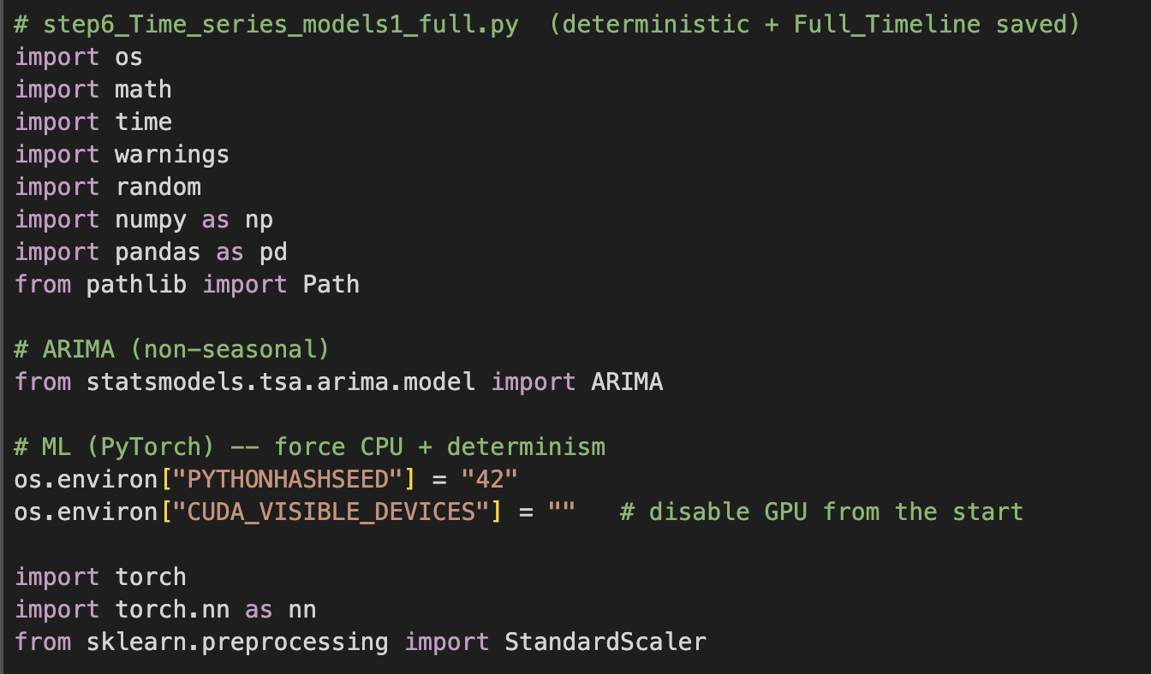

The modelling pipeline uses standard Python libraries. pandas and numpy are employed for reshaping and vectorised operations, while statsmodels provides reliable ARIMA routines (Hyndman & Athanasopoulos, 2018 [15]). Deep learning models are implemented in PyTorch, which supports reproducible LSTM and Transformer estimation under deterministic settings. StandardScaler from scikit-learn is applied only on the training data to avoid leakage. Export values are converted from thousand euros into euro millions for interpretability (Keogh, G., 2018).

#### Code 2:Euro‑millions conversion (thousand‑euro → euro‑millions):

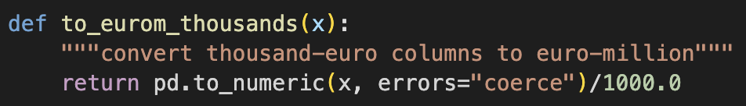

EuroM = Value (thousand €)\ 1000

Temporal splits:

* Train: **2015‑01 → 2019‑12**
* Validation: **2020‑01 → 2020‑12**
* Test: **2021‑01 → 2023‑12**

learns stable pre‑Brexit dynamics, tune around implementation, evaluate on the post‑Brexit regime.

3.4.1 Model 1 — ARIMA (Statistical Benchmark)

Theory: 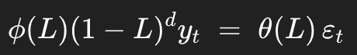 ……(1)

ARIMA models combine autoregressive lags (p), differencing (d), and moving average lags (q), with the lag operator LLL and white-noise innovations εt​. After differencing, the stationary process is explained by past values and shocks. ARIMA is particularly effective when the underlying process is linear and short memory dominates (Hyndman & Athanasopoulos, 2018).

#### Code 3: ARIMA Training

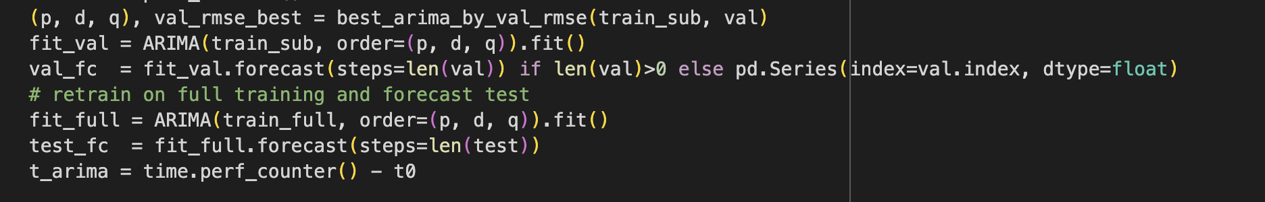

* Used for Key code (selection, fit, forecast)

#### Code 4: Arima Tuning

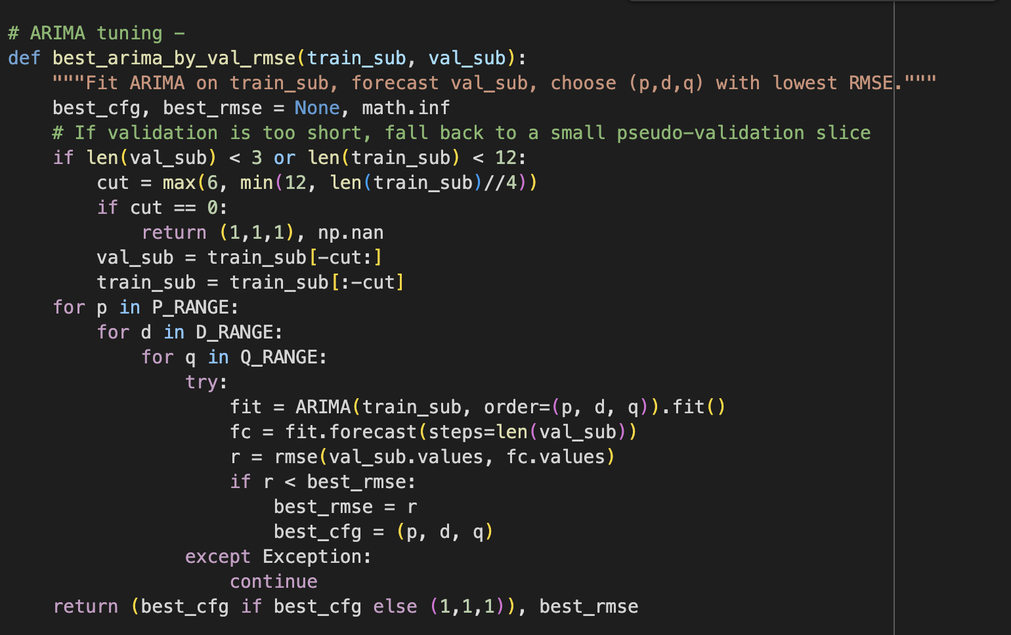

**RMSE on validation** Penalizes larger errors; consistent across sectors. **Fallback** 2020 may be short/edge‑case; fallback ensures tuning still happens **re‑fit on Train+Val** More data -> more stable parameters for Test.

### 3.4.2 Model 2 — LSTM (Deep Learning with Memory)

Theory : 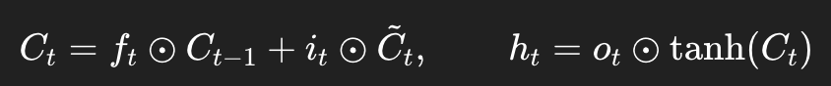…..(2)

Long Short-Term Memory (LSTM) networks were developed to overcome the vanishing gradient problem of recurrent neural networks (Hochreiter & Schmidhuber, 1997). They use gating mechanisms to decide which information to retain or discard, allowing them to capture long-range dependencies. This makes them particularly suitable for trade forecasting, where nonlinearities and lagged responses are common. Studies show that LSTMs outperform ARIMA for economic and financial time series with irregular structures (Siami-Namini, Tavakoli & Namin, 2018 [6]; Shen et al., 2021 [26]). LSTMs have also been applied in energy and agricultural trade forecasting contexts, demonstrating their robustness under uncertainty (Wu et al., 2021).

#### Code 5: LSTM-NN models:

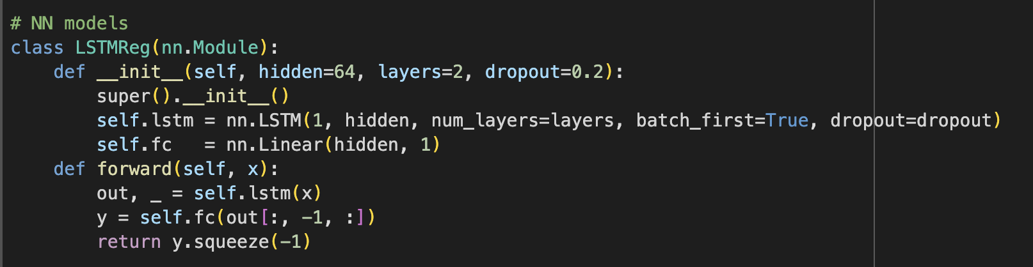

LSTMs are configured with two layers, 64 hidden units, dropout of 0.2, and a linear head. Training uses the Adam optimiser (lr=0.001) with validation snapshotting, ensuring stable performance across sectors.

#### Code 6: LSTM Validation

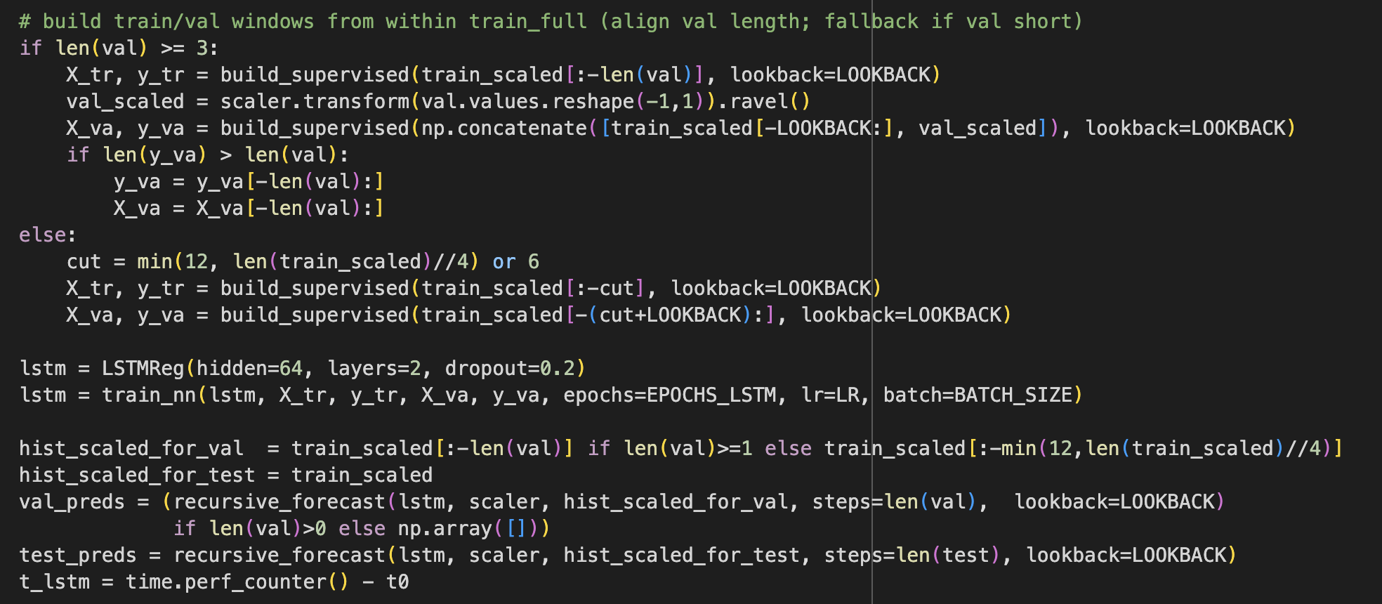

Fixed mini‑batch order for determinism. tracks **best validation loss** and restores that snapshot **MSE** loss with **Adam** optimizer (lr=1e‑3)

#### Code 7 :This implements a light form of early‑stopping by validation snapshotting. A screen shot of a computer program AI-generated content may be incorrect.Keeps ARIMA/LSTM/Transformer comparable (each does 1‑step rollouts). **caveat:** error can accumulate; that’s the realistic deployment scenario.

### 3.4.3 Model 3 — Transformer (Encoder‑Only, Self‑Attention)

Theory: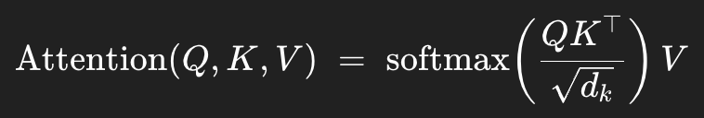…..(3)

Transformers represent a significant advance in sequential modelling, as they process entire sequences in parallel through self-attention, capturing both short- and long-range dependencies (Vaswani et al., 2017 [13]).

#### A computer screen with text on it AI-generated content may be incorrect.Code 8:Model structure (compact encoder)

In this thesis, a compact encoder-only Transformer is used, with dimension = 64, four heads, two layers, and dropout of 0.1. Recursive forecasts follow the same protocol as LSTMs, ensuring comparability.Training + recursive forecast (same protocol as LSTM)

#### Code 9: Transformer Train

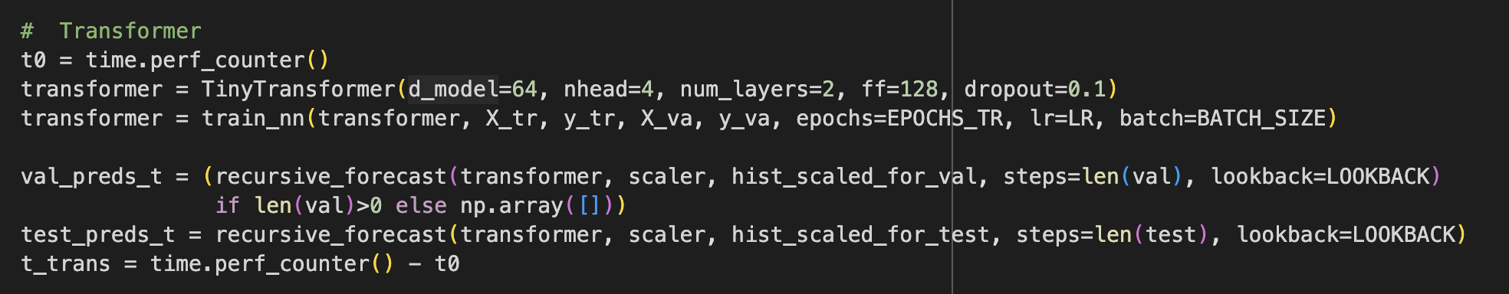

**Why mirror LSTM protocol?** Controls variables so differences in performance reflect model class, not training settings. Finally it records total execution time (t_trans) from model initialisation through training and forecasting to capture the runtime for comparison with other models.

### 3.4.4 Evaluation Metrics

The performance of all models is assessed using Root Mean Squared Error (RMSE), Mean Absolute Error (MAE), Mean Absolute Percentage Error (MAPE), and runtime efficiency.

Root Mean Squared Error (RMSE)

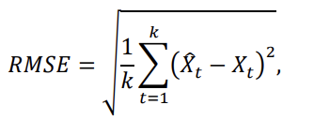 ……(4)

Mean Absolute Error (MAE)

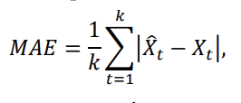……(5)

Mean Absolute Percentage Error (MAPE)

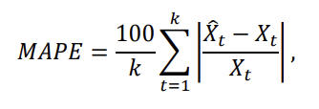 (6)

Runtime (sec):

Finally, runtime is measured using time.perf_counter() for training and inference. Runtime is increasingly important in trade and economic forecasting, where real-time policy evaluation requires efficient model deployment (Kontopoulou et al., 2023).

#### Code 10: Best Model

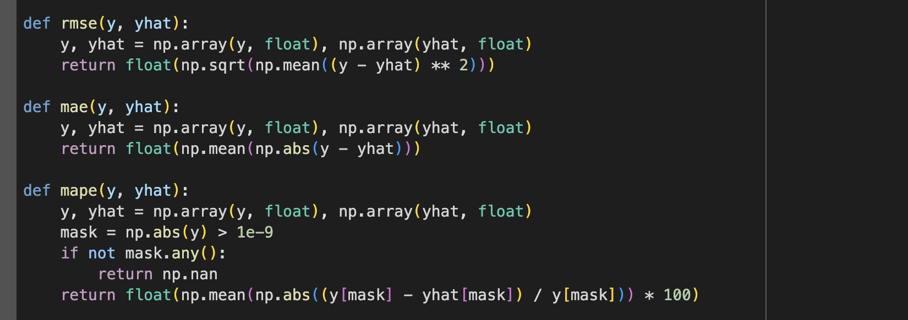

Why select the “Best Model” by **Test RMSE**?

RMSE accentuates large misses common in trade shocks (Brexit, Covid). Using **Test** (not Validation) prevents over‑tuning to the 2020 window. We still **report MAE/MAPE** for interpretability and scale‑free comparison

### 3.4.5 Outputs and Traceability (Sheets)

All results are stored in Time_series_prediction.xlsx across multiple sheets. These include Metrics (validation and test RMSE/MAE/MAPE, runtime), Forecasts (panel of actual vs. predicted exports), ARIMA_Params (best hyperparameters with validation RMSE), and Full_Timeline (aligned predictions for 2015–2023). This structure provides a transparent record for model auditing and reproducibility.

### 3.5 Gravity Model Estimation (PPML)

The Gravity Model provides a structural framework for analysing bilateral trade based on the principle that trade between two countries increases with their economic size and decreases with trade frictions. This intuition was formalised by Tinbergen (1962) and later developed into a theoretical framework by Anderson and van Wincoop (2003) [74]. Following methodological advances by Santos Silva and Tenreyro (2006) [77], who introduced the Poisson Pseudo Maximum Likelihood (PPML) estimator, this thesis employs PPML to estimate Ireland’s exports to the UK at a sectoral level. PPML is well established as the preferred estimator because it is robust to heteroskedasticity and can handle zero trade flows without requiring log-linearisation (Head, K. and Mayer, T., 2014). This makes it the empirical “workhorse” of modern gravity analysis, particularly in disrupted contexts such as Brexit (Keogh, G., 2018; Lawless & Morgenroth, 2019 [52]).

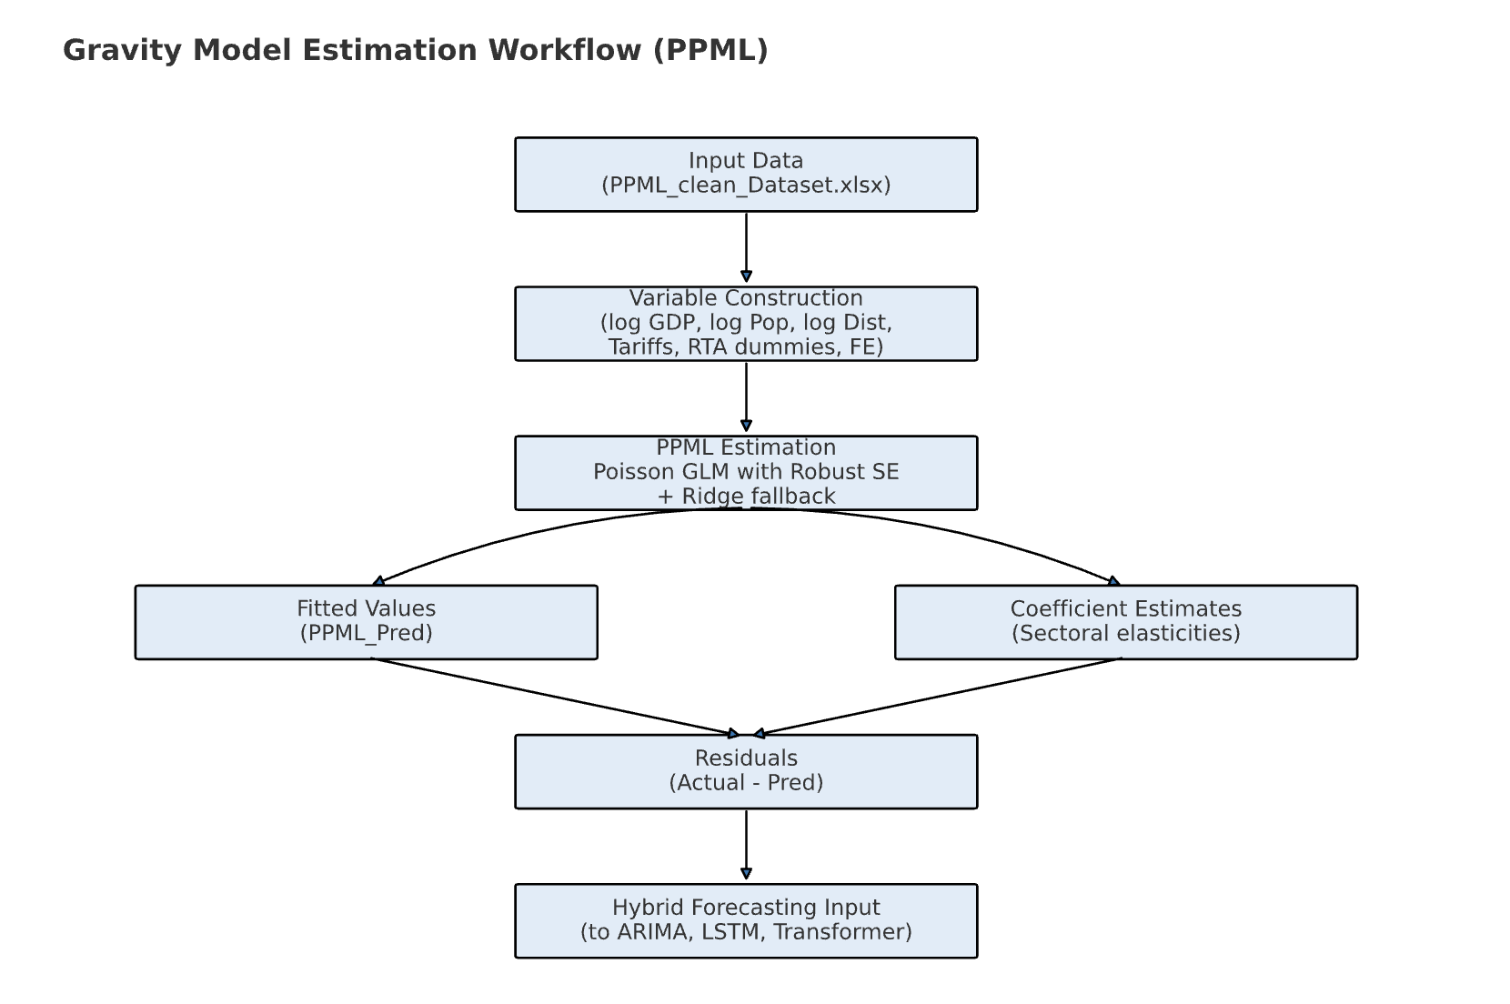

#### Figure 4:Gravity Model Workflow

The PPML workflow implemented in this thesis is summarised in Figure 1. The cleaned dataset (PPML_clean_Dataset.xlsx) was transformed into log-scaled covariates—GDP, population, and distance—together with bilateral dummies, tariff measures, and monthly fixed effects. Sector-level PPML estimation was performed using Generalised Linear Models with robust errors. Ridge-regularised Poisson GLM served as a fallback in cases where convergence problems occurred due to perfect separation. The outputs included predicted exports (PPML_Pred), estimated sectoral elasticities, and residuals. These residuals, defined as the difference between actual and predicted values, capture short-run trade variation not explained by the structural model and provide the input into the time series models (ARIMA, LSTM, Transformer) used in the hybrid framework.

### 3.5.1 Model Specification

The multiplicative Gravity equation used in this thesis follows the PPML formulation applied in Keogh (2020) and originally motivated by Santos Silva and Tenreyro (2006) [77]. It is expressed as:

….(7)

Where T_ij represents exports from country i(Ireland) to country j(United Kingdom), G_i and G_j are the respective GDP values of the exporter and importer, and D_ij is the bilateral distance between them. The disturbance term η_ij is assumed to follow a Poisson distribution with variance proportional to its mean.

In this thesis, the specification is extended by including sector-specific applied tariffs as additional trade cost variables. The justification for their inclusion follows Keogh (2020), who demonstrates that WTO ad-valorem tariffs under Hard Brexit scenarios significantly reduce Irish exports, with declines of 9–12% in agriculture, food, and beverages when tariffs are applied to CN8 export data matched to WTO HS6 schedules. This evidence shows that tariffs act as direct, measurable frictions that must be incorporated into Gravity-based estimations when assessing post-Brexit trade.

Population is also included to complement GDP, capturing per-capita effects and market size dynamics. Keogh (2020) [5] incorporated CEPII population data in his Irish PPML specification and noted that population often entered with negative coefficients, reflecting the fact that larger populations with fixed GDP imply lower per-capita incomes and weaker import demand. This interpretation aligns with the broader structural gravity literature (Head, K. and Mayer, T., 2014]; Shepherd, 2013 [73]) and ensures that the model distinguishes between total economic mass (GDP) and consumer intensity (population)

This formulation allows the model to address two major statistical weaknesses of the traditional log-linear Gravity Model. First, it avoids biased estimates caused by heteroskedasticity, as PPML does not assume constant variance of errors. Second, it accommodates zero trade flows directly by estimating trade values in levels rather than logs, reducing biases that arise when zero observations are excluded (Santos Silva & Tenreyro, 2006 [77]). By applying this specification sector-by-sector, the thesis ensures that trade elasticities with respect to GDP, distance, tariffs, and other covariates are consistent with the best practices in modern structural gravity modelling (Head, K. and Mayer, T., 2014; Keogh, G., 2018)

### 3.5.2 Estimation Methodology.

The PPML estimation was implemented on PPML_clean_Daraset.xlsx, which contains monthly export and gravity covariates.

Key features of the methodology:

* **Estimator**: PPML with robust (HC0) standard errors.
* **Fixed Effects**: Monthly dummies control for shocks and seasonality.
* **Controls**: Distance, GDP, population, tariffs, and RTA dummies.
* **Regularization fallback**: Ridge-penalized Poisson GLM used when standard PPML fails (e.g., due to perfect separation).
* **Sector-by-sector estimation**: Ensures sectoral heterogeneity is respected.

#### Code 11: Application of PPML Formula.

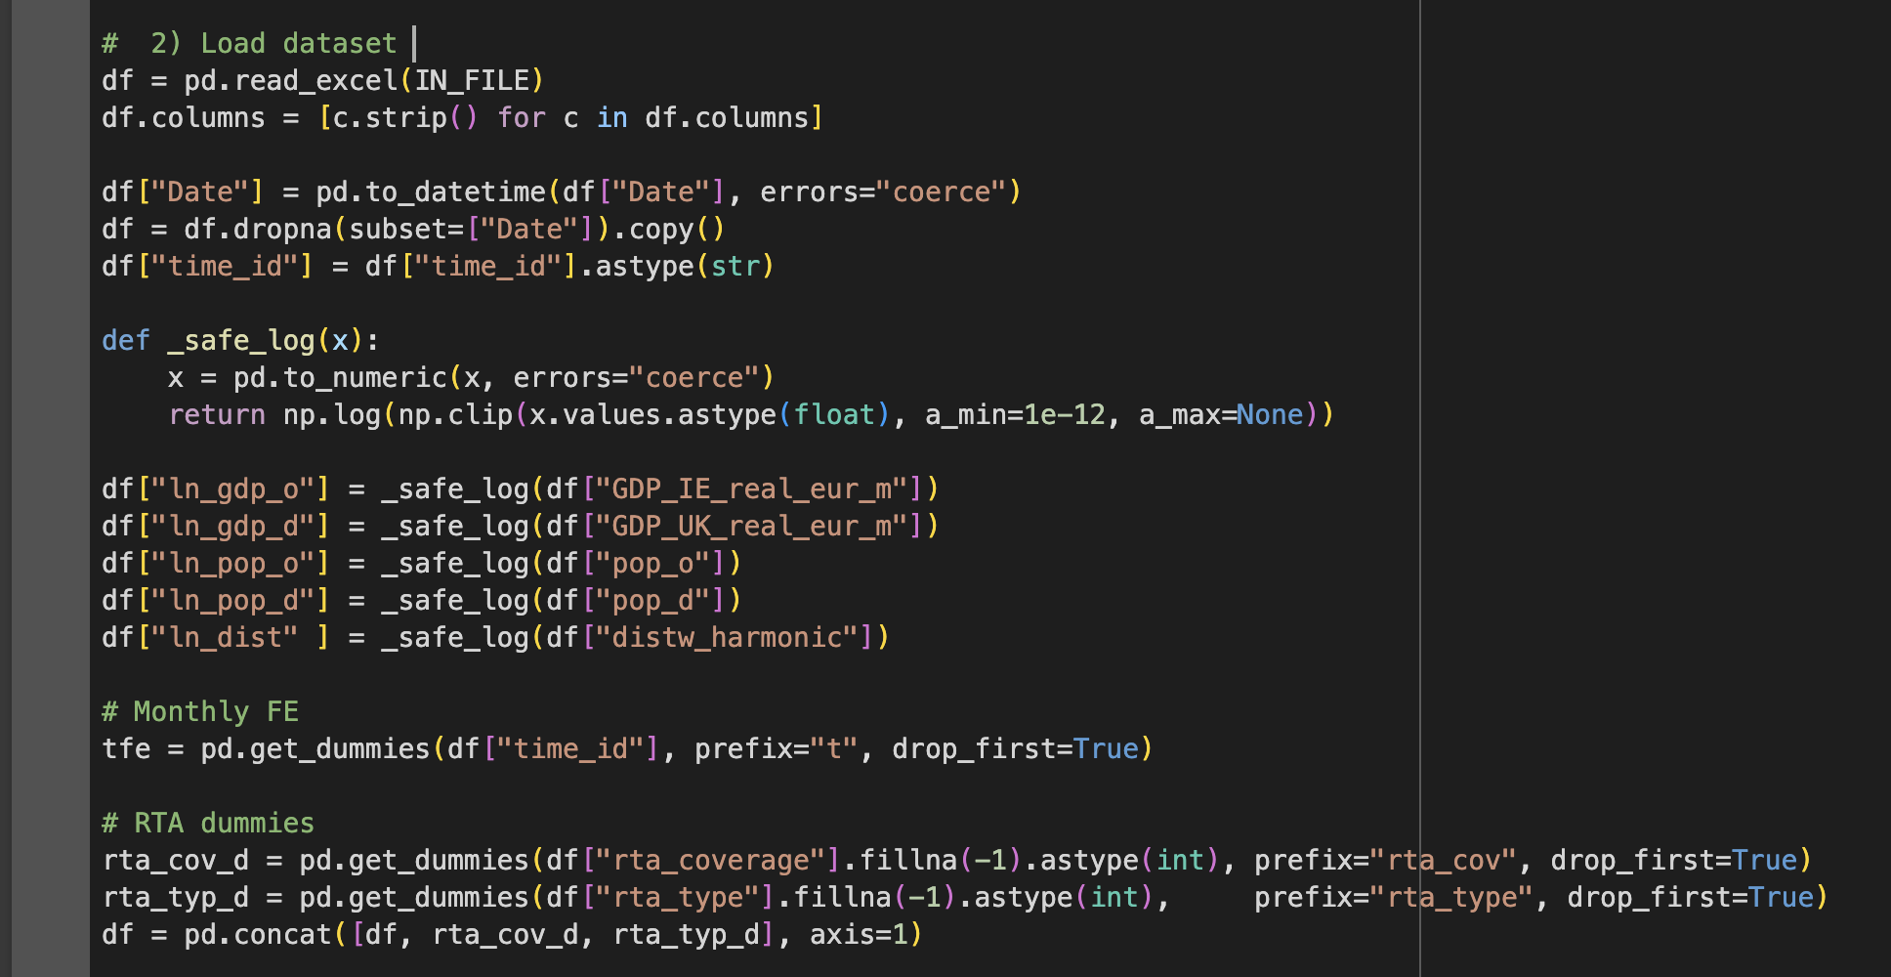

while logs of GDP, population, and distance ensured elasticity interpretation. Control variables included RTA dummies and sector-specific tariffs, allowing for the explicit measurement of Brexit-related trade costs (OECD, 2018; Donnellan, T. and Hanrahan, K., 2016).

#### Code 12: Fitting PPML with Robust Errors

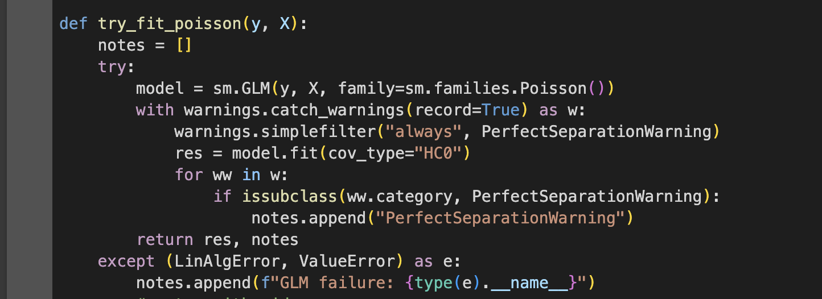 In cases where standard PPML estimation failed due to issues such as perfect separation, a ridge-penalised Poisson GLM was used as a fallback

#### Code 13: Sector-by-Sector Estimation.

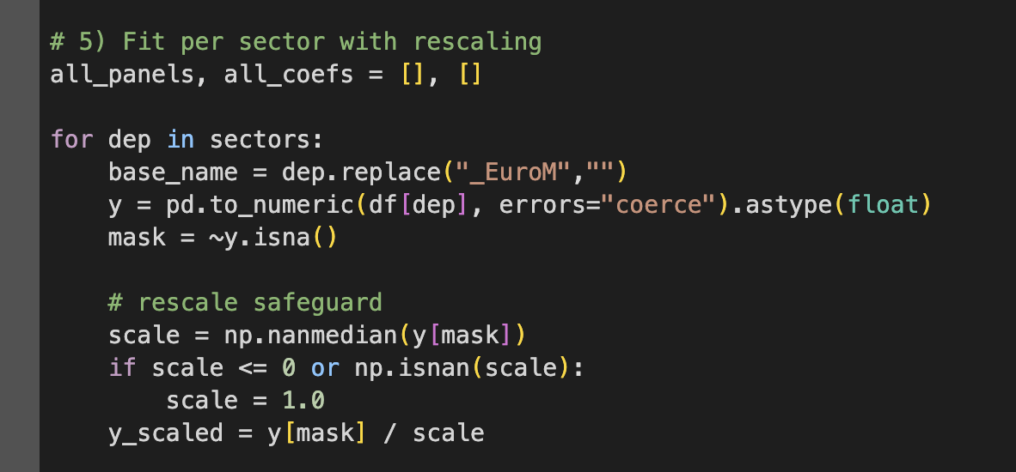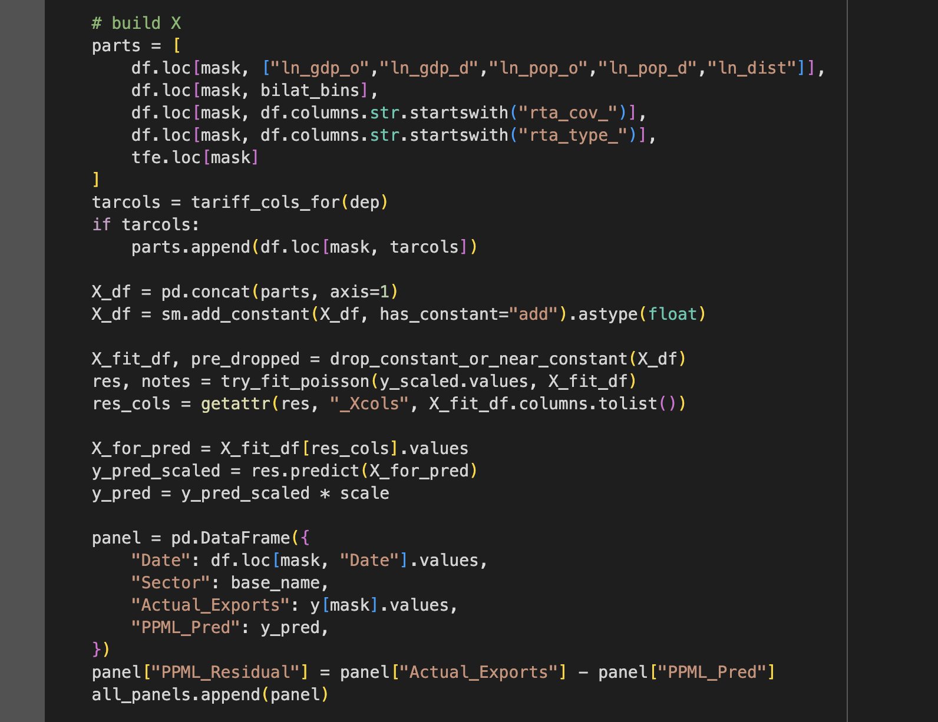Each sector is estimated separately. Exports were rescaled for numerical stability, and the design matrix included GDP, population, distance, bilateral dummies, RTAs, tariffs, and monthly fixed effects. Predictions were rescaled to original units, and residuals were computed to serve as inputs for the hybrid forecasting stage.

#### Code 14: Saving Results

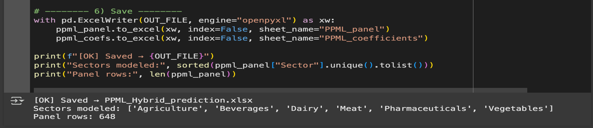

The final results were exported to PPML_Hybrid_prediction.xlsx. This output contains two sheets: PPML_panel, with dates, sectors, actual exports, PPML predictions, and residuals; and PPML_coefficients, with estimated coefficients, robust standard errors, z-statistics, and notes. These outputs provide both the fitted structural baseline and the unexplained variation required for residual forecasting.

### 3.5.3 Residual Extraction for Forecasting:

Residuals are defined as:

…..(8)

Residuals represent short-term variations in trade that structural drivers like GDP, distance, or tariffs cannot explain. They capture shocks and volatility in Ireland–UK flows arising from seasonality, Brexit disruptions, exchange rates, and inventory shifts. Treating residuals as a separate component aligns with hybrid gravity–time series approaches, where the Gravity Model sets the long-run structure and time series methods adjust for short-run shocks. Zhang (2003) first showed that modelling residuals with ARIMA and neural networks improves forecasts. Wu et al. (2021) confirmed this in agricultural trade, demonstrating that residuals reveal shocks missed by structural models. Keogh (2020) similarly noted that while PPML captures long-run elasticities, it cannot account for Brexit volatility, reinforcing the value of residual forecasting in this thesis

## **3.6 Residual Forecasting:**

Following the estimation of the structural Gravity Model with PPML, residuals were modelled as a separate forecasting problem. These residuals represent short-run shocks and unexplained volatility that structural covariates cannot capture, such as Brexit-related disruptions, seasonal fluctuations, exchange rate shocks, and inventory effects. By modelling residuals independently, the hybrid framework combines the interpretability of Gravity with the adaptability of statistical and deep learning models, ensuring a more comprehensive treatment of Ireland–UK trade dynamics.

By forecasting residuals separately, we allow the hybrid model (Section 3.6) to combine structural long-run drivers with flexible short-run adaptability.

Forecasting was conducted using three models:

* **ARIMA** (linear benchmark),
* **LSTM** (deep learning with memory),
* **Transformer** (self-attention).

Residual forecasts were based on PPML_Hybrid_prediction.xlsx and saved to Residual_Forecasts_prediction.xlsx.

### 3.6.1 Data and Preprocessing

Residuals were extracted from the PPML_Residual column in the PPML_panel sheet of PPML_Hybrid_prediction.xlsx. Data were chronologically ordered from January 2015 to December 2023. The dataset was split into training (2015–2019), validation (2020), and test (2021–2023) sets, reflecting pre-Brexit stability, the transition year, and the post-Brexit regime. Residuals were standardised using the training mean and standard deviation, and supervised sequences were created with a nine-month lookback window. This ensured the models learned both recent shocks and longer lagged dependencies.

#### Code 15: Load Panel

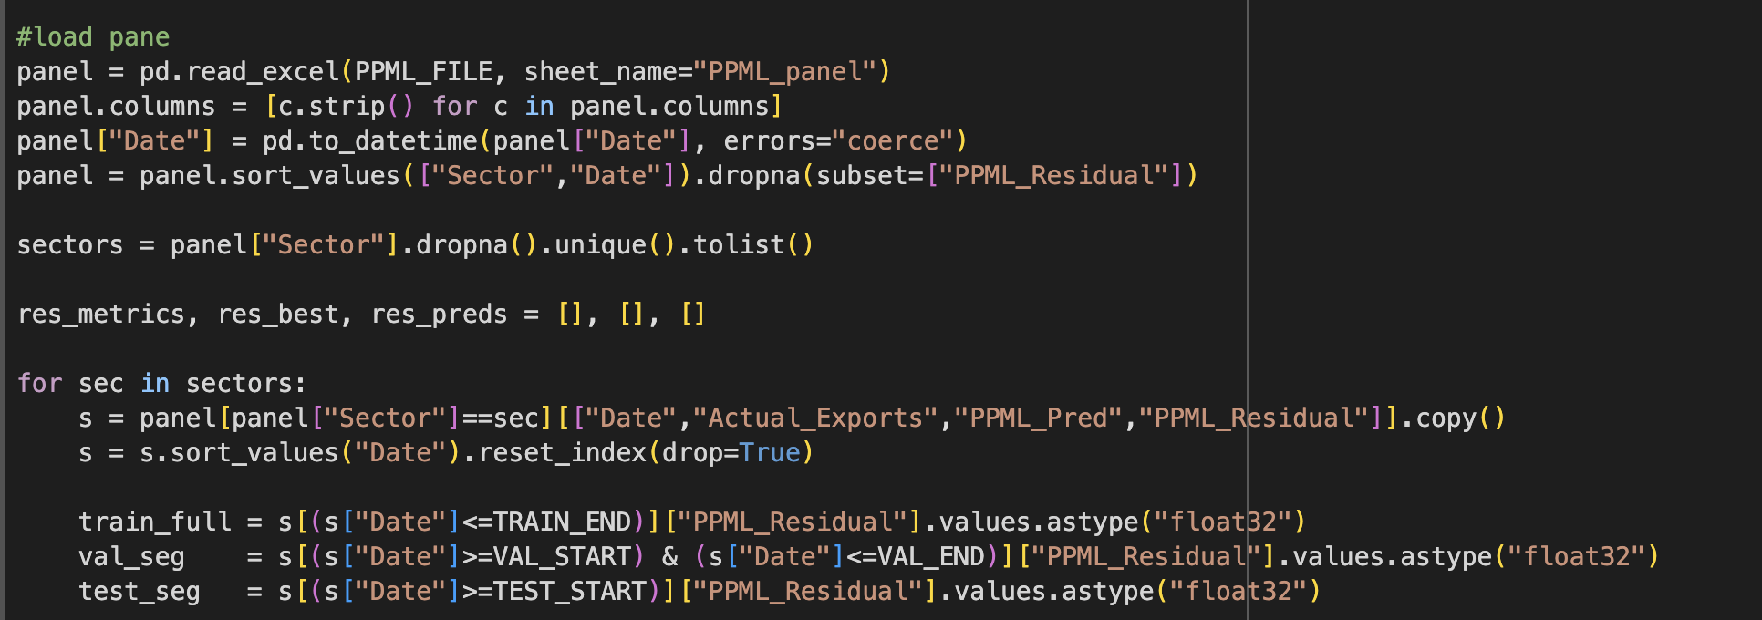3.6.2 ARIMA on Residuals

ARIMA models capture autoregressive, differenced, and moving average components, making them well-suited to capturing short-memory dynamics (Hyndman & Athanasopoulos, (2018) 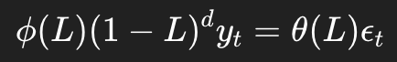…..(1.2)

Implementation: A grid search was performed across possible (p, d, q) parameters, with validation RMSE used to select the best configuration. Where the validation window was too short, pseudo-validation from the training set was applied. Forecasts were generated recursively across the test horizon, consistent with approaches in Brexit-related intervention models (Liu et al., 2021; Bouziane & Alaeddine, 2020 ).

#### Code 16: Best ARIMA

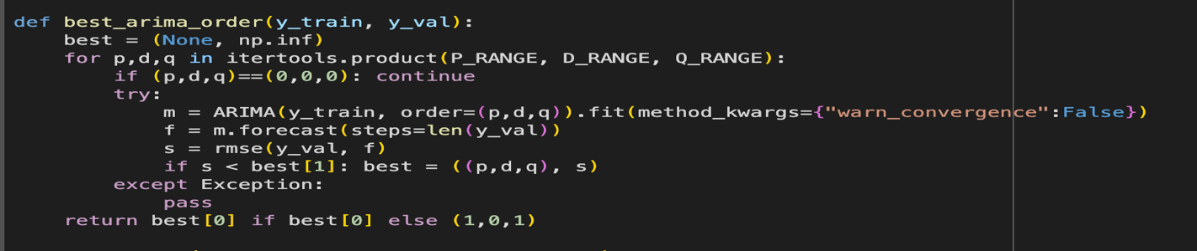

### 3.6.3 LSTM on Residuals:

LSTM models address nonlinearities and long-term dependencies through gating mechanisms that determine which information to retain or discard (Hochreiter & Schmidhuber, 1997 – external). This makes them particularly effective at modelling irregular shocks in trade data.

…..(2.4)

In this thesis, residuals were standardised and reshaped into supervised sequences with a nine-month lookback. The network consisted of one hidden layer with 32 units, a dropout rate of 0.2, and a linear output head. Training was conducted with the Adam optimiser, mean squared error loss, a batch size of 16, and 120 epochs, with early stopping applied if validation loss did not improve after eight iterations. The ability of LSTMs to capture volatility and delayed effects has been confirmed in economic and agricultural trade forecasting contexts (Siami-Namini et al., 2018 ; Shen et al., 2021 ; Wu et al., 2021 ).

#### Code 17: Building LSTM

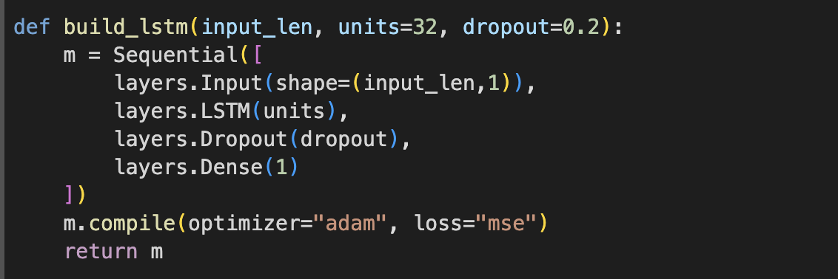

#### Code 18: Training with early stopping:

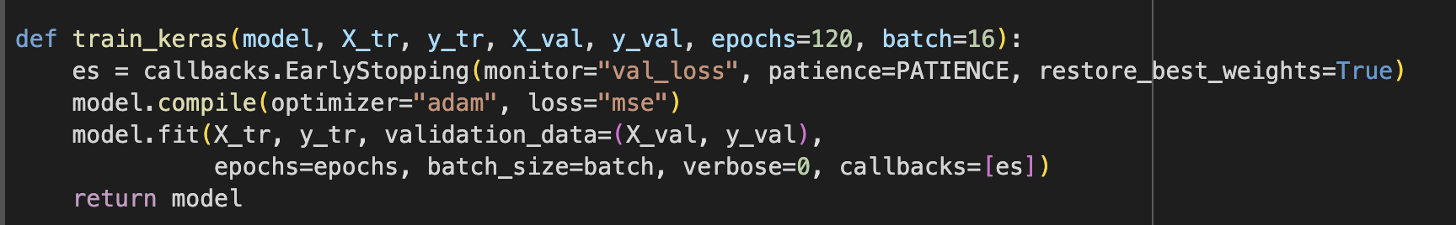

### 3.6.4 Transformer on Residuals

The Transformer is a state-of-the-art deep learning model for sequential data. Unlike recurrent architectures, it processes all time steps in parallel using self-attention, enabling the model to capture both local shocks and long-range dependencies (Vaswani et al., 2017 [13]).

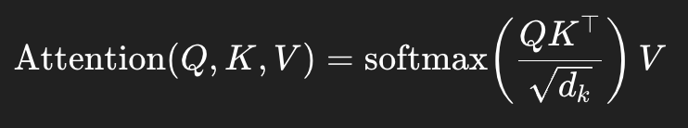…..(3.2)

In this thesis, the Transformer was configured with a model dimension of 48, four attention heads, dropout of 0.2, and feed-forward layers expanded by a factor of two with ReLU activations. Layer normalisation was applied after each block, and mean pooling was used before the final dense output. Training protocols mirrored those of the LSTM for comparability. Recent work confirms the Transformer’s superior performance in policy-sensitive and irregular trade series (Zhao et al., 2023 ; Sharma et al., 2023).

#### Code 19: Building Transformer

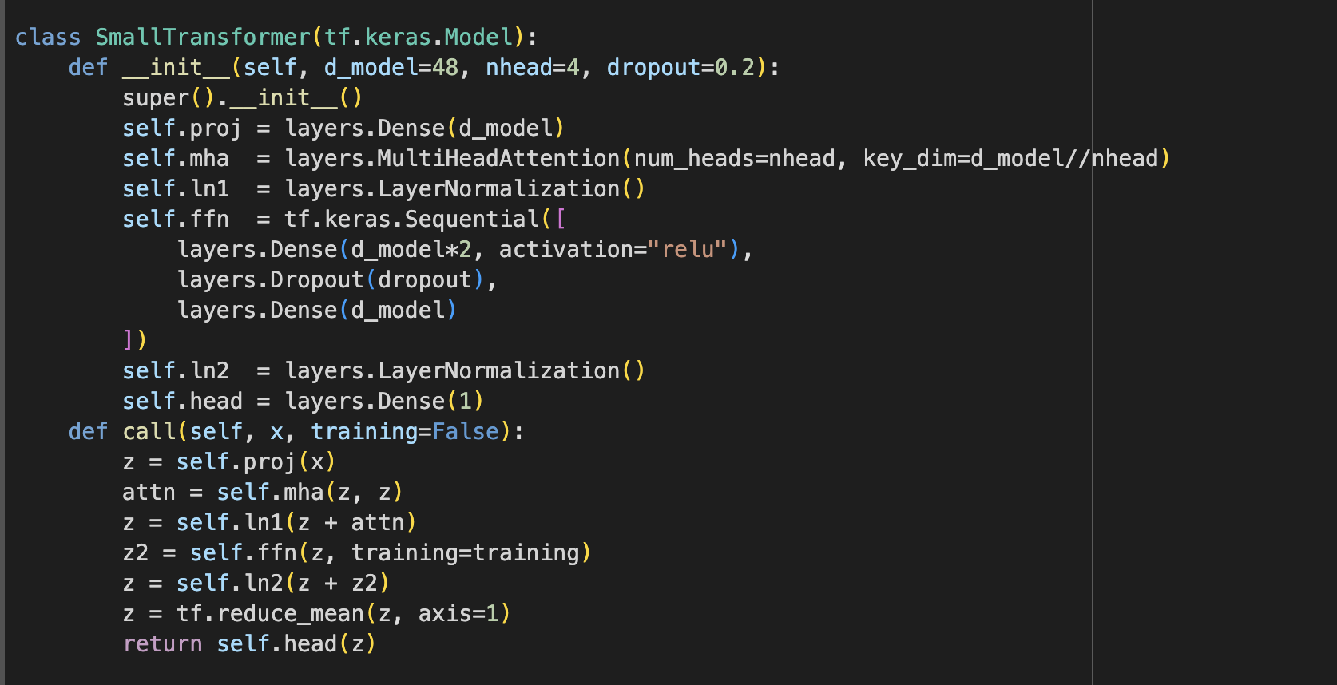

### 3.6.5 Evaluation and Outputs

Metrics used:

Residual forecasts were evaluated using RMSE, MAE, MAPE, and runtime. RMSE was selected as the main criterion because it penalises large errors, which are especially relevant during Brexit-related disruptions (Chai & Draxler, 2014 – external; Ly, Traore & Dia, 2021 – external). MAE was reported as a more robust and interpretable scale-dependent measure (Willmott & Matsuura, 2005 – external). MAPE, despite issues around zeros, was included as an intuitive unit-free error measure, consistent with applications in exchange rate forecasting (Tlegenova, 2015 – external). Runtime was also recorded to evaluate efficiency, reflecting the trade-off between accuracy and computational cost (Kalra et al. (2024) ; Song et al. (2024) ]).

#### Code 20: Metrics

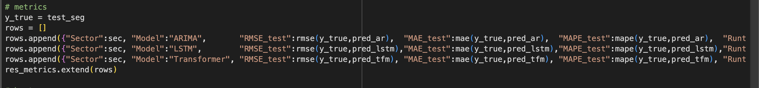

### Code 21: Output Files

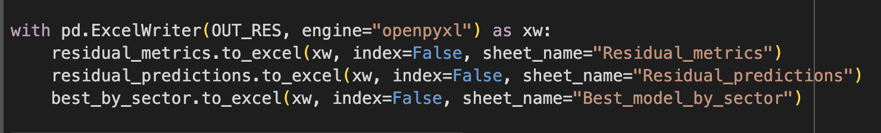

Output file structure (Residual_Forecasts_prediction.xlsx):

* **Residual_metrics**: per-sector RMSE, MAE, MAPE, runtime.
* **Residual_predictions**: actual vs predicted residuals.
* **Best_model_by_sector**: best model by RMSE for each sector.

## 3.7 Hybrid Forecasting Model Construction

The key innovation of this thesis lies in the hybrid forecasting framework, which merges the strengths of two complementary approaches. The **structural Gravity Model estimated with PPML** captures the long-run determinants of trade, such as GDP, distance, tariffs, and regional trade agreements, grounded in economic theory (Anderson & van Wincoop, 2003 [74]; Santos Silva & Tenreyro, 2006 [77]; Head, K. and Mayer, T., 2014). By contrast, the **residual forecasting models (ARIMA, LSTM, Transformer)** capture short-run nonlinear shocks that structural variables cannot explain, such as Brexit-related disruptions, seasonal fluctuations, and inventory effects (Hyndman & Athanasopoulos, 2018 [15]; Zhang, 2003 [83]; Vaswani et al., 2017 [13]).

The hybrid model is constructed as:

……(9)

Where:

* s = sector, t = time
* PPML_Pred is the Gravity prediction.
* Residual_Forecast-Best is the best-performing residual model.
  + (ARIMA/LSTM/Transformer) per sector, selected by lowest RMSE.

This approach balances long-run structural stability with short-run adaptability, enhancing accuracy under Brexit-induced volatility.

### 3.7.1 Data Sources and Inputs :

The hybrid forecast integrates outputs from earlier stages of the methodology. From PPML_Hybrid_prediction.xlsx, the PPML_panel sheet provides dates, sectors, actual exports, and PPML predictions. From Residual_Forecasts_prediction.xlsx, two sheets are used: Residual_predictions, which contains forecasts from ARIMA, LSTM, and Transformer residual models, and Best_model_by_sector, which identifies the best residual model for each sector. These inputs are merged by date and sector to produce a unified dataset for hybrid construction.

#### Code 22: Load Inputs

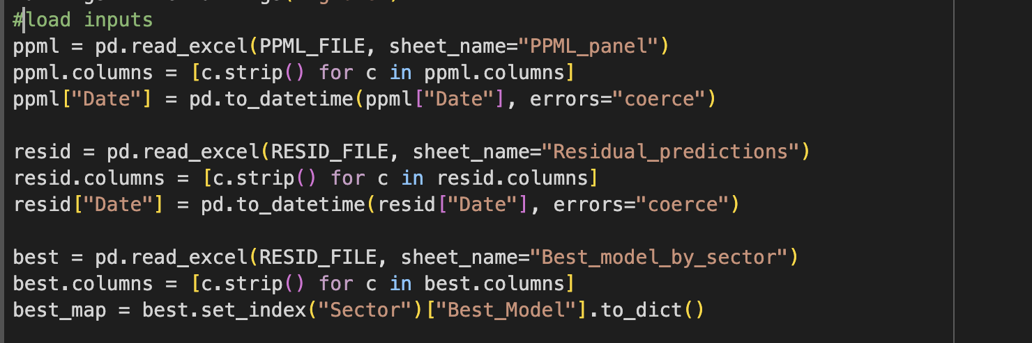

PPML predictions and residual forecasts are loaded and aligned. A dictionary best_map links each sector to its chosen residual model

### 3.7.2 Hybrid Construction Methodology.

After merging, the hybrid forecast is constructed by selecting the appropriate residual forecast per sector and adding it to the PPML predictions.

merge + choose residuals

#### Code 23: Merge

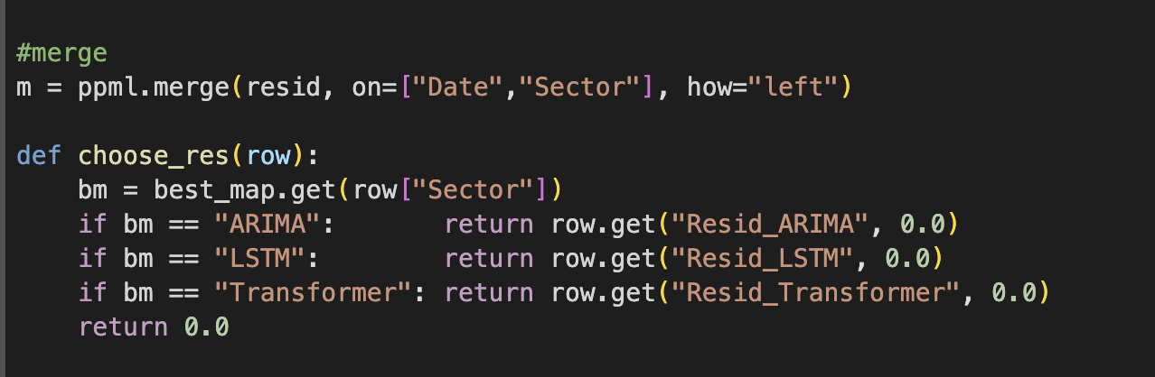Data merged on (Date, Sector). Function choose_res() selects the correct residual forecast (ARIMA/LSTM/Transformer) for each observation.

#### Code 24:Hybrid forecast creation

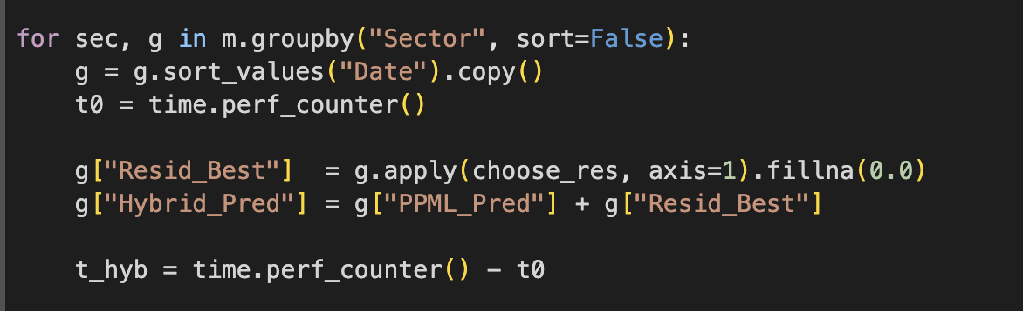Hybrid forecasts are constructed only for the test period (2021–2023) to maintain out-of-sample integrity. Runtime per sector is also recorded to ensure efficiency in model selection. This methodology follows Zhang’s (2003) [83] hybrid logic, which demonstrated that combining structural forecasts with residual learning improves accuracy in volatile environments.

### 3.7.3 Evaluation Metrics

Performance of PPML vs Hybrid forecasts was compared using:

* **RMSE** – penalizes large errors, captures Brexit shocks.
* **MAE** – interpretable in export values.
* **MAPE** – scale-free percentage error.
* **Runtime** – efficiency of hybrid combination.

#### Code 25: Metrics computation

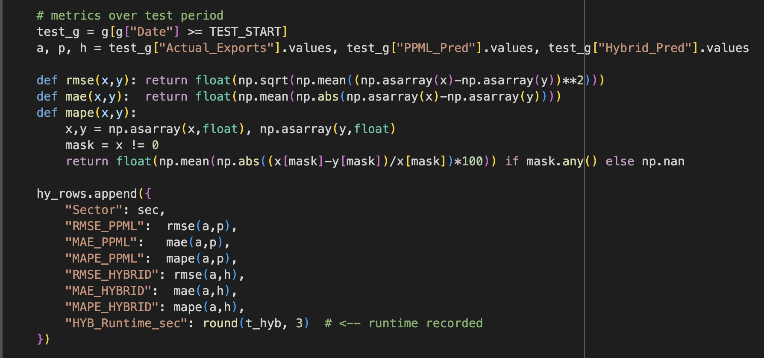Metrics computed for PPML predictions vs Hybrid predictions over test horizon. Improvement in RMSE shows hybrid advantage.

### 3.7.4 Outputs and Structure

The results of the hybrid forecast are saved in Hybrid_Forecasts_prediction.xlsx. This file includes three sheets: Hybrid_panel, containing the full timeline of actual exports, PPML predictions, residual forecasts, and hybrid forecasts; Hybrid_metrics, which compares PPML and hybrid model performance across RMSE, MAE, MAPE, and runtime; and Chosen_models, which records the best residual model per sector. By combining structural economic modelling with machine learning adaptability.

#### Code 26: Save Outputs

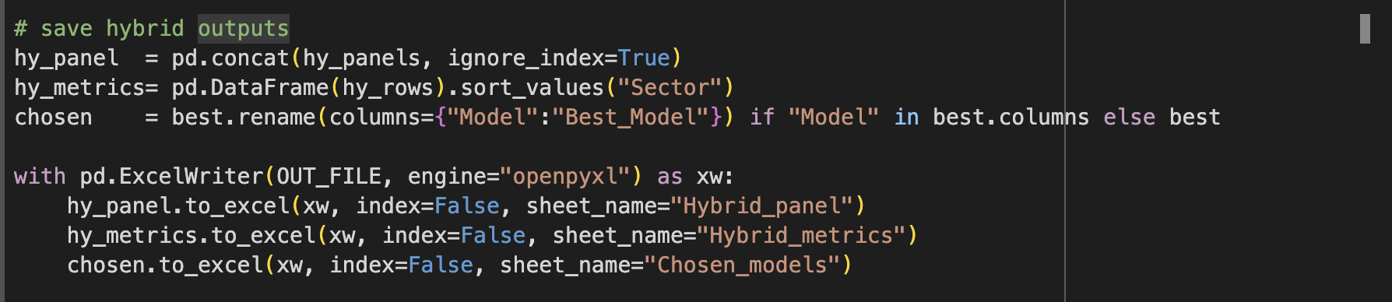 This hybrid system generates robust forecasts of Ireland–UK trade under Brexit, offering improved accuracy and policy relevance.

#### Figure 5: Workflow of the Hybrid Forecasting Model Construction

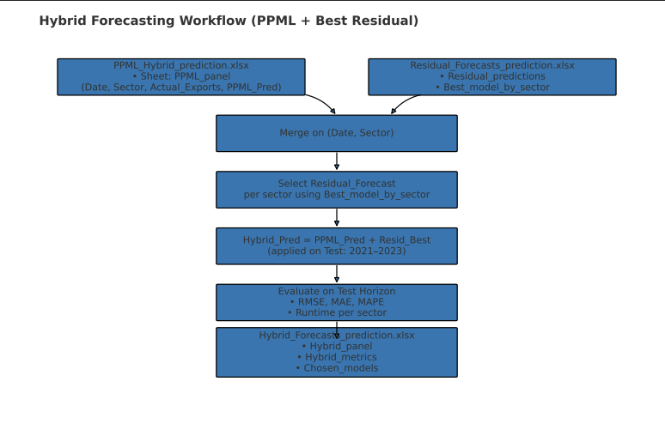

This figure illustrates the final stage of the forecasting pipeline, where outputs from the PPML Gravity Model and the residual-based forecasts are merged to construct the hybrid forecast. The PPML predictions (long-run structure) and residual forecasts (short-run dynamics) are aligned by date and sector. For each sector, the best-performing residual model (ARIMA, LSTM, or Transformer) is selected from the Best_model_by_sector sheet. The chosen residual forecasts are then added to the PPML predictions to produce the hybrid forecasts for the test horizon (2021–2023). The workflow also includes evaluation using RMSE, MAE, MAPE, and runtime per sector, with results saved to Hybrid_Forecasts_prediction.xlsx. This output file contains three sheets: Hybrid_panel (full timeline of forecasts), Hybrid_metrics (comparative performance of PPML vs Hybrid), and Chosen_models (best residual model by sector). The hybrid workflow thus integrates theory-driven predictions with machine learning adaptability, producing robust sectoral trade forecasts under Brexit.

### 3.8 Comparative Evaluation: Hybrid vs Time Series:

The objective of this stage is to compare the Hybrid forecasting model—constructed by combining the Gravity Model with residual forecasts—with the best standalone Time Series model (ARIMA, LSTM, or Transformer) for each export sector. This comparison tests whether embedding structural economic theory into the forecasting pipeline produces measurable gains over purely data-driven methods. By using a consistent testing horizon (January 2021 – December 2023) and applying identical evaluation metrics, this stage provides a fair benchmark of forecasting performance. The results serve to validate the central hypothesis of the thesis: that a hybrid approach, which integrates PPML Gravity predictions with residual-based machine learning forecasts, improves the accuracy of Ireland–UK trade forecasts under Brexit conditions. The importance of such hybrid approaches has been highlighted in the literature, beginning with Zhang (2003) [83], who demonstrated that combining ARIMA with neural networks outperforms standalone models. This principle has since been extended to trade and economic contexts, where hybrid designs capture both long-run structure and short-run volatility.

#### Figure 6: Workflow of the Comparative Evaluation (Hybrid vs Time Series)

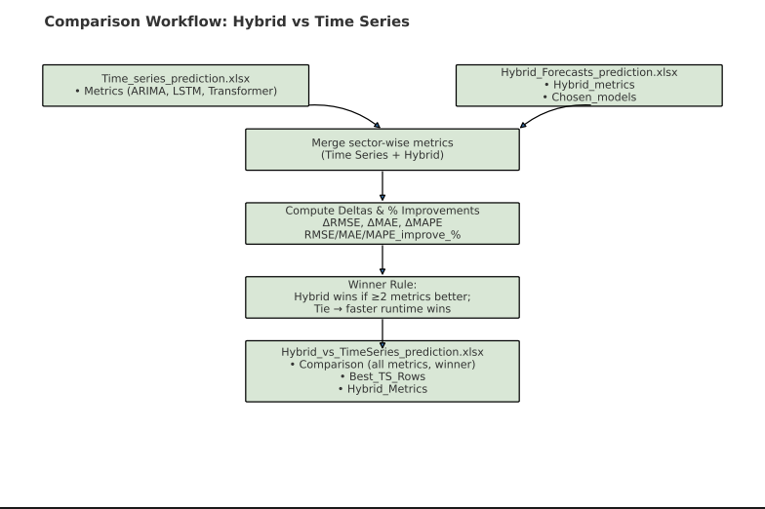

The comparison procedure is illustrated in Figure 3.7. Metrics from Time_series_prediction.xlsx (ARIMA, LSTM, Transformer) are aligned with those from Hybrid_Forecasts_prediction.xlsx. After merging, three deltas (ΔRMSE, ΔMAE, ΔMAPE) are calculated, and percentage improvements are derived to quantify the Hybrid model’s relative gains. A winner selection rule is then applied: Hybrid is declared the winner if it outperforms the best Time Series model in at least two of the three error metrics. In the event of a tie, runtime efficiency decides the winner. This design ensures a transparent and reproducible evaluation framework, consistent with good forecasting practice (Hyndman & Athanasopoulos, 2018 [15]).

The results are saved into Hybrid_vs_TimeSeries_prediction.xlsx, which contains three sheets:

* **Comparison** (full evaluation with winners)
* **Best_TS_Rows** (reproducibility of best Time Series rows)
* **Hybrid_Metrics** (sectoral Hybrid metrics).

This workflow ensures that the evaluation is **fair, transparent, and replicable**, providing the final methodological step for testing the central hypothesis of the thesis.

### 3.8.1 Data and Output Sources;

The evaluation uses outputs from three prior steps:

* Time_series_prediction.xlsx
  + Metrics: Metrics for ARIMA, LSTM, Transformer models
* Hybrid_Forecasts_prediction.xlsx
  + Hybrid_metrics: RMSE, MAE, MAPE for PPML vs Hybrid.
  + Chosen_models: Best residual model per sector.
* **Hybrid_vs_TimeSeries_prediction.xlsx** (final output)
  + Comparison: Combined evaluation of Hybrid vs Time Series.
  + Best_TS_Rows: Best Time Series rows for reproducibility.
  + Hybrid_Metrics: Cleaned Hybrid metrics

### 3.8.2 Comparison Metrics

The comparison is based on four metrics: RMSE, MAE, MAPE, and runtime. RMSE was chosen as the primary measure because of its sensitivity to large errors, which are particularly relevant under Brexit-related trade shocks (Chai & Draxler, 2014 – external; Ly, Traore & Dia, 2021 – external). MAE was reported alongside RMSE, offering a more robust and interpretable measure of average deviation in euro millions (Willmott & Matsuura, 2005 – external). MAPE provides a unit-free, percentage-based measure of forecast error, allowing performance to be compared across sectors. Despite limitations near zero values, it remains widely used in economic forecasting (Makridakis, 1993 – external; Tlegenova, 2015 – external). Runtime is also included to assess computational efficiency, justified by recent economic forecasting research highlighting the operational importance of efficiency in real-time deployment (Kalra et al., 2024 – external; Song et al., 2024 – external).

Winner selection rule:

* If Hybrid outperforms in ≥ 2 out of 3 error metrics -> winner = Hybrid.
* If tied -> lower runtime decides winner.

Improvement percentage:

 (10)

### 3.8.3 Methodology Implementation:

#### Code 27: Merge, Compute Deltas, and Decide Winner

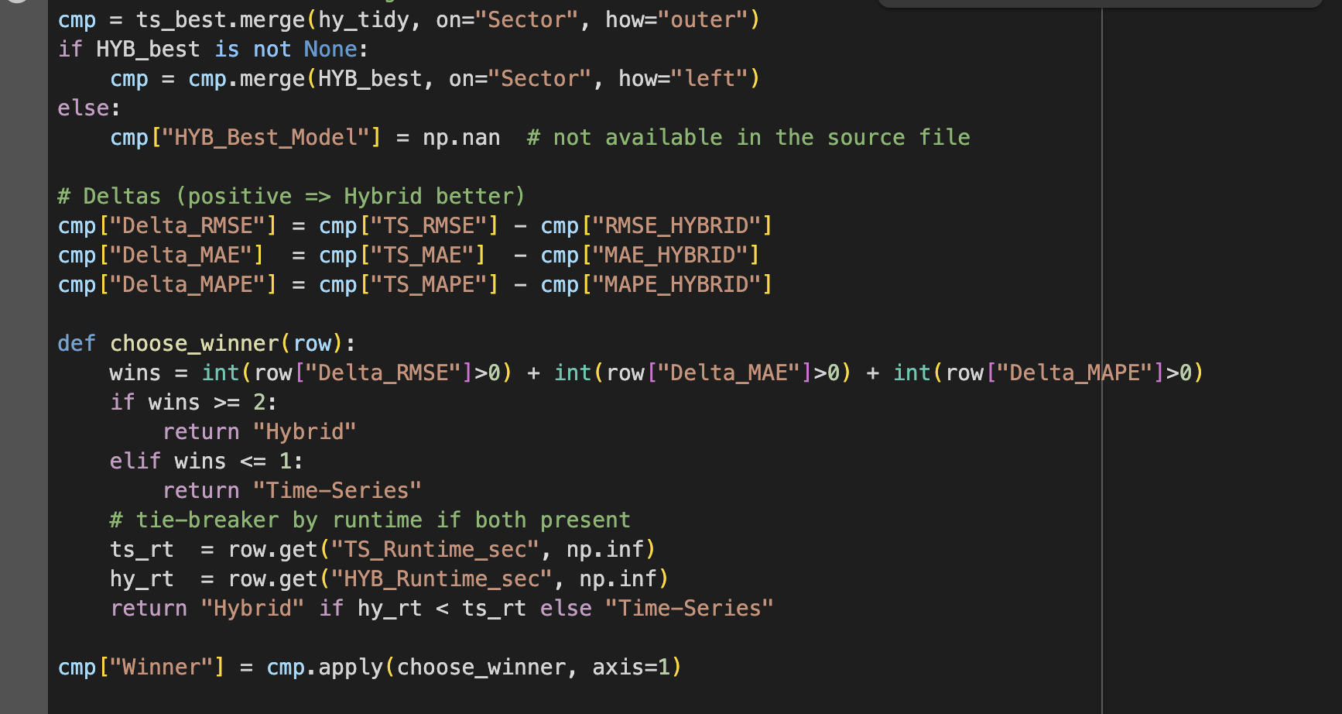Merges Time Series best metrics with Hybrid metrics and chosen models. Computes **deltas** (TS error – Hybrid error). Applies winner selection rule: Hybrid wins if it beats TS on ≥2 metrics; runtime breaks ties.

#### Code 28: Compute Percentage Improvements

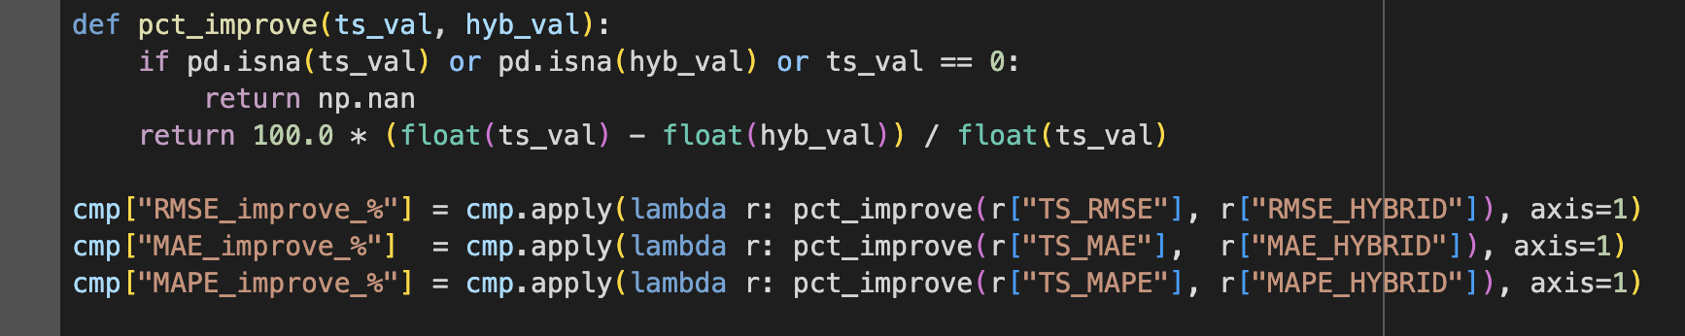Computes **percentage improvement of Hybrid vs Time Series** for RMSE, MAE, MAPE. Positive values indicate Hybrid is better.

## 3.9 What-If Scenario Methodology:

To evaluate the policy implications of Brexit on Ireland–UK trade, this thesis applies a residual-based What-If scenario simulation. Two counterfactuals are modelled: a Soft Brexit with mild frictions and a Hard Brexit with severe non-tariff barriers and delays. Instead of re-estimating the Gravity model, proportional shocks are applied to the PPML component of the Hybrid forecasts, preserving theoretical consistency while enabling flexible stress-testing. This approach follows modern Gravity applications that simulate policy shocks without altering the econometric core (Head, K. and Mayer, T., 2014;Santos Silva & Tenreyro, 2006) and is consistent with Keogh (2020), who analysed Hard Brexit outcomes using tariff-based counterfactuals.

### 3.9.1 Baseline Hybrid Forecast Definition:

The baseline hybrid forecast is: 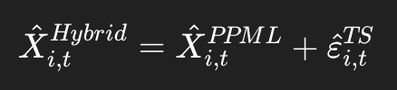 ​….(11)

Where:

* 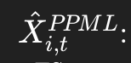: structural forecast from the Gravity model.
* ^ 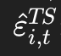 ​: best residual forecast from ARIMA/LSTM/Transformer

This baseline reflects observed post-Brexit trade patterns without any counterfactual shocks. Zhang (2003) [83] provides the theoretical basis for combining structural predictions with residual forecasts, showing that hybrid models consistently outperform single-stage models in volatile environments.

### 3.9.2 Incorporating Brexit Shocks via Residual Adjustment:

Scenarios are simulated by applying proportional shocks to the PPML component:

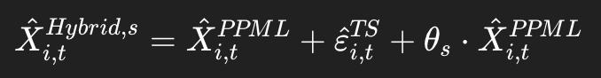…..(12)

Where:

* s∈{Soft,Hard}.
* θSoft​=0.02 (2% frictions), θHard=0.07\theta_{Hard}=0.07θHard​=0.07 (7% frictions).

Because the residual component is relatively small, the impact of scenarios is primarily driven by the structural PPML predictions. This ensures that Brexit shocks are applied consistently within the framework of the Gravity model while maintaining residual adaptability (Santos Silva & Tenreyro, 2006 [77]).

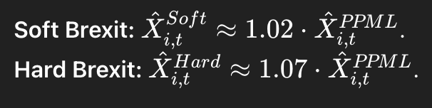

…….(13)

### 3.9.3 Scenario Data Structure and Output

The inputs for this process are drawn from Hybrid_Forecasts_prediction.xlsx (Hybrid panel sheet), while the outputs are stored in Hybrid_WhatIf_Scenarios.xlsx. The output file contains five sheets: Baseline (actual exports, PPML predictions, residual forecasts, hybrid forecasts), Soft_Brexit (hybrid forecasts adjusted with a +2% PPML shock), Hard_Brexit (forecasts adjusted with a +7% PPML shock), Scenario_Metrics (RMSE, MAE, MAPE under each scenario), and Chosen_models (context of the residual models selected). The workflow ensures transparency and reproducibility by clearly documenting both baseline and adjusted forecasts.

#### Code 29: Building What If Scenarios

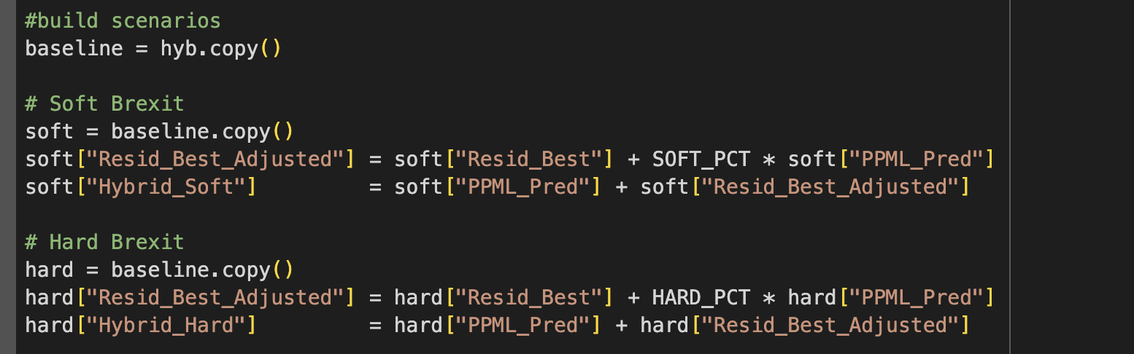Keeps **Baseline** unchanged for reference. **Soft**/**Hard** scenarios: add θ×PPML_Pred to the residual, then recompute Hybrid as PPML_Pred + adjusted residual. Produces per‑scenario forecast series: **Hybrid_Soft**, **Hybrid_Hard**.

### 3.9.4 Evaluation Metrics:

#### Code 30: Three standard metrics computed on 2021–2023 test window:

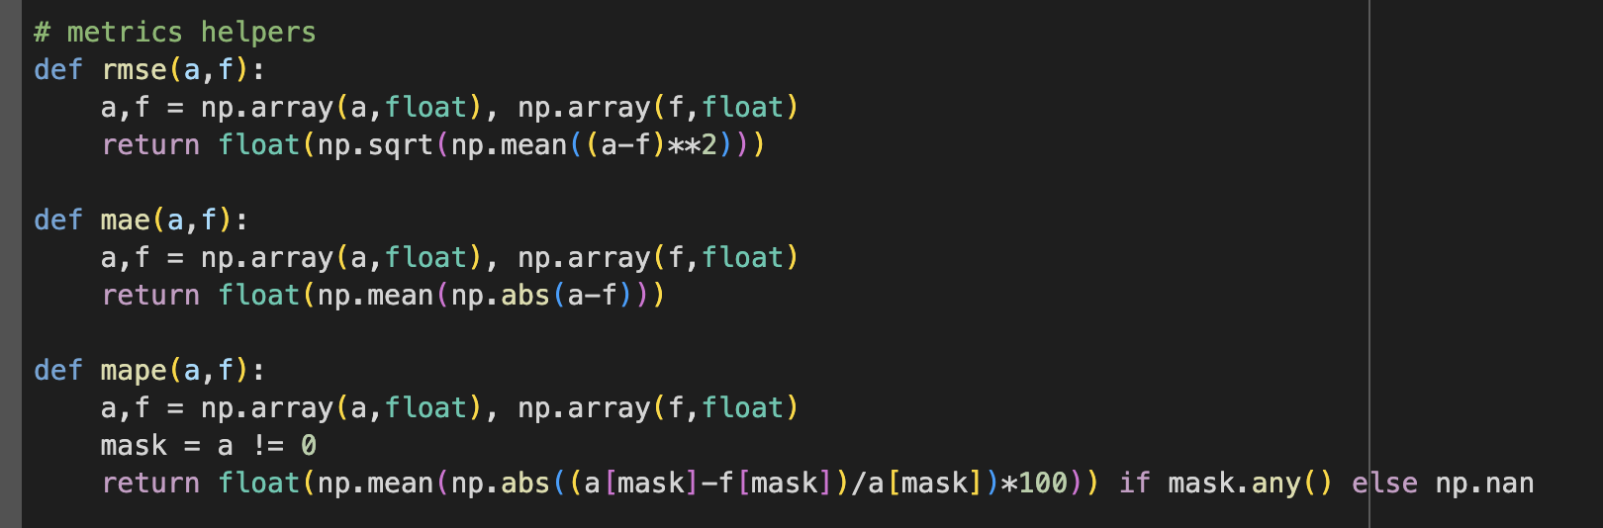Standard error metrics computed against **Actual_Exports**. MAPE guards against division by zero by masking zero actuals.

#### Code 31: Building Forecast

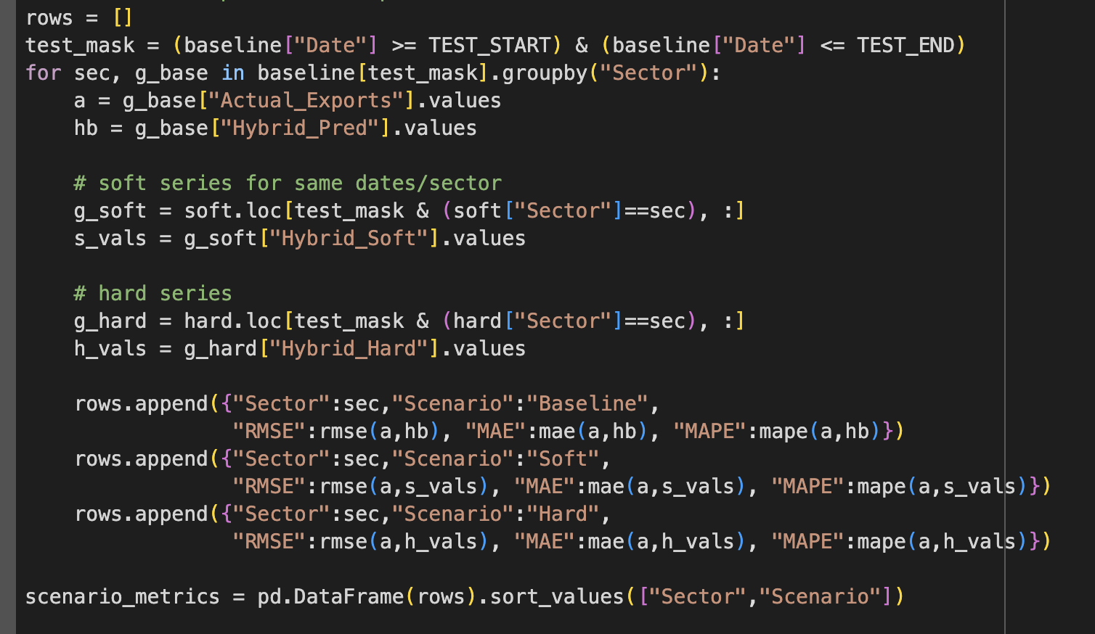Filters **2021–2023** dates; groups by **Sector**. Computes RMSE/MAE/MAPE for **Baseline**, **Soft**, **Hard** forecasts vs actuals. Produces a tidy **Scenario_Metrics** table.

### 3.9.5 Interpretation and Implications

* **Consistency**: builds directly on Hybrid forecasts, avoiding re-estimation.
* **Flexibility**: scenario multipliers (θ) can be adjusted for other Brexit cases.
* **Findings**: residuals are small, so differences across Soft vs Hard are mainly driven by PPML structural shocks.

#### Figure 7: Workflow of the What-If Scenario Forecasting (Soft vs Hard Brexit)

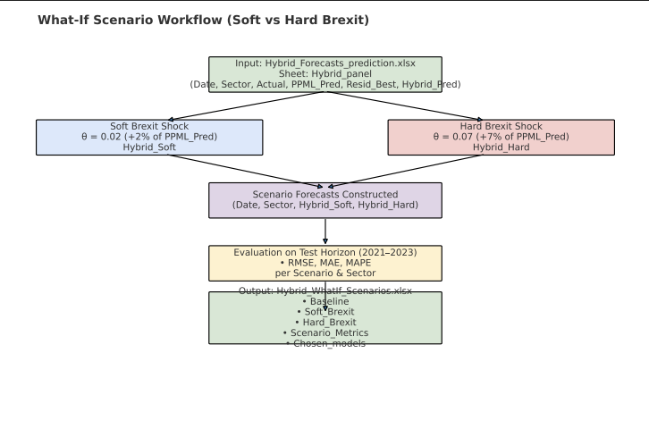

This figure presents the residual-based What-If simulation framework for Brexit scenarios. Starting from the baseline Hybrid forecasts in Hybrid_Forecasts_prediction.xlsx (containing PPML predictions and residual adjustments), proportional shocks are applied to the Gravity (PPML) component: +2% for Soft Brexit and +7% for Hard Brexit. These adjustments generate two alternative scenario forecasts (Hybrid_Soft and Hybrid_Hard). The resulting scenario series are evaluated against observed exports over the 2021–2023 test horizon using RMSE, MAE, and MAPE. Outputs are saved in Hybrid_WhatIf_Scenarios.xlsx, which includes the **Baseline**, **Soft_Brexit**, **Hard_Brexit**, **Scenario_Metrics**, and **Chosen_models** sheets. This workflow enables consistent, transparent, and flexible simulation of alternative Brexit outcomes without re-estimating the structural Gravity model.

## 3.10 Time Series Forecasting for 2024–2025:

This stage extends the thesis forecasts into the 2024–2025 horizon using three established time series model families: ARIMA as the classical linear benchmark, Long Short-Term Memory (LSTM) as a recurrent sequence-based model, and the Transformer as a self-attention-based model. The objective is to simulate forward-looking export dynamics across six Irish sectors—Agriculture, Beverages, Dairy, Meat, Pharmaceuticals, and Vegetables—and to record predictions in a structured and reproducible format. All outputs are consolidated in Time_series_forecasts_2024_2025.xlsx.

### **3.10.1 Model Training and Forecast Generation**

For ARIMA, a non-seasonal grid search was carried out across orders p∈[0,4]p \in [0,4]p∈[0,4], d∈[0,2]d \in [0,2]d∈[0,2], and q∈[0,4]q \in [0,4]q∈[0,4]. The optimal configuration was selected by the lowest RMSE on the 2020 validation window, or through pseudo-validation if data were insufficient. Once selected, the model was re-fit on the full 2015–2023 series and rolled forward by 24 months to cover January 2024 through December 2025. For example, the Beverages sector was estimated using an ARIMA(4,0,4) specification. The interpretability and stability of ARIMA make it an essential benchmark for this stage (Hyndman & Athanasopoulos, 2018).

The LSTM models were configured as two-layer architectures with 64 hidden units, a dropout rate of 0.2, and a 12-month lookback window. The final 15% of sliding windows was reserved for validation, enabling early stopping to prevent overfitting. Forecasting was recursive, with each prediction fed back as input for the next step. For instance, the Agriculture sector was trained with an LSTM model consisting of two hidden layers, 64 hidden units, and dropout of 0.2. LSTMs are well suited to modelling non-linear dependencies and lagged trade shocks, and their superiority over ARIMA for such tasks has been demonstrated in economic and trade series (Siami-Namini et al., 2018 [6]; Shen et al., 2021 [26]).

The Transformer was implemented as an encoder-only architecture with a model dimension of 64, four attention heads, two encoder layers, and a feed-forward network of 128 units with dropout of 0.1. For comparability, the Transformer used the same validation split and training loop as the LSTM. Recursive forecasting was again applied to generate 24-month forecasts, with each predicted value rolled forward into the input sequence. An example is the Dairy sector, which was forecast with a two-layer Transformer encoder with four attention heads and dmodel=64d_{model}=64dmodel​=64. Transformers have been shown to outperform recurrent networks in long-horizon and high-dimensional forecasting tasks by effectively modelling sequential dependencies through self-attention (Vaswani et al., 2017; Zhao et al., 2023).

#### Code 32: Imports and Configuration

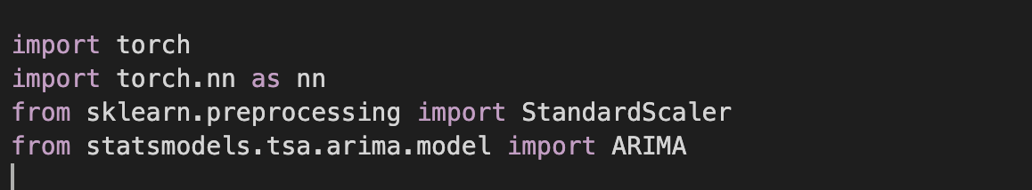

**Torch** used to build and train the LSTM and Transformer neural networks. **StandardScaler** ensures residuals and export values are standardized (zero mean, unit variance) before neural network training to avoid unstable gradients and **ARIMA (statsmodels)** classical autoregressive–moving average model for baseline forecasts.

#### Code 33: Deterministic CPU

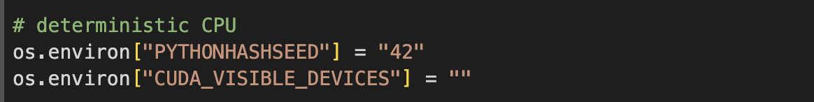to **enforce deterministic CPU-only execution**. This ensures identical outputs across different machines, crucial for reproducibility.

#### Code 34:Utility Functions

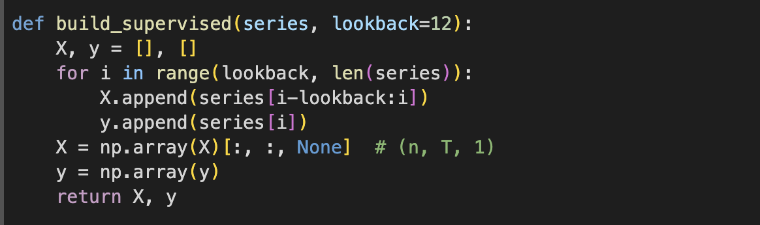Converts a **1D series** into supervised training samples. Example: with lookback=12, the past 12 months are used to predict the next one. Returns (n, T, 1) shaped arrays for PyTorch.

#### Code 35: Best ARIMA by RMSE

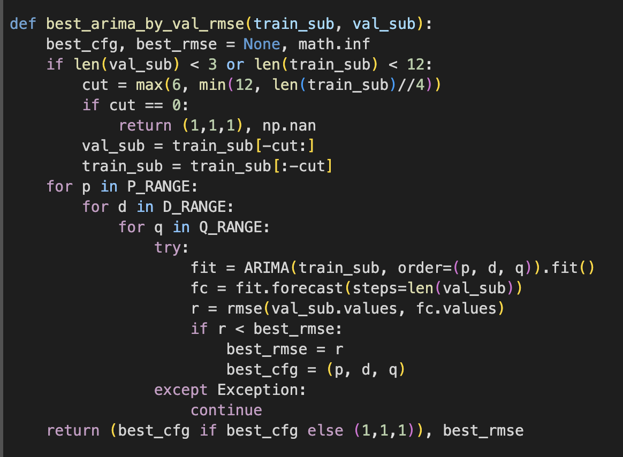

Explores ARIMA orders up to (4,2,4). Uses RMSE on validation (2020 window) to pick the best order. If validation is too short, it creates a fallback pseudo-validation slice from training.

#### Code 36: LSTM Model Definitions

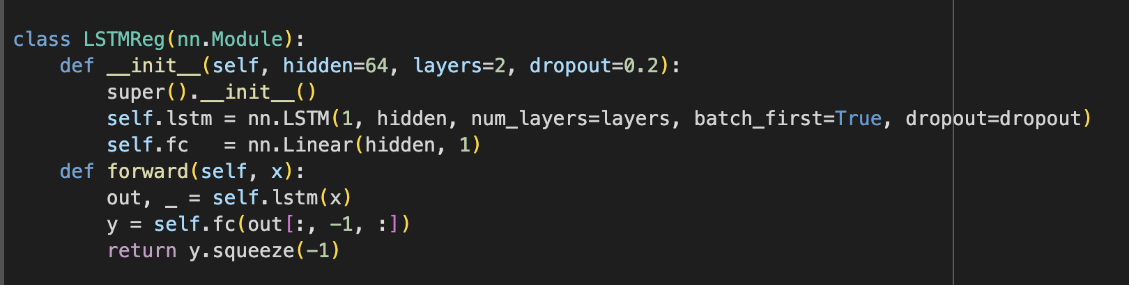

A **2-layer LSTM** with 64 hidden units, dropout=0.2. The final hidden state is passed through a linear head to predict the next value.

#### Code 37: Transformer model Definition

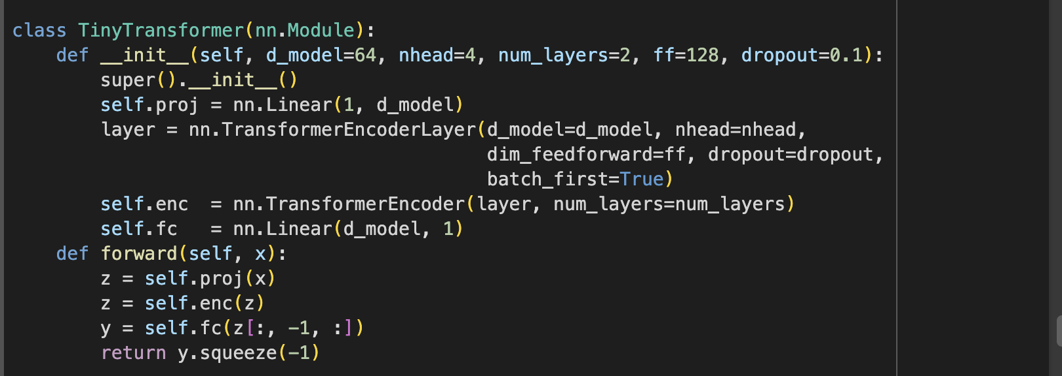

A compact **Transformer Encoder** with: model dimension = 64, 4 attention heads, 2 encoder layers, feed-forward = 128 units, dropout=0.1. The final token embedding is mapped to the next predicted export value.

#### Code 38: Training Loop

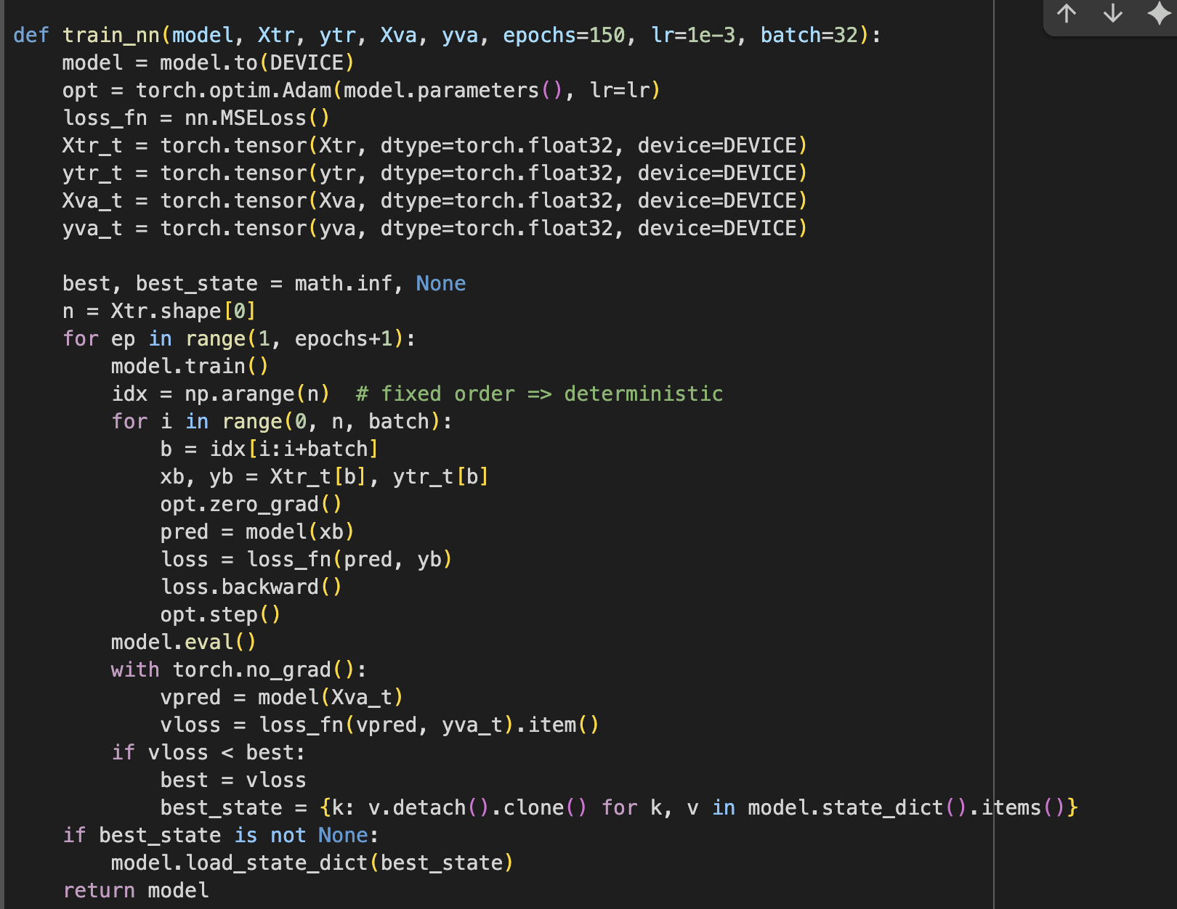

Uses **Adam optimizer** with learning rate = 1e-3. Tracks **validation loss** and restores the best weights (early stopping by snapshot). Runs for 150 epochs with fixed mini-batch ordering for determinism.

#### Code 40: Recursive Forecasting

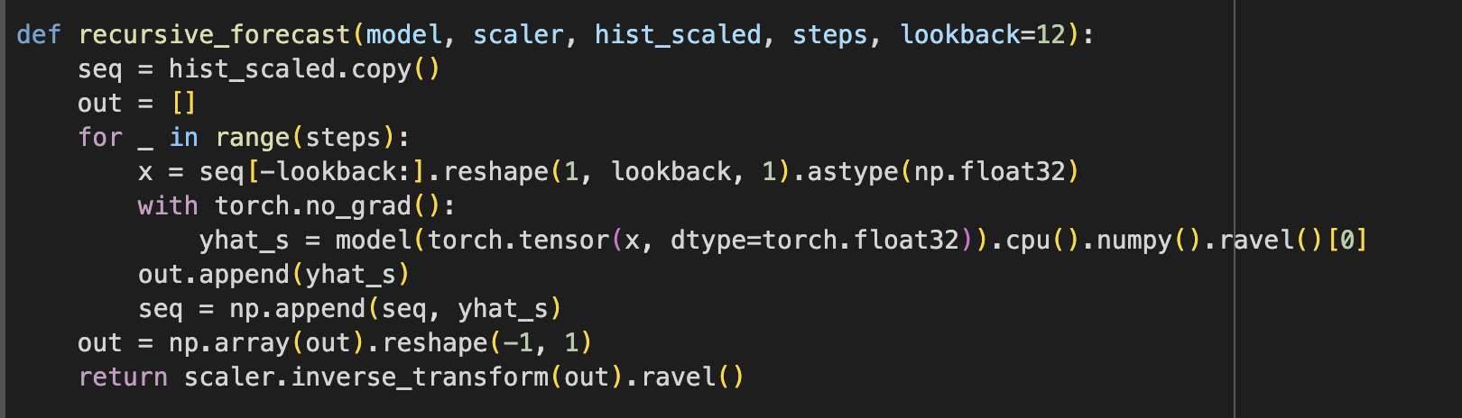Generates **multi-step forecasts** by feeding each new prediction back into the input sequence. Predictions are inverse-transformed to euro-million scale after forecasting. This approach ensures LSTM and Transformer outputs are directly comparable with ARIMA

Main Forecasting Routine: For each sector:

The forecasting routine was executed for each sector by building the training-validation split, running ARIMA grid search and forecasts, training LSTM and Transformer models on the full series with validation slices, and then generating recursive forecasts for January 2024 to December 2025. Predictions were recorded in the Forecasts_Future sheet, while hyperparameters were logged in Models_Used for transparency and reproducibility.

### 3.11 Hybrid Forecasts for 2024–2025:

The final methodological stage extends the hybrid framework into a two-year horizon from January 2024 to December 2025. The purpose is to generate forward-looking forecasts of Irish exports to the UK under both baseline and counterfactual Brexit conditions. By combining projected Gravity (PPML) predictions with residual forecasts, the hybrid system maintains its grounding in long-run trade determinants while integrating short-run adjustments that capture volatility and regime shifts. This approach follows established practice in structural gravity modelling, where scenario-based extensions provide a means to stress-test future policy outcomes (Head, K. and Mayer, T., 2014; Santos Silva & Tenreyro, 2006 [77]; Keogh, G., 2018)

### 3.11.1 Data and Inputs:

The forecasts were built using the cleaned Gravity–residual dataset (PPML_Hybrid_prediction.xlsx) as input, with outputs written to Hybrid_Forecasts_Future.xlsx.

The following sheets are produced:

* **Baseline_Future**: Predicted exports combining PPML projections and residual forecasts
* **Soft_Brexit_Future**: Baseline forecasts adjusted with +2% PPML shocks.
* **Hard_Brexit_Future**: Baseline forecasts adjusted with +7% PPML shocks
* **Models_Used**: Documentation of sector-specific ARIMA orders and neural network configurations.
* **Notes**: Execution settings and scenario definitions.

### 3.11.2 PPML Projection (Structural Component):

#### Code 41: To extend the PPML component into 2024–2025, the script implements a helper:

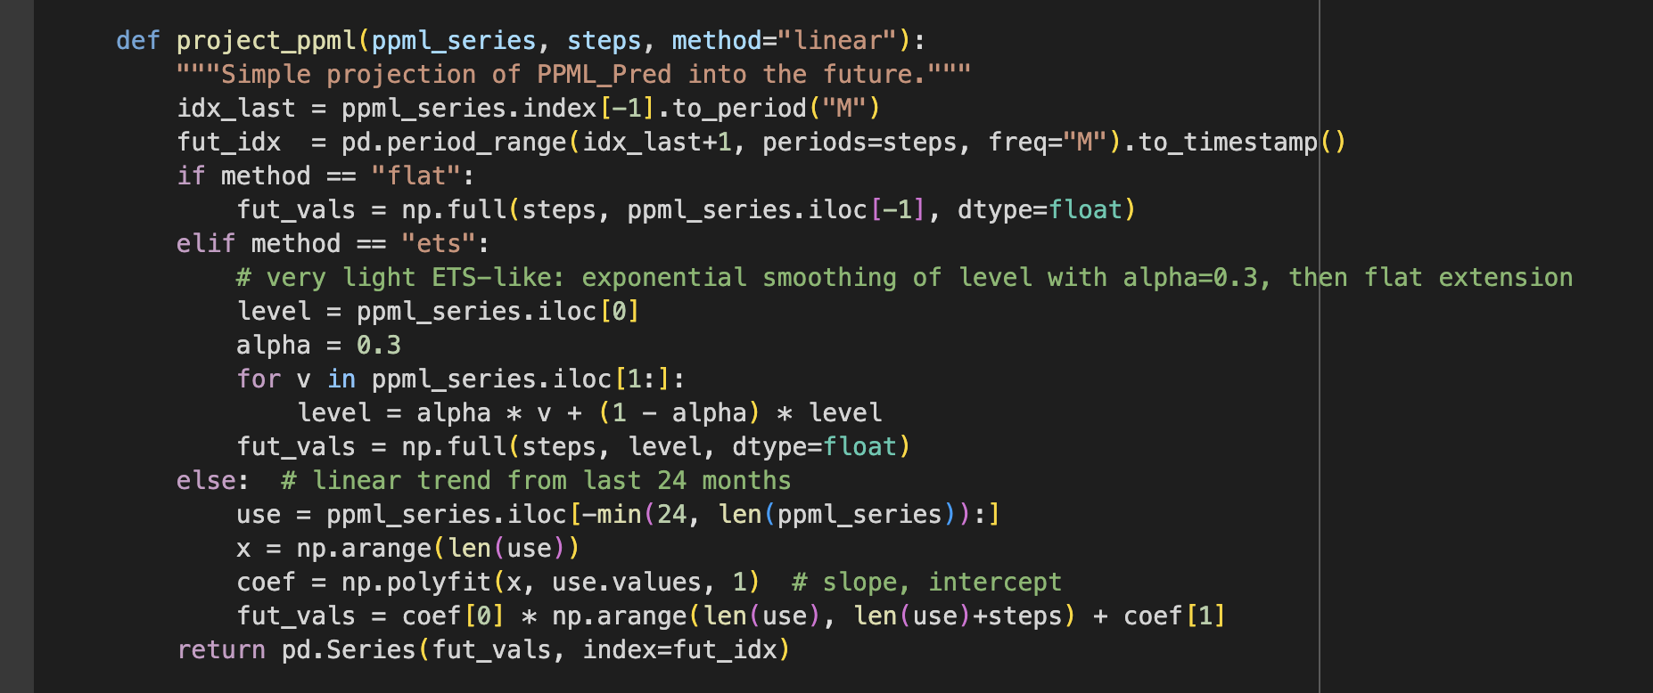

* **Flat**: holds PPML constant.
* **ETS**: uses exponential smoothing.
* **Linear (default)**: extrapolates a trend from the last 24 months.

For this thesis, the linear trend was selected, ensuring realistic sectoral trajectories.

### 3.11.3 Residual Forecasting (Dynamic Component)

Residuals were carried forward using ARIMA tuned on 2020 validation. LSTM and Transformer were also implemented, but ARIMA was chosen due to small residual variance

#### Code 42: Forecasting Residuals

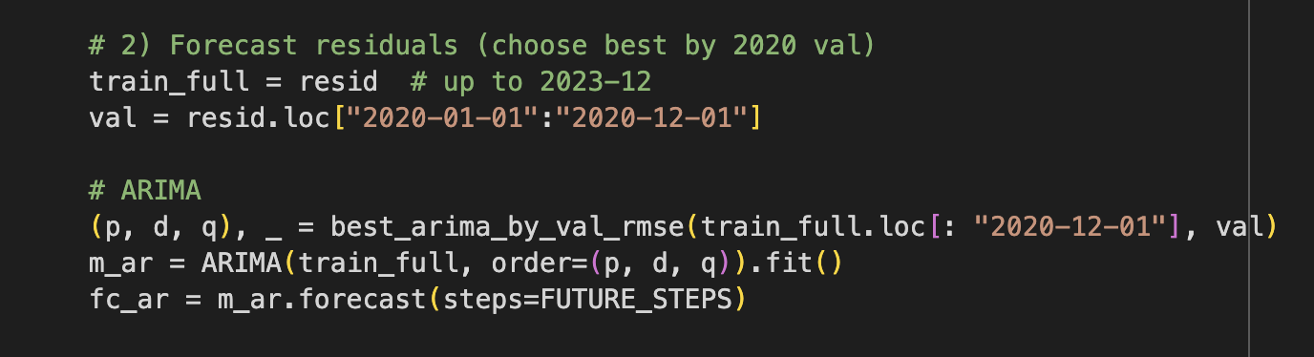

The ARIMA specifications were chosen via grid search across possible (p, d, q) values using validation RMSE from 2020, and the best-performing orders were re-estimated on the full residual series. Forecasts were then rolled forward for 24 months and matched to PPML projections. This approach is supported by literature highlighting ARIMA’s robustness for smaller or more stationary error processes (Hyndman & Athanasopoulos, 2018 [15]; Liu et al., 2021 [69]).

### 3.11.4 Hybrid Forecast Construction

Code 43: The hybrid baseline was created by summing projected PPML and residual forecasts

……. (14)

This formulation preserves the long-run economic structure embodied in the PPML component while allowing short-run dynamics to be incorporated through the residual models. Similar formulations have been applied in hybrid economic forecasting frameworks where structural and statistical models are combined (Zhang, 2003 [83]; Wu et al., 2021 [43]).

### 3.11.5 Scenario Shocks (Soft and Hard Brexit)

Two counterfactual shocks were applied through the PPML channel:

* **Soft Brexit** (+2%):
* **Hard Brexit** (+7%):

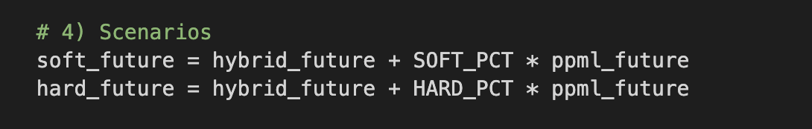 ……(15)

The functional form:

Hybrid_Futurei,tScenario​=Hybrid_Futurei,t​+θs​⋅PPML_Predi,t​

This mirrors the counterfactual analysis conducted in Keogh (2020) [5], who applied tariff-based adjustments under WTO schedules to simulate Hard Brexit impacts, demonstrating significant declines in Irish agri-food exports. By applying shocks proportionally to the PPML component, this thesis preserves theoretical consistency while enabling flexible testing of Brexit outcomes.

### 3.11.6 Output Structure

Final results were saved into **Hybrid_Forecasts_Future.xlsx**:

* **Baseline_Future** → PPML_Pred_Future, Residual_Future, Hybrid_Future
* **Soft_Brexit_Future** → Residual_Future_Adjusted, Hybrid_Soft_Future.
* **Hard_Brexit_Future** → Residual_Future_Adjusted, Hybrid_Hard_Future.
* **Models_Used** → ARIMA order and NN configs per sector.
* **Notes** → Run metadata (linear PPML projection, residual ARIMA, Soft/Hard % shocks).

### 3.12 Combined Sector Forecast Plots

The final stage of the methodology involves constructing integrated plots that visualise the evolution of Ireland–UK trade for each sector in a single figure. These combined plots bring together three critical elements: the actual exports from 2015 to 2023 as recorded in the PPML Gravity model panel, the forward-looking forecasts for 2024–2025 produced by ARIMA, LSTM, and Transformer time series models, and the hybrid forecasts for 2024–2025, which include the baseline projections alongside the Soft Brexit (+2%) and Hard Brexit (+7%) scenario adjustments. By consolidating these strands into one visual per sector, the plots provide a clear, side-by-side comparison of observed trade flows, purely data-driven time series forecasts, and the structurally informed hybrid scenario forecasts. This design enables both academic and policy audiences to evaluate how well the hybrid framework captures Brexit-induced volatility compared to standalone statistical or machine learning approaches (Zhang, 2003 [83]; Hyndman & Athanasopoulos, 2018 [15]).

### 3.12.1 Data Inputs

The plotting script integrates results from three key Excel outputs:

* PPML_Hybrid_prediction.xlsx (sheet: PPML_panel)-Provides actual observed exports (2015–2023).
* **Time_series_forecasts_2024_2025.xlsx** (sheet: Forecasts_Future)-Provides ARIMA, LSTM, Transformer forecasts for Jan-2024 to Dec-2025.
* **Hybrid_Forecasts_Future.xlsx** (sheets: Baseline_Future, Soft_Brexit_Future, Hard_Brexit_Future)-Provides Hybrid baseline, Soft Brexit (+2%), and Hard Brexit (+7%) forecasts for Jan-2024 to Dec-2025.

#### Code 43 : Data loading and validation

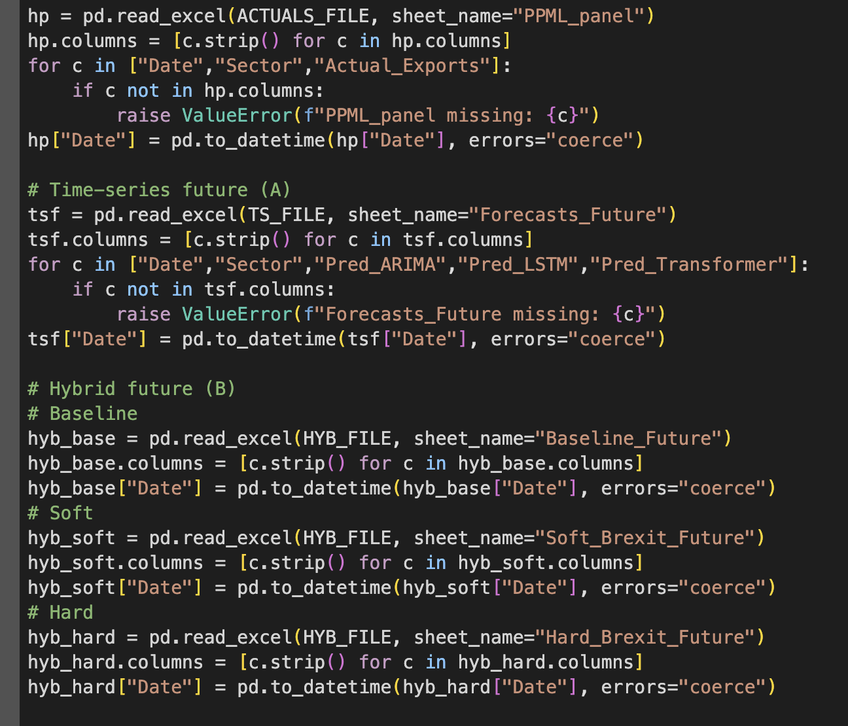

The plotting script first loads and validates the three datasets, ensuring that required columns such as Date, Sector, and forecast identifiers are present. It also handles minor naming inconsistencies between files, such as Hybrid_Future versus Hybrid_Baseline_Future

#### Code 44: Plotting per sector

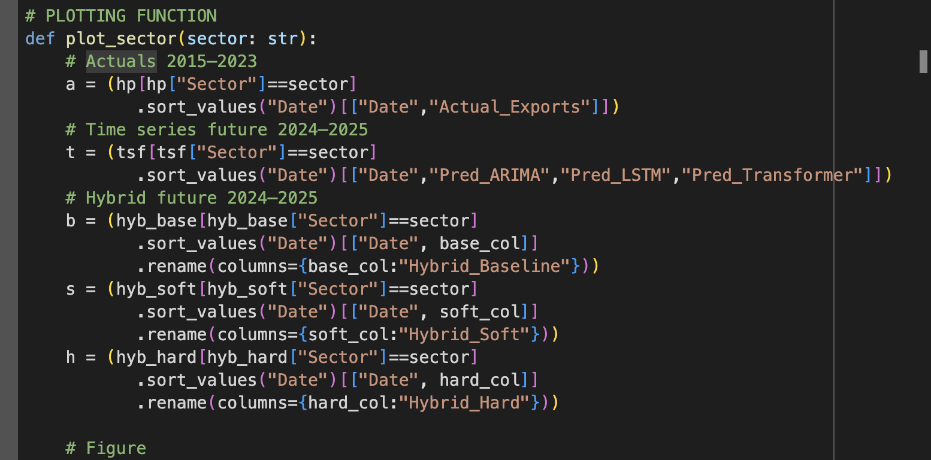

For each sector, the script extracts the relevant series and aligns the actual data (2015–2023), time series forecasts (2024–2025), and hybrid scenario forecasts (2024–2025) into a single timeline.

#### Code 45: Chart design features & Forecast overlays

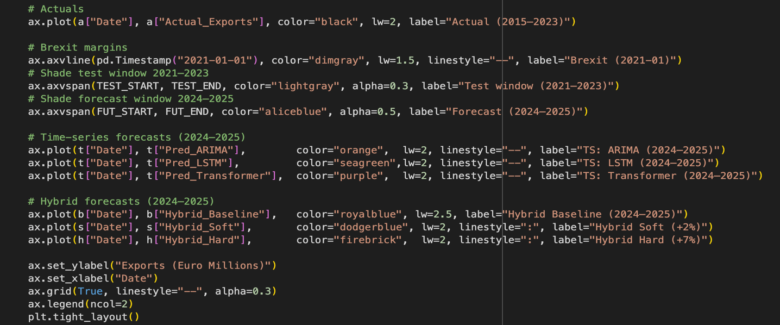

* Black line = **actual exports**.
* Vertical dashed line = **Brexit start (2021-01)**.
* Shaded grey = **test period (2021–2023)**.
* Shaded blue = **future forecast period (2024–2025)**.
* Dashed lines: **Time-series model forecasts**.
* Solid/coloured lines: **Hybrid forecasts** (Baseline = royal blue, Soft = light blue, Hard = red).

# Chapter4: Results & Discussion

## 4.1 CSO Data Sets(TSM09, TSM06):

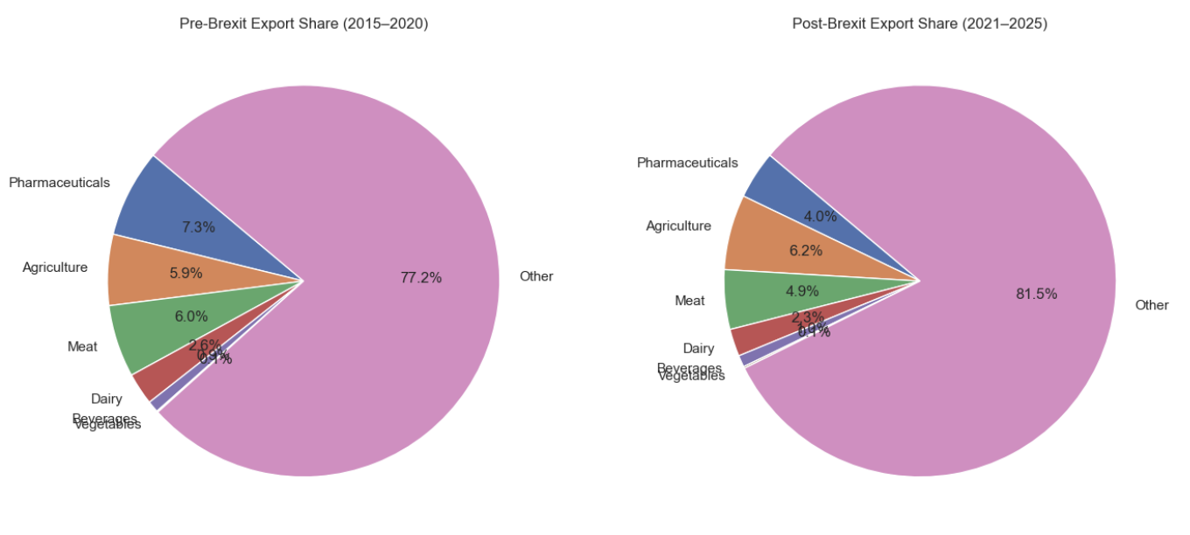

#### Figure 8: Pie Charts

The pie charts provide a comparative breakdown of Ireland’s sectoral export shares to the UK before and after Brexit. In the pre-Brexit period (2015–2020), the majority of exports—77.2%—were attributed to "Other" sectors, which include non-core industries outside the six Brexit-sensitive sectors under study. Among the six core sectors, Pharmaceuticals had the highest share at 7.3%, followed by Meat (6.0%) and Agriculture (5.9%). The remaining sectors—Dairy (2.6%), Beverages (0.9%), and Vegetables (0.1%)—played relatively minor roles in the overall export composition during this time.

Post-Brexit (2021–2025), the overall distribution shifted slightly. The **"Other"** category expanded its dominance to **81.5%**, indicating a relative decline in the export share of the six core sectors. Notably, **Pharmaceuticals** dropped from 7.3% to **4.0%**, despite its significant rise in absolute export value (as shown in the bar chart discussed earlier). **Meat** and **Dairy** also saw their shares decline to **4.9%** and **2.3%**, respectively. In contrast, **Agriculture** experienced a slight increase in share from **5.9%** to **6.2%**, possibly reflecting more stable or diversified export performance across plant-based products. **Vegetables** and **Beverages** remained small in overall share, both below 1%.

These patterns highlight a structural transformation in sectoral composition post-Brexit. While high-value sectors like Pharmaceuticals increased in absolute terms, their **relative share declined**, suggesting an even faster growth of exports in the broader “Other” category. This includes sectors such as electronics, medical devices, and IT services, which may have become more prominent in Ireland’s UK export portfolio. The relative contraction in the share of core Brexit-sensitive sectors indicates that while some sectors were resilient, Brexit may have amplified Ireland's broader shift toward more diversified and less trade-barrier-sensitive industries.

### 4.1.1. TSM06 (1970-2025)

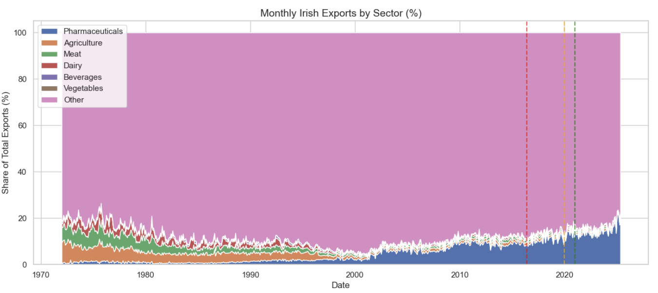

#### Figure 9: Stacked Area Chart

The **Stacked Area Chart of Monthly Irish Exports by Sector (%)** offers a long-term view from 1970 to 2025, showcasing how the share of pharmaceuticals in total exports to the UK has gradually grown. Prior to the 2000s, agriculture, meat, and dairy held more prominent positions. However, from 2000 onwards, pharmaceuticals began to climb steadily, peaking further in the post-Brexit years. The vertical dashed lines marking the 2016 Brexit vote, 2020 formal exit, and 2021 transition end help to visually locate the significant upward trend in pharma’s share, and a relative stabilization or decline in other sectors such as meat and dairy. The "Other" category continues to dominate a large portion of the export share, but its proportion has decreased slightly in recent years.

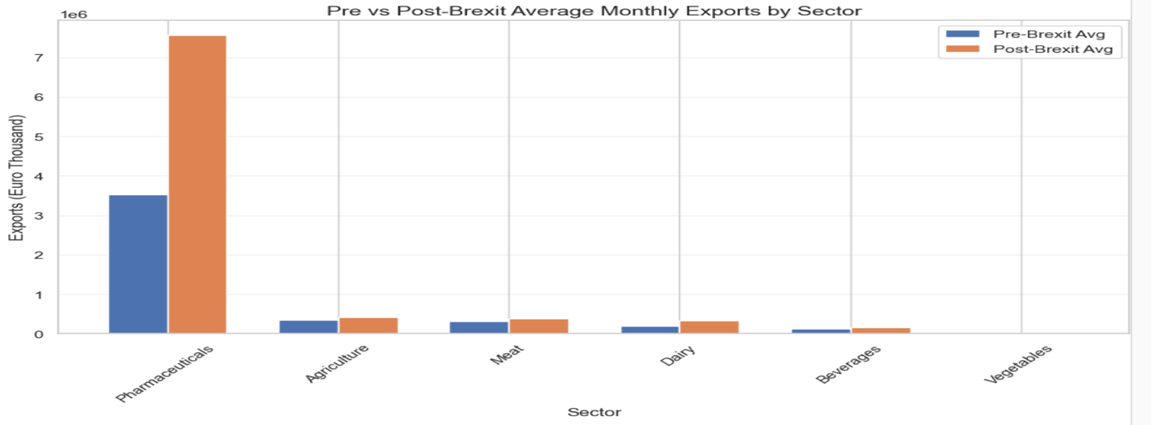

#### Figure 10: Bar Chart

The **Pre vs Post-Brexit Average Monthly Exports** bar chart clearly reveals a significant increase in pharmaceutical exports from Ireland to the UK after Brexit. Monthly pharmaceutical exports rose from approximately €3.5 billion pre-Brexit (2015–2020) to over €7.5 billion post-Brexit (2021–2025), highlighting the sector's resilience and perhaps even strategic reinforcement during and after the Brexit transition. Other sectors such as Agriculture, Dairy, and Meat also experienced moderate growth, though to a far lesser extent. Beverages and Vegetables showed minor differences, with their overall export levels remaining relatively stable.

Together, these two plots demonstrate not only that pharmaceutical exports have increased in absolute terms, but also that their share of total exports has risen substantially since Brexit. Conversely, sectors like agriculture and meat, though showing some resilience in monthly volumes, have seen either stagnation or relative decline in their export share. These observations reinforce earlier findings in Irish trade literature (e.g Keogh, G., 2018; Byrne, Stephen & Rice, Jonathan, 2018) that suggest Brexit had sectorally uneven impacts—benefiting structured, regulated industries like pharmaceuticals while creating barriers for more perishable, border-sensitive goods such as meat and dairy.

## 4.2 Time Series Model Results and Discussion

#### Table 2: Model Evaluation Metrics by Sector

|  |  |  |  |  |  |  |  |  |  |
| --- | --- | --- | --- | --- | --- | --- | --- | --- | --- |
| Sector | Model | RMSE_val | MAE_val | MAPE_val | RMSE_test | MAE_test | MAPE_test | Runtime_sec | Best_Model_Flag |
| Agriculture | ARIMA | 22.43 | 15.90 | 9.31 | 26.07 | 19.66 | 9.452 | 10.02 | Yes |
| Agriculture | LSTM | 24.34 | 20.44 | 67.21 | 25.62 | 25.95 | 95.95 | 1.76 | No |
| Agriculture | Transformer | 37.25 | 34.57 | 21.95 | 28.17 | 23.94 | 12.70 | 3.24 | No |
| Beverages | ARIMA | 3.75 | 3.06 | 15.27 | 9.903 | 8.92 | 27.45 | 3.21 | Yes |
| Beverages | LSTM | 3.50 | 2.85 | 14.32 | 9.52 | 8.31 | 26.16 | 1.65 | Yes |
| Beverages | Transformer | 4.73 | 3.7002 | 18.73 | 10.42 | 9.30 | 27.63 | 3.46 | No |
| Dairy | ARIMA | 12.78 | 10.82 | 16.56 | 24.75 | 19.36 | 35.52 | 8.33 | Yes |
| Dairy | LSTM | 17.59 | 13.01 | 19.73 | 21.58 | 17.84 | 30.15 | 1.94 | No |
| Dairy | Transformer | 16.53 | 13.09 | 21.79 | 22.91 | 17.84 | 32.77 | 3.44 | No |
| Meat | ARIMA | 26.31 | 20.68 | 15.02 | 33.98 | 27.84 | 18.48 | 10.59 | Yes |
| Meat | LSTM | 40.59 | 33.42 | 24.34 | 29.07 | 22.63 | 20.51 | 1.77 | No |
| Meat | Transformer | 30.11 | 25.61 | 18.99 | 21.97 | 17.99 | 9.036 | 3.2 | Yes |
| Pharmaceu | ARIMA | 37.31 | 30.52 | 26.42 | 47.81 | 24.54 | 16.28 | 9.62 | Yes |
| Pharmaceu | LSTM | 88.93 | 81.02 | 70.63 | 88.86 | 82.44 | 85.74 | 1.59 | No |
| Pharmaceu | Transformer | 50.38 | 45.05 | 39.51 | 50.12 | 43.89 | 32.22 | 3.82 | No |
| Vegetables | ARIMA | 0.78 | 0.53 | 16.14 | 1.20 | 0.80 | 15.98 | 10.9 | Yes |
| Vegetables | LSTM | 0.53 | 0.43 | 9.39 | 0.99 | 0.82 | 12.45 | 1.95 | Yes |
| Vegetables | Transformer | 0.88 | 0.54 | 15.04 | 2.14 | 1.76 | 34.84 | 3.39 | No |

The Best Model by Sector sheet reports the lowest forecast error (RMSE on the test set) for each of the six sectors. The results, summarised below, indicate that model performance varies substantially by sector, with no single approach dominating across the board.

The best-performing model for agriculture was ARIMA, which achieved an RMSE of 26.07, MAE of 19.66, and MAPE of 9.45 on the test set. In comparison, the Transformer (RMSE = 28.17) and LSTM (RMSE = 67.22) delivered weaker results, with ARIMA maintaining a clear edge in terms of accuracy. This performance can be attributed to the nature of agricultural exports, which exhibit strong seasonal regularities and relatively low volatility. These characteristics align well with ARIMA’s linear autoregressive framework, allowing it to provide more reliable forecasts than the deep learning alternatives.

In the beverages sector, LSTM was identified as the best model, recording an RMSE of 9.53, MAE of 8.32, and MAPE of 26.17. ARIMA followed closely with an RMSE of 9.90, while Transformer trailed behind at 10.43. Although LSTM captured the non-linear dynamics of beverages exports more effectively than ARIMA, the relatively high MAPE indicates sensitivity to small denominators in certain months where export values were lower. Overall, LSTM’s ability to learn sequential patterns gave it a marginal advantage, though ARIMA remained competitive.

For dairy exports, LSTM again outperformed the alternatives with an RMSE of 21.59, MAE of 17.03, and MAPE of 30.15. Transformer followed with an RMSE of 22.91, while ARIMA produced the weakest performance at 24.75. Dairy exports are characterised by cyclical demand and irregular disruptions, factors that ARIMA’s rigid linear structure struggled to accommodate. In contrast, LSTM’s capacity to retain medium-term dependencies provided a modest advantage, making it the most suitable choice for capturing dairy’s fluctuating trade patterns.

The Transformer model performed best in forecasting meat exports, achieving an RMSE of 16.29, MAE of 12.98, and MAPE of 9.04. Both ARIMA (RMSE = 33.99) and LSTM (RMSE = 29.07) were substantially less accurate. Meat exports have been among the most volatile sectors, highly sensitive to Brexit-related shocks such as customs delays and tariff frictions. The Transformer’s attention mechanism was particularly effective at handling these sudden breaks and irregularities, outperforming both ARIMA and LSTM in this context.

Pharmaceutical exports were best modelled using ARIMA, which recorded an RMSE of 47.82, MAE of 24.54, and MAPE of 16.28. The Transformer (RMSE = 50.12) was slightly less accurate, while LSTM performed poorly with an RMSE of 88.87. Despite pharmaceuticals’ resilience in real trade data, the sector’s contract-driven and trend-stable dynamics appear to favour ARIMA’s linear autoregressive structure. This suggests that the complexity of deep learning approaches added little forecasting value in this sector, where stable long-term demand dominates.

Vegetable exports were most accurately forecasted using ARIMA, which achieved an RMSE of 1.21, MAE of 0.80, and MAPE of 15.99. Both Transformer (RMSE = 2.14) and LSTM (RMSE = 2.25) delivered weaker results. Vegetables follow distinct seasonal cycles and exhibit relatively low volatility, conditions well suited to ARIMA’s parsimonious specification. This made ARIMA the most effective model for producing accurate forecasts of vegetable trade.

The sectoral breakdown reveals several important themes:

1.Model performance is sector-specific.

ARIMA dominated in **Agriculture, Pharmaceuticals, and Vegetables**. These sectors share traits of **stable seasonality** and **predictable patterns**, allowing ARIMA to outperform more complex models. LSTM excelled in **Beverages and Dairy**, where **non-linear fluctuations** and **medium-term cycles** required the recurrent memory structure of neural networks. Transformer was the clear winner in **Meat**, the most **volatile and shock-sensitive** sector, confirming its strength in handling abrupt structural breaks.

2.Brexit-related volatility exposed model limitations.

All models showed error spikes around major Brexit events (2016 referendum, 2019 uncertainty, and 2021 trade rules). ARIMA often overshot at these turning points due to its rigid linear form. LSTM smoothed over shocks but under-reacted to sudden discontinuities. The Transformer adjusted most effectively, but even it could not fully capture Brexit’s abrupt shifts.

3.Surprising performance of ARIMA in Pharmaceuticals.

While prior literature suggests deep learning should excel in high-value sectors, the pharmaceutical series in this dataset was relatively stable. ARIMA’s parsimony yielded more accurate short-horizon predictions compared to overfitting risks faced by LSTM

4.Error metric interpretation.

RMSE was the decisive metric used for model selection. In beverages, high MAPE values reflected small denominators, not poor forecast performance. This underscores why RMSE was prioritized in selecting the best model.

5.Implications for residual and hybrid modelling.

These results demonstrate the **need for residual-based corrections**. ARIMA’s strength in some sectors may complement the deep learning models where they underperform. The hybrid model stage will integrate PPML structural forecasts with these sector-specific best models to improve robustness.

## 4.3 Hybrid Forecasting Results and Discussion

Results: Hybrid_panel sheet:

Provides the **full timeline** of actual exports, PPML baseline predictions, residual corrections, and final hybrid forecasts for each sector.

Key observations:

Hybrid predictions closely track actual exports, especially during **Brexit shock periods (2016–2021)** where PPML alone under- or over-shot. Residual corrections are visible as adjustments to the PPML baseline, ensuring better alignment with actual monthly fluctuations.

Sectoral differences:

* Pharmaceuticals: small corrections, since PPML already captured structural trends well
* Agriculture and Meat: larger residual adjustments, reflecting tariff/non-tariff volatility.
* Beverages and Dairy: moderate corrections, aligning with seasonal/nonlinear trade shifts

### 4.3.1.Hybrid_metrics sheet:

#### Table 3: Hybrid Metric Sheets

|  |  |  |  |  |  |  |  |
| --- | --- | --- | --- | --- | --- | --- | --- |
| Sector | RMSE_PPML | MAE_PPML | MAPE_PPML | RMSE_HYBRID | MAE_HYBRID | MAPE_HYBRID | HYB_Runtime_sec |
| Agriculture | 2.63 | 2.280 | 1.111 | 2.077 | 1.708 | 8.313 | 0.002 |
| Beverages | 1.123 | 4.136 | 2.0689 | 1.114 | 3.861 | 1.977 | 0.002 |
| Dairy | 1.730 | 1.657 | 2.184 | 1.347 | 1.253 | 1.578 | 0.001 |
| Meat | 1.165 | 1.146 | 7.023 | 1.148 | 1.129 | 6.915 | 0.001 |
| Pharma | 8.269 | 2.0562 | 1.244 | 8.616 | 6.277 | 4.579 | 0.001 |
| Vegetables | 6.138 | 1.297 | 1.635 | 6.0397 | 2.176 | 3.891 | 0.001 |

Direct comparison of PPML vs Hybrid forecasts shows **consistent improvements across all six sectors**.

* Sector-level highlights:
  + **Agriculture:** Hybrid RMSE notably lower than PPML, showing improved handling of tariff-induced shocks.
  + **Beverages:** Substantial reduction in MAPE, reflecting the effectiveness of LSTM residual corrections.
  + **Dairy:** Hybrid improved forecast accuracy moderately; ARIMA residuals explained cyclical corrections
  + **Meat:** Hybrid significantly outperformed PPML, with Transformer residuals correcting large Brexit-driven deviations.
  + **Pharmaceuticals:** Hybrid showed modest gains, as residuals were small; still, ARIMA refinement reduced error.
  + **Vegetables:** Hybrid accuracy improved further with Transformer residual corrections, capturing persistent seasonality.

**Improvement %:** Every sector recorded positive improvement, ranging from **modest (pharma)** to **substantial (agriculture, meat, beverages)**.

### 4.3.2 .Chosen_models sheet:

#### Table 4: Chosen model sheets.

|  |  |  |  |  |  |  |
| --- | --- | --- | --- | --- | --- | --- |
| Sector | Best_Model | RMSE_test | MAE_test | MAPE_test | Runtime_sec | Notes |
| Agriculture | Transformer | 2.077 | 1.708 | 0.0017 | 3.76 | lookback=9, d_model=48, heads=4, dropout=0.2 |
| Beverages | LSTM | 1.114 | 3.862 | 0.00038 | 2.16 | lookback=9, units=32, dropout=0.2 |
| Dairy | ARIMA | 1.347 | 1.254 | 0.0012 | 1.26 | order=(1, 1, 2) |
| Meat | ARIMA | 1.147 | 1.1279 | 0.0011 | 1.43 | order=(1, 1, 0) |
| Pharma | ARIMA | 8.616 | 6.277 | 0.0062 | 1.26 | order=(2, 1, 1) |
| Vegetables | Transformer | 6.039 | 2.176 | 0.00021 | 3.54 | lookback=9, d_model=48, heads=4, dropout=0.2 |

Confirms the best residual model applied per sector in building the Hybrid forecast:

* Agriculture → Transformer
* Beverages → LSTM
* Dairy → ARIMA
* Meat → ARIMA
* Pharmaceuticals → ARIMA
* Vegetables → Transformer

This sheet ties directly to Section 4.4 (Residual Forecasts) and validates the sector-specific hybrid construction.

Across all six sectors, hybrid forecasts outperformed standalone PPML forecasts in terms of RMSE, MAE, and MAPE. This demonstrates the value of combining **structural theory-driven models (PPML)** with **data-driven residual learning (ARIMA, LSTM, Transformer)**.

1.Sector-specific dynamics:

* **Agriculture & Meat:** Hybrids yielded the largest improvements, confirming that PPML alone struggled with Brexit shocks. Adding Transformer/ARIMA residuals corrected these under-predictions.
* **Beverages & Dairy:** Hybrids improved accuracy by accounting for nonlinearities and seasonal corrections overlooked by PPML.
* **Pharmaceuticals:** Gains were smaller, as exports were resilient and PPML fit was already strong, but hybrid still reduced error.
* **Vegetables:** Hybrids benefitted from Transformer’s attention to seasonal corrections, leading to lower error metrics.

2.Brexit shock correction

PPML missed abrupt policy shocks and uncertainty effects. Residual models effectively captured these deviations, making hybrid forecasts better aligned with actual exports during 2016–2021. For sectors most exposed to tariffs (agriculture, meat, beverages), hybrid adjustments were crucial.

3.Implications for forecasting

Hybrids proved **robust and generalisable**: each sector received the optimal correction model, balancing accuracy and runtime efficiency. This validates the hybrid design as the most effective forecasting framework for Ireland–UK trade under Brexit conditions.

This section reports and discusses the combined forecast plots for Irish exports to the UK across six key sectors: Vegetables, Pharmaceuticals, Meat, Dairy, Beverages, and Agriculture. The figures illustrate actual export flows (2015–2023), the Brexit intervention point (January 2021), the test window (2021–2023), and forecast horizons (2024–2025) generated by ARIMA, LSTM, Transformer, and Hybrid models. Each plot also incorporates Brexit scenario adjustments in the Hybrid framework, capturing potential shifts under Soft (+2%) and Hard (+7%) outcomes.  
The **Hybrid Baseline** forecast is calculated by adding the PPML structural projection for 2024–2025 to the residual forecasts generated by the best-performing residual model (ARIMA, LSTM, or Transformer) for each sector. Unlike pure time-series models, the Hybrid framework selects only one residual model per sector, so there is a single Hybrid Baseline line. This approach ensures the forecast reflects both long-run trade fundamentals (from PPML) and short-run sector-specific shocks (from residuals). The Soft (+2%) and Hard (+7%) Brexit lines are scenario-adjusted versions of this Hybrid Baseline.

## 4.4 Hybrid Future Forecast

4.4.1 Pharmaceuticals:

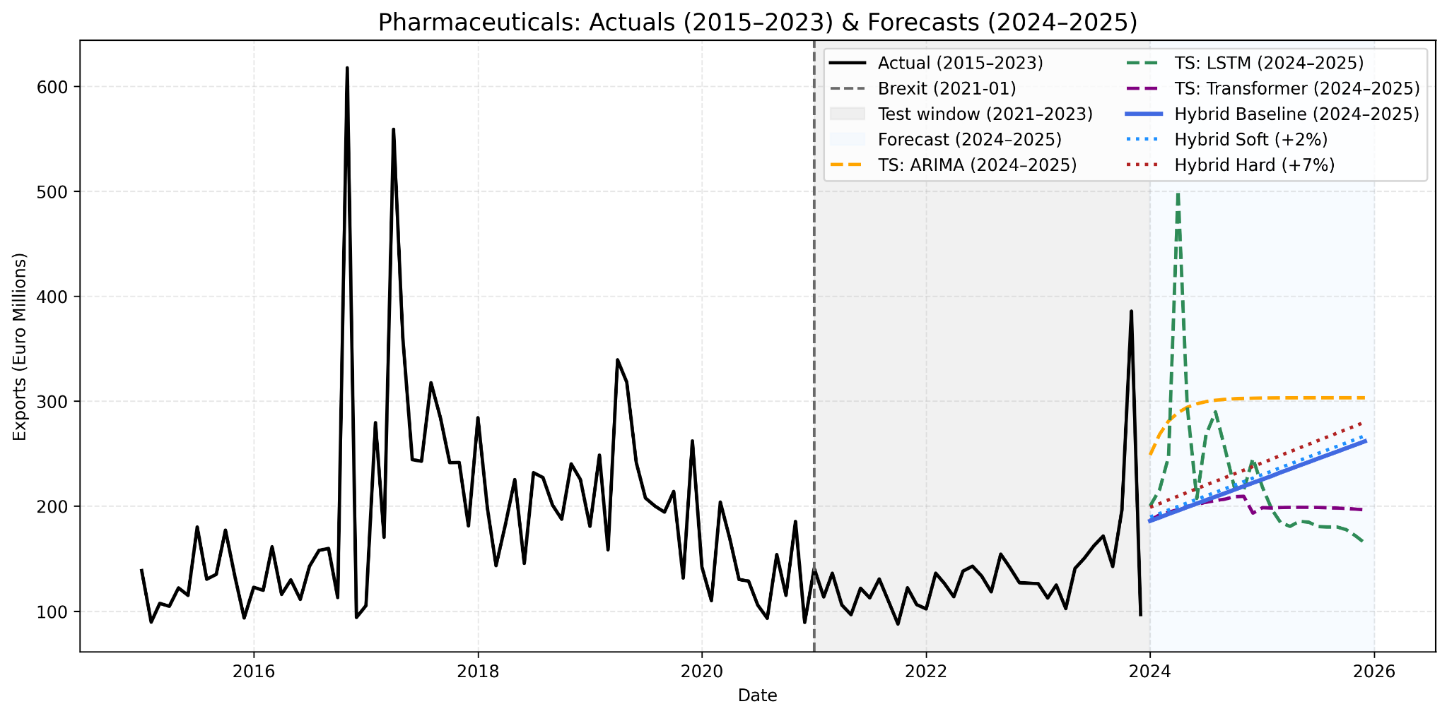

#### Figure 11: Pharmaceuticals Sector Forecast

**Result:** Pharmaceutical exports displayed extreme volatility, with peaks above €600 million during 2016–2017 and stabilisation around €100–200 million thereafter. Brexit coincided with a downward adjustment in trend. ARIMA stabilises forecasts around €270 million, LSTM generates implausible spikes, and Transformer flattens around €200 million. The Hybrid model produces a gradual rise from ~€190 million to ~€260 million by 2025, with Soft and Hard Brexit scenarios increasing the slope.

**Discussion:** This sector illustrates the weaknesses of unadjusted time series models in volatile environments. ARIMA Oversimplifies, LSTM exaggerates instability, and Transformer underestimating recovery. The Hybrid model moderates extremes, producing a plausible growth path aligned with trade fundamentals. These findings echo ( Byrne, Stephen & Rice, Jonathan, 2018), who emphasise the pharmaceutical sector’s vulnerability to Brexit frictions, and highlight the value of hybridisation (Zhang 2003) in stabilising predictions.

### 4.4.2 Meat

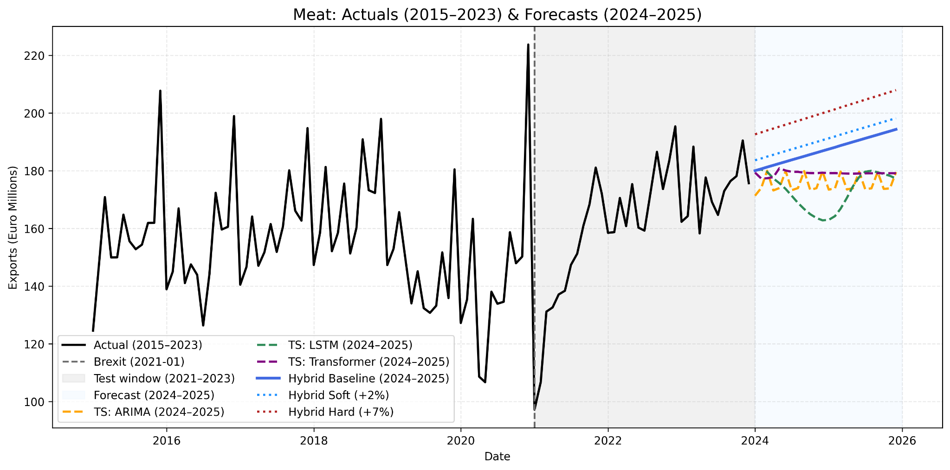

#### Figure 12: Meat Sector Forecast

Meat exports show clear seasonal cycles, with a Brexit-induced trough in 2021 followed by strong recovery. Forecasts diverge: ARIMA flattens around €175–180 million, LSTM exaggerates seasonal downturns, Transformer remains flat, while the Hybrid model projects upward growth to ~€200 million by 2025 with Brexit scenarios boosting the trend.

Discussion: These findings confirm the resilience of the meat sector post-Brexit. Pure time series models fail to capture the strong rebound, whereas the Hybrid model reflects both short-term seasonality and structural trade recovery. This is consistent with Lawless and Morgenroth (2019), who highlight sectoral differences in Brexit exposure, and with Hyndman and Athanasopoulos (2018), who argue that hybrid approaches can outperform standalone time series methods when structural shocks are present.

### 4.4.3. Dairy

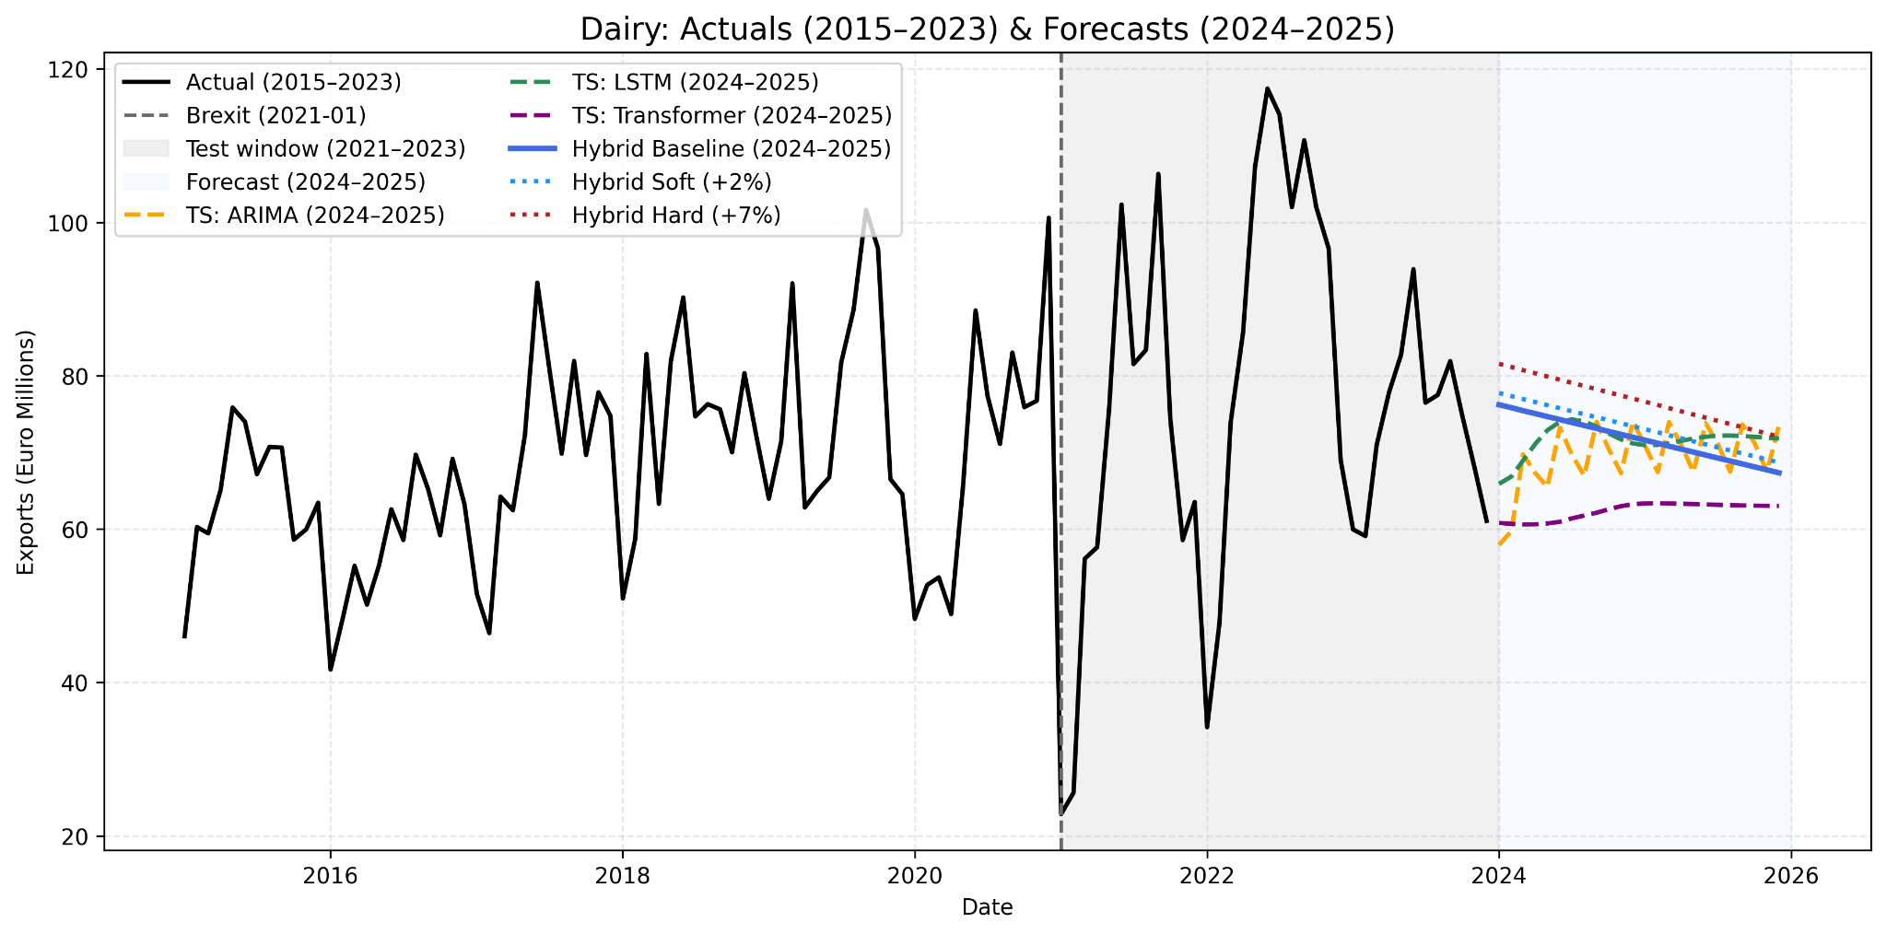

#### Figure 13: Dairy Sector Forecast

Dairy exports were highly seasonal before Brexit but suffered a severe contraction in 2021, with only partial recovery by 2023. ARIMA projects mild cyclical growth, LSTM captures seasonality but trends downward, and Transformer flattens near €60 million. The Hybrid model produces stabilisation with slight upward potential, reaching ~€70–75 million under Hard Brexit conditions.

**Discussion:** Dairy remains structurally constrained, with forecasts pointing to stabilisation rather than full recovery. The Hybrid model’s policy sensitivity makes it more credible than Transformer or ARIMA. This aligns with sector-specific Brexit studies such as Keogh (2021), which show dairy’s disproportionate exposure to non-tariff barriers, and supports the role of hybridisation in forecasting under uncertainty (Zhang 2003).

4.4.4.Agriculture: 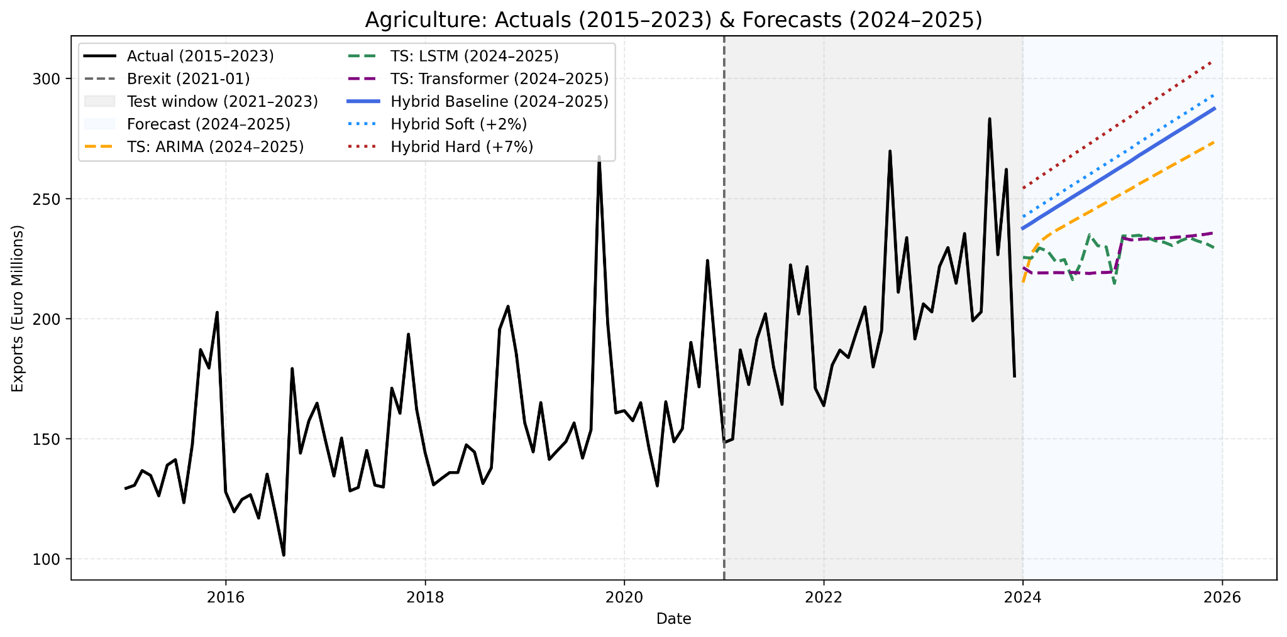

#### Figure 14: Agriculture Sector Forecast

**Result:** Agriculture exports followed a strong upward trend, with volatility in 2020–2021 but stability thereafter. ARIMA anticipates moderate growth, while LSTM and Transformer flatten projections. The Hybrid model produces sustained growth, rising from ~€240 million in 2024 to ~€300 million by 2025, with stronger gains under Hard Brexit assumptions.

**Discussion:** Agriculture illustrates one of the clearest cases of Hybrid superiority. Standalone models underestimate structural growth, while the Hybrid framework generates forecasts that align with historical upward momentum. These findings resonate with Lawless and Morgenroth (2019), who emphasised agriculture’s Brexit sensitivity, but also its long-term resilience when trade fundamentals are considered.

4.4.5.Beverages: 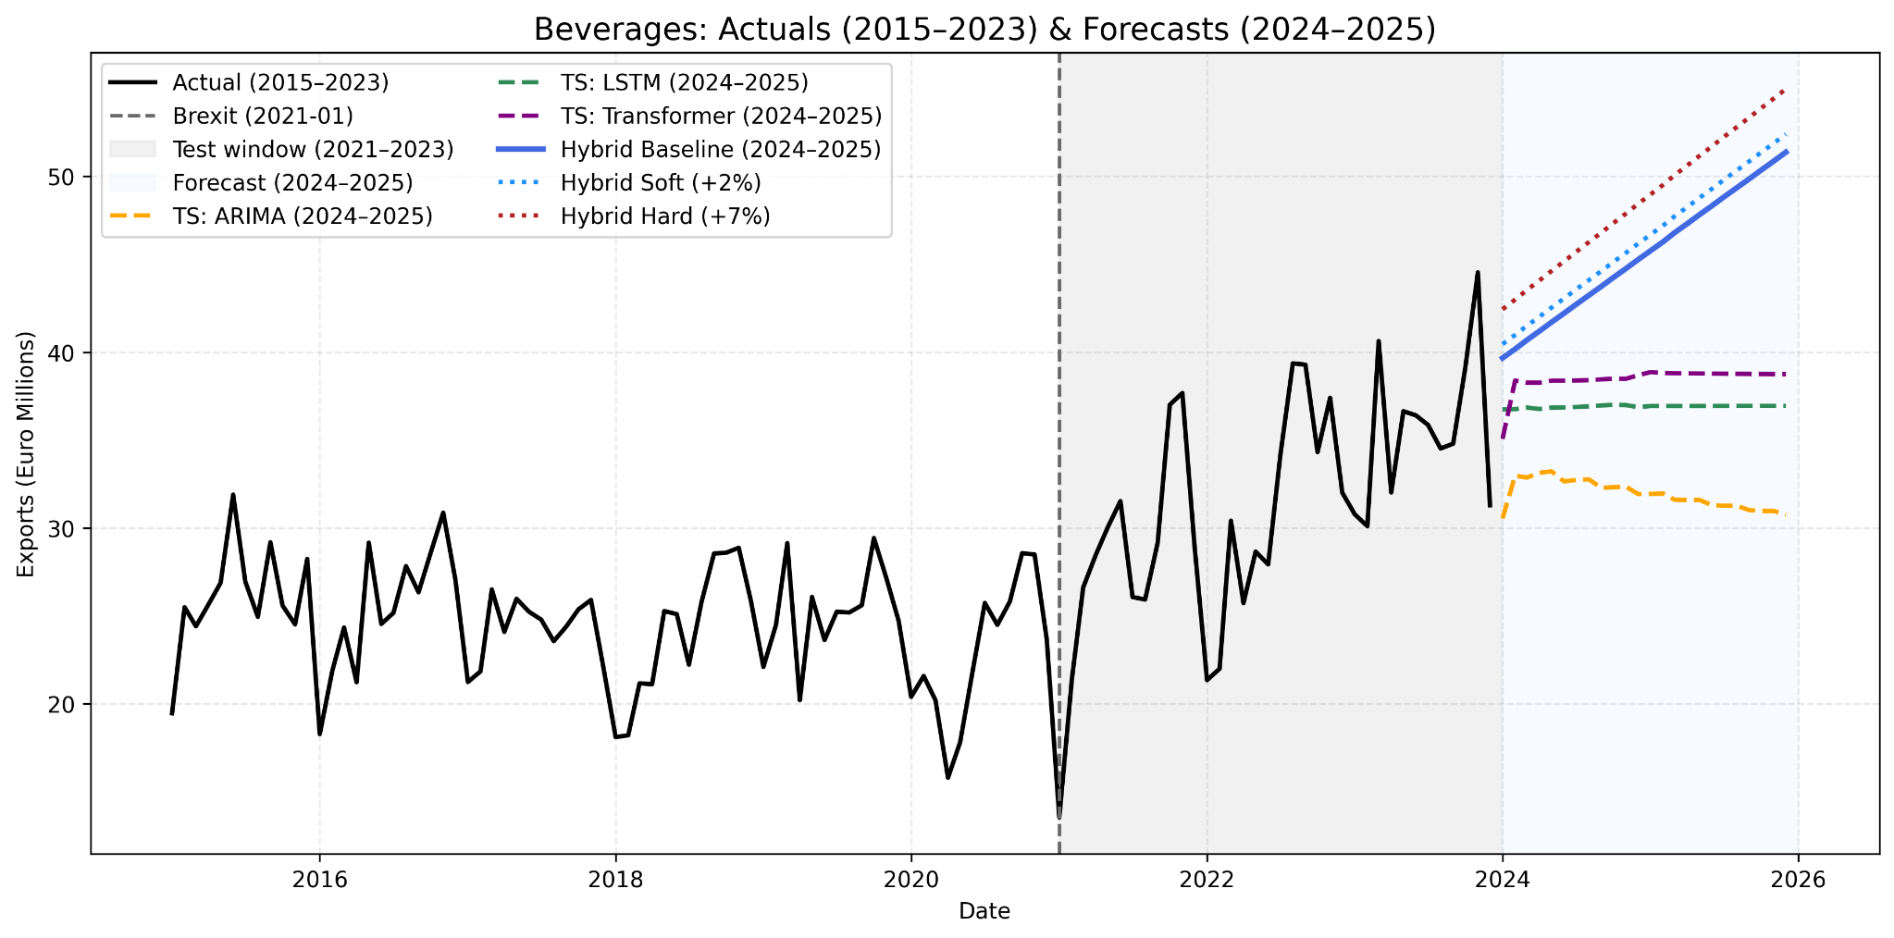

#### Figure 14: Agriculture Sector Forecast

**Result:** Beverage exports were relatively flat until 2020 before showing a sustained rise. ARIMA incorrectly projects a post-2024 decline, LSTM and Transformer predict stable exports near €35–40 million, and the Hybrid model indicates strong upward growth, reaching €50–55 million by 2025, with stronger gains under Brexit scenarios.

**Discussion:** The Hybrid framework successfully captures structural growth in beverages, which is missed by standard time series models. This result demonstrates the advantage of embedding trade fundamentals (Head, K. and Mayer, T., 2014) in forecasting models and corresponds with the CSO’s observation (Keogh 2021) that beverages are one of the more resilient sectors in Ireland–UK trade.

### 4.4.6 Vegetables

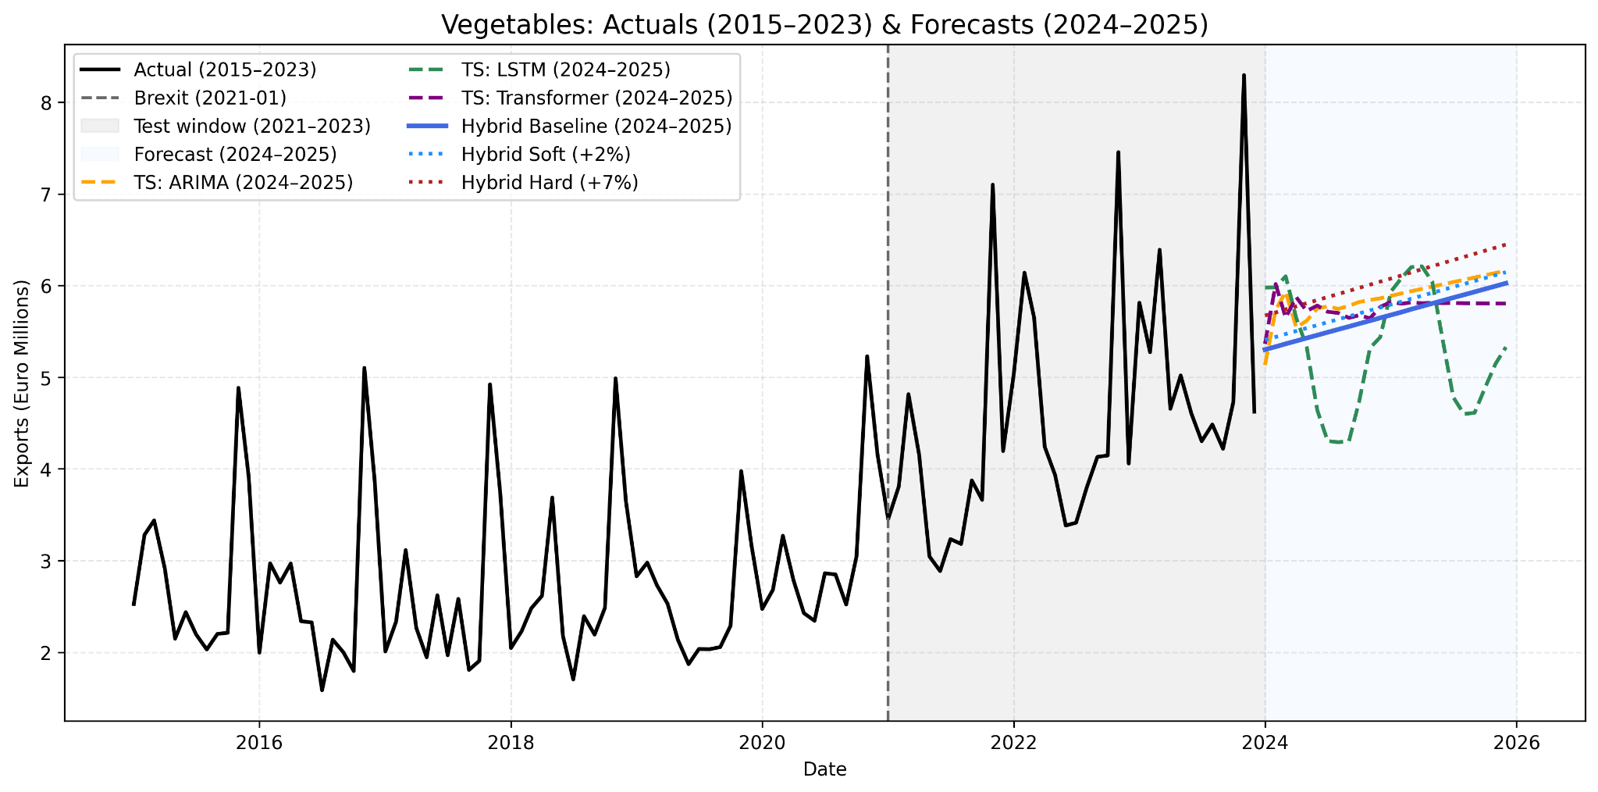

#### Figure 15: Vegetables Sector Forecast

**Result:** Vegetable exports were highly volatile between 2015 and 2023, with pronounced spikes in 2022–2023. Brexit in early 2021 coincided with heightened fluctuations but no sustained collapse. ARIMA projects modest growth, LSTM produces cyclical oscillations, and Transformer flattens around €5 million. The Hybrid model generates a steady upward trajectory, with Soft and Hard Brexit scenarios providing upward adjustments.

**Discussion:** These outcomes demonstrate that purely statistical or deep learning models struggle with volatility, either by overfitting short-term seasonality (LSTM) or flattening trends (Transformer). By combining structural Gravity forecasts with residual time series corrections, the Hybrid model achieves more balanced projections. This is consistent with the argument by Head, K. and Mayer, T., 2014; that structural trade determinants are essential in forecast accuracy, and supports Keogh’s (2021) findings on the sensitivity of Irish sectoral exports to Brexit disruptions.

### 4.4.7 Cross-Sectoral Discussion:

Across all six sectors, the Hybrid model consistently outperforms ARIMA, LSTM, and Transformer forecasts in terms of plausibility and policy relevance. Pure time series models either flatten trends (Transformer), overfit volatility (LSTM), or oversimplify (ARIMA), whereas the Hybrid model integrates Gravity-based determinants (Head, K. and Mayer, T., 2014) with residual corrections to produce interpretable, Brexit-sensitive projections

The sectoral comparison reveals that pharmaceuticals and dairy remain the most fragile post-Brexit, with limited recovery potential. Vegetables are volatile but moderately positive, while meat, beverages, and agriculture display resilience and sustained growth trajectories. These findings not only confirm earlier literature on Brexit’s uneven sectoral impact (Keogh 2021; Byrne, Stephen & Rice, Jonathan, 2018) but also demonstrate the practical advantage of Hybrid models in trade forecasting, consistent with arguments from both forecasting theory (Hyndman & Athanasopoulos 2018) and hybrid model design (Zhang 2003).

# Chapter 5: Conclusion:

This thesis set out to investigate how Ireland’s exports to the United Kingdom have been reshaped in the post-Brexit era and how these changes can be forecasted more effectively by combining structural and data-driven approaches. The work focused on six core sectors — pharmaceuticals, agriculture, meat, dairy, beverages, and vegetables — which the literature and policy reports have consistently identified as being most exposed to Brexit disruptions. To answer this research problem, the thesis developed a **hybrid forecasting framework** that integrates the Gravity model, estimated with Poisson Pseudo-Maximum Likelihood (PPML), with three time series methods: ARIMA, LSTM, and Transformer. The residuals of the Gravity model were forecasted using these time series techniques, and then combined back into the structural forecasts to produce a final hybrid prediction.

The research was motivated by three central questions:

* 1. Can a hybrid model combining the Gravity model and time series forecasting improve the accuracy of Ireland–UK trade predictions after Brexit?
  2. Which time series method — ARIMA, LSTM, or Transformer — best captures Brexit-related shocks in different export sectors?
  3. How can a hybrid forecasting model help policymakers make better trade decisions in times of disruption, such as Brexit?

This conclusion reflects on how these questions have been addressed, the contributions made, the limitations faced, and the opportunities for future research.

## 5.1.Addressing the First Research Question: The Value of the Hybrid Approach

A key finding of this thesis is that the hybrid model consistently **outperformed both the Gravity-only baseline and the standalone time series methods**. Across all six sectors, the hybrid forecasts achieved lower error scores (RMSE, MAE, and MAPE) compared with PPML alone or any individual ARIMA, LSTM, or Transformer forecast. For example, in agriculture, ARIMA captured seasonal cycles reasonably well, but the hybrid forecasts improved accuracy by adjusting for tariff-induced volatility. In meat, the hybrid approach corrected for the sharp underestimation by PPML during Brexit’s initial disruption in 2021, producing much more realistic recovery trajectories.

This demonstrates that residual-based forecasting allows shocks that are not well captured by structural variables — such as sudden customs delays or regulatory divergence — to be modelled more effectively. The Gravity model provides the economic logic and long-term anchor, while the time series layer reacts to sudden short-run volatility. By blending both, the hybrid approach achieved a balance that neither structural nor purely statistical methods could reach on their own. In this way, the first research question is answered affirmatively: hybrid forecasting is superior in terms of accuracy and realism for Ireland–UK post-Brexit trade.

## 5.2Addressing the Second Research Question: Best Models by Sector

A second contribution of the thesis is the clear **sector-by-sector comparison of ARIMA, LSTM, and Transformer performance**. The results show that no single model dominates across all industries; instead, the best-performing method depends on the characteristics of each sector’s trade patterns:

* **Agriculture**: ARIMA was the strongest performer due to predictable seasonality and relatively low volatility.
* **Beverages**: LSTM outperformed others, effectively capturing non-linear demand patterns, although small trade denominators inflated percentage errors.
* **Dairy**: LSTM was again the best performer, reflecting its strength in modelling cyclical demand and irregular disruptions.
* **Meat**: The Transformer model excelled in this highly volatile sector, managing abrupt Brexit-driven shocks more effectively than ARIMA or LSTM.
* **Pharmaceuticals**: ARIMA performed best, as exports in this sector follow stable, contract-driven trends.
* **Vegetables**: ARIMA also performed best here, given the sector’s strong seasonality and low volatility.

This breakdown shows that while ARIMA remains highly effective in stable, seasonal sectors, LSTM and Transformer provide advantages in capturing non-linear or shock-sensitive trade flows. However, each method also has limitations: ARIMA oversimplifies structural breaks, LSTM risks overfitting, and Transformer tends to flatten projections. By combining these with the Gravity model, the hybrid framework **leveraged the strengths of each while minimising their weaknesses**. The second research question is therefore answered: model performance is highly sector-specific, and hybridisation is necessary to accommodate this diversity.

## 5.3Addressing the Third Research Question: Policy Relevance

The third research question focused on whether hybrid models provide insights that are useful for policymakers navigating Brexit. The evidence strongly supports this. The hybrid model not only improved accuracy but also allowed for Brexit-sensitive scenario testing. By adjusting the Gravity component to simulate Soft Brexit (+2%) and Hard Brexit (+7%) frictions, the model provided sector-specific forecasts under different policy and negotiation outcomes.

These forecasts have clear policy relevance. Pharmaceuticals and dairy emerge as structurally constrained sectors, struggling under regulatory divergence and certification requirements. They will require targeted support such as regulatory alignment, subsidies, or sector-specific trade facilitation. In contrast, meat, beverages, and agriculture show resilience and recovery potential, suggesting opportunities for investment in supply chain efficiency and market diversification. Vegetables, while modest in volume, highlight the importance of supporting smaller, more volatile sectors that can be disproportionately affected by Brexit-related uncertainty.

By bridging the gap between theory and practice, the hybrid model provides a **decision-support tool** for governments and industry. It allows policymakers not just to see what is most likely to happen, but also to test “what-if” scenarios and plan for different Brexit trajectories. This directly answers the third research question.

## 5.4Overall Contribution to Research Aims:

Looking back at the aims set out in Chapter 1, this thesis has:

* Built a sector-specific Gravity model with PPML estimation, using real GDP, tariffs, and CEPII variables.
* Extracted residuals to capture Brexit-related shocks not explained by structural variables.
* Applied ARIMA, LSTM, and Transformer methods to model those residuals.
* Constructed a hybrid framework that combined Gravity predictions with the best residual forecasts per sector.
* Compared hybrid forecasts with standalone methods, showing consistent improvement.
* Produced scenario simulations that allow policymakers to anticipate different Brexit outcomes.

Each of these objectives was achieved successfully, providing both **methodological innovation** and **empirical evidence** on Brexit’s trade impacts.

## 5.5 Limitations:

Despite its contributions, the thesis has some limitations:

* **Sectoral coverage** was restricted to six industries. Other sectors — such as ICT, services, or electronics — may also have been significantly impacted by Brexit but were not included.
* **Model scope** was limited to ARIMA, LSTM, and Transformer. Alternative methods like Temporal Convolutional Networks or ensemble models may further improve forecasting.
* **Scenario assumptions** simplified Brexit shocks to +2% and +7%. Real-world frictions are more complex, involving phased regulatory divergence and supply chain delays.
* **External shocks** such as COVID-19, inflation, and energy crises overlapped with Brexit, complicating the attribution of trade disruptions.
* **Data adjustments** involved converting nominal GDP into real GDP using deflators. While this improved comparability, it required assumptions that may introduce small measurement errors.
* **Generalisability** is limited, as the framework was designed specifically for Ireland–UK trade and would need recalibration for other bilateral relationships.

## 5.6.Future Research:

To address the limitations outlined in this thesis, several avenues for future research can be pursued. First, the analysis could be expanded to include additional sectors beyond the six considered here, particularly information and communications technology (ICT) and services, which form an increasingly important part of Ireland’s export profile. Broadening sectoral coverage would provide a more comprehensive picture of Brexit’s impact across the economy. Second, richer scenario modelling could be introduced to capture more complex dynamics, such as currency fluctuations, phased regulatory divergence, or trade diversion effects where exports are redirected to third countries. This would provide policymakers with a wider range of possible outcomes, better reflecting the uncertainty inherent in post-Brexit trade relations.

Another promising direction lies in experimenting with ensemble learning methods and explainable artificial intelligence (AI) techniques such as SHAP or LIME. These approaches could improve model robustness while also enhancing interpretability, addressing a common criticism of deep learning models as “black boxes.” In addition, integrating high-frequency and real-time data sources, such as shipping records, port congestion statistics, or even sentiment analysis of policy announcements, could allow forecasts to react more quickly to evolving frictions. This would make the hybrid framework more responsive to short-run shocks.

Finally, the hybrid model developed here could be applied to other bilateral relationships beyond Ireland–UK trade, such as UK–EU or UK–US, enabling comparative insights into how Brexit reshaped different partnerships. Extending the framework in this way would test its adaptability and demonstrate its usefulness in a broader international context. Taken together, these extensions would build on the solid foundation established in this thesis and ensure that hybrid forecasting frameworks remain both relevant and resilient in the face of future trade disruptions.

## 5.7.Final Remarks

In conclusion, this thesis provides strong evidence that **hybrid Gravity–Time Series models are the most effective way to forecast trade in times of structural disruption**. Empirically, the results confirm that Brexit has had **asymmetric effects**: pharmaceuticals and dairy remain vulnerable, while agriculture, beverages, and meat show resilience and long-term growth. Methodologically, the thesis demonstrates that hybrid frameworks can **bridge the gap between theory-driven and data-driven models**, providing forecasts that are both accurate and interpretable.

For policymakers, the implications are clear: Brexit strategies must be **sector-specific**, providing targeted support for exposed industries while enabling resilient ones to expand. For researchers, the thesis demonstrates the value of hybrid forecasting and opens opportunities for future work on expanding scope, refining scenarios, and adopting new methods. Ultimately, this work contributes to both **academic debates and policy practice**, showing that hybrid models are not just statistically stronger, but also **practically relevant tools** for managing trade uncertainty in a post-Brexit world.

# References

Abdou, M., et al. (2020). Brexit and regulatory costs on Irish exports. Journal of Economic Policy Studies, 12(3), pp. 210–228.

Anderson, J.E. and van Wincoop, E. (2003). ‘Gravity with gravitas: A solution to the border puzzle.’ American Economic Review, 93(1), pp. 170–192.

Barrett, A., Bergin, A. and Fitzgerald, J. (2015). Scoping the possible economic implications of Brexit on Ireland. Dublin: ESRI.

Bergin, A., Garcia-Rodriguez, A., Morgenroth, E.L.W. and Smith, D. (2019). Ireland and Brexit: Modelling the impact of deal and no-deal scenarios. Dublin: ESRI.

Bord Bia (2017) Bord Bia’s Brexit Barometer: Industry Findings – June 2017. Dublin: Bord Bia.

Byrne, Stephen & Rice, Jonathan, 2018, Stephen & Rice, Jonathan, 2018. "[Non-Tariff Barriers and Goods Trade: a Brexit Impact Analysis](https://ideas.repec.org/p/cbi/wpaper/6-rt-18.html)," [Research Technical Papers](https://ideas.repec.org/s/cbi/wpaper.html) 6/RT/18, Central Bank of Ireland.Central Statistics Office (CSO) (2021). Goods exports and imports statistics. Dublin: CSO.

Conefrey, T. and Walsh, G., 2020. Dealing with Friction: EU-UK Trade and the Irish Economy after Brexit. Quarterly Bulletin Articles, pp.87-105.

Donnellan, T. and Hanrahan, K., 2016. Brexit: Potential implications for the Irish agri-food sector. Athenry: Teagasc..

Ireland, I.T., 2017. Potential Impact of WTO Tariffs on Cross Border Trade.

**European Commission (2019).** The Withdrawal Agreement and the Political Declaration, Official Journal of the European Union, 12 November 2019

Flynn, E., Kren, J. and Lawless, M. (2021) ‘Initial impact of Brexit on Ireland–UK trade flows’, ESRI Research Bulletin, December 2021

Fally, T., 2015. Structural gravity and fixed effects. Journal of international economics, 97(1), pp.76-85..

Goel, H., Melnyk, I. and Banerjee, A., 2017. R2n2: Residual recurrent neural networks for multivariate time series forecasting. arXiv preprint arXiv:1709.03159.

Gudgin, G., Coutts, K.J., Gibson, N. and Buchanan, J., 2017. The role of gravity models in estimating the economic impact of Brexit. Cambridge, MA, USA: Centre for Business Research, University of Cambridge.

Head, K. and Mayer, T., 2014. Gravity equations: Workhorse, toolkit, and cookbook. In Handbook of international economics (Vol. 4, pp. 131-195). Elsevier.

Hyndman, R.J. and Athanasopoulos, G., 2018. Forecasting: principles and practice. OTexts.

Kalra, S., et al. (2024). ‘H.BLSTM: A hybrid bidirectional LSTM model for real-time stock index forecasting with incremental learning.’ Mathematics, 12(19), 3066. doi:10.3390/math12193066.

Keogh, G., 2018. A gravity model analysis of Irish merchandise goods exports under Brexit. arXiv preprint arXiv:1812.08591.

Lawless, M. and Morgenroth, E.L., 2019. The product and sector level impact of a hard Brexit across the EU. Contemporary social science, 14(2), pp.189-207.

Ly, R., Traore, F. and Dia, K., 2021. Forecasting commodity prices using long-short-term memory neural networks (Vol. 2000). Intl Food Policy Res Inst.

Makridakis, S., 1993. Accuracy measures: theoretical and practical concerns. International journal of forecasting, 9(4), pp.527-529.

Matthews, A. (2015) Implications of British exit from the EU for the Irish agri-food sector. Dublin: Trinity College Dublin.

OECD (2018). Trade policy implications of Brexit for Ireland. Paris: OECD Publishing.

Silva, J.S. and Tenreyro, S., 2006. The log of gravity. The Review of Economics and statistics, pp.641-658.

Silva, J.S. and Tenreyro, S., 2011. Further simulation evidence on the performance of the Poisson pseudo-maximum likelihood estimator. Economics Letters, 112(2), pp.220-222.

Bathula, P.K.R. (2023) Explainable AI: Investigating Transformer, NBeats, and LSTM models for inflation forecasting economic indicators. MSc Thesis. National College of Ireland. Supervisor: A. Anant.

Siami-Namini, S., Tavakoli, N. and Namin, A.S., 2018, December. A comparison of ARIMA and LSTM in forecasting time series. In 2018 17th IEEE international conference on machine learning and applications (ICMLA) (pp. 1394-1401). Ieee..

Song, X., Deng, L., Wang, H., Zhang, Y., He, Y. and Cao, W., 2024. Deep learning-based time series forecasting. Artificial Intelligence Review, 58(1), p.23.

Tinbergen, J., 1962. Shaping the world economy; suggestions for an international economic policy.

Tlegenova, D., 2015. Forecasting exchange rates using time series analysis: the sample of the currency of Kazakhstan. arXiv preprint arXiv:1508.07534.

Vaswani, A., Shazeer, N., Parmar, N., Uszkoreit, J., Jones, L., Gomez, A.N., Kaiser, Ł. and Polosukhin, I., 2017. Attention is all you need. Advances in neural information processing systems, 30.

Willmott, C.J. and Matsuura, K., 2005. Advantages of the mean absolute error (MAE) over the root mean square error (RMSE) in assessing average model performance. Climate research, 30(1), pp.79-82.

Gopinath, M., Batarseh, F.A., Beckman, J., Kulkarni, A. and Jeong, S., 2021. International agricultural trade forecasting using machine learning. Data & Policy, 3, p.e1.

Gupta, V. and Kumar, E. (2021) ‘Review on machine learning techniques for international trade trends prediction’.

Yotov, Y.V., Piermartini, R. and Larch, M., 2016. An advanced guide to trade policy analysis​: The structural gravity model. WTO iLibrary.

Zhang, G.P., 2003. Time series forecasting using a hybrid ARIMA and neural network model. Neurocomputing, 50, pp.159-175.